User Manual: Accounts Receivable

| july-20 |

**Document Overview**

**Documentation Goals**

This documentation is intended to provide instruction for all ***Accounts Receivable*** functions. It details the use of ***Invoices, Credit and Debit Memos, Receipts, Charges, and File Maintenance.***

**Documentation Disclaimers**

* Teach a user how to utilize The Accounts Receivable system.
* Provide instructions for working with Accounts Receivable Invoices, creating and posting Debit and Credit Memos, working with cash receipts, and maintaining Accounts Receivable system files.

**Table of Contents**

**Overview of Advantzware Specific Keys and Icons** 6

Function Keys 6

Advanced Software Standard Function Keys 7

Program Icons 8

**Accounts Receivable Overview** 9

**Update/Enter AR Invoices [AU]** 10

Enter Invoice/Credit/Rebuild [AU1] 10

Overview 10

Add/Update Invoice 13

Add/Update Invoice Item 15

AR Invoice Edit List [AU2] 18

Overview 18

Print AR Invoices [AU3] 20

Overview 20

Post AR Invoices [AU4] 22

Overview 22

Update Posted Invoice Detail [AU5] 24

**Write AR Credit/Debit Memos [AW]** 25

Overview 25

Enter/Edit CR/DB Memos [AW1] 25

Add/Update Memo 28

Add/Update Memo Invoice Line 29

CR/DB Memo Edit List [AW2] 31

Overview 31

Print AR Credit/Debit Memos [AW3] 32

Post Credit/Debit Memos [AW4] 34

Overview 34

**Cash Receipts Processing [AC]** 36

Overview 36

Enter/Edit Cash Receipts [AC1] 36

Add/Update Cash 38

Add/Update Cash Line 40

Edit/Post AR Cash Receipts [AC2] 42

Overview 42

Enter Miscellaneous Receipts [AC3] 44

Overview 44

Add/Update Receipt 45

Edit/Post AR Miscellaneous Receipts [AC4] 46

Overview 46

Apply/Reapply Cash Memos [AC5] 48

Browse On Account 48

Apply/Reapply 49

Update Apply/Reapply 50

Edit/Post AR Applied Items [AC6] 51

Void Cash Receipts [AC7] 53

Voided Cash Receipt Registers [AC8] 54

**Bill Finance Charges [AB]** 55

**Query Accounts Receivables [AQ]** 56

AR Invoice Inquiry [AQ1] 56

Credit Status 59

Bill Notes 59

BOL 60

Customer Inquiry [AQ2] 61

Overview 61

AR Invoices 61

AR Credit/Debit Memos [AQ3] 62

Browse CR/DB 62

Cash Receipts [AQ4] 64

Browse Cash 64

Ship-To Inquiry [AQ5] 66

Browse Ship-To 66

**Reports for Receivables [AR]** 67

Customer List [AR1] 67

Carrier List [AR2] 70

Sales Tax Code [AR3] 72

Statements [AR4] 74

Aged Receivables [AR5] 76

Customer Ship-To List [AR6] 80

AR Mailing List [AR7] 82

Bank Deposit Report [AR8] 85

Cash Receipts by Sales Rep [AR9] 87

AR Accounts by Customer [AR)] 90

Past Due Aging [AR!] 92

Customer Snapshot Totals [AR@] 95

Customer Ship-To List [AR#] 98

Cash Forecast Report [AR$] 101

Commission Cash Receipt [AR%] 103

Cash Receipts by Sales Rep [AR^] 106

**List More Reports for Receivables [AL]** 109

Detail Cash History Report [AL1] 109

Detail Miscellaneous Cash History Report [AL2] 111

Detail Invoice Report [AL3] 113

**File Maintenance for Customers [AF]** 115

Customers [AF1] 115

Overview 115

Add/Update Customer 118

Ship-To 126

Add/Update Ship-To 128

Sold To 131

Add/Update Sold To 132

Total Sales 133

Pricing 134

Add/Update Pricing 135

Credit Status 136

Add/Update API/EDI 138

Customer Types [AF2] 139

Add/Update Type 141

Sales Rep Commissions [AF3] 142

Add/Update Sales Group 144

Matrix 146

Add/Update Matrix 147

Budgets 148

Add/Update Period 148

Payment Terms [AF4] 149

Add/Update Terms 151

Sales Territories [AF5] 152

Add/Update Territory 154

Taxing Authority Codes [AF6] 155

Add/Update Code 157

AR Control [AF7] 159

Update AR Control 159

Truck Common Carriers [AF8] 161

Add/Update Carrier 163

Matrix 164

Add/Update Matrix 165

Truck/Trailer 167

Add Truck/Trailer 168

AR Class [AF9] 170

View Class 171

Add/Update Class 172

# **Overview of Advantzware Specific Keys and Icons**

## Function Keys

|  |  |
| --- | --- |
| BRWS | The browser, which is a list of records in this file. This is functionally equivalent to the Find option of our standard package. |
| VIEW | View record provides the ability to ADD, CHANGE, DELETE, and UPDATE an individual record. |
| SORT BY | The selections at the bottom of the browser, which will sort the list alphabetic order. |
|  |  |
| Update | Update the current record. |
| Reset | Reset the current record. |
| Add | Add a record. |
| Copy | This will copy the existing record. |
| Delete | Delete the current record displayed on the screen. |
| Cancel | Cancel the information that was entered. |
| Save | Save the record. |
|  |  |
|  | Takes the user to the first current record. |
|  | Moves backward one record. |
|  | Moves forward one record. |
|  | Takes the user to the last current record. |
|  |  |
| F1 | Miscellaneous Fields |
| F3 | Search |
| F3 | List |
| F4 | Notes |
| F6 | Browse |
| F7 | Viewer |
| F12 | Exit |

## Advanced Software Standard Function Keys

|  |  |
| --- | --- |
| Next | Shows the next sequential record. |
| Prev | Shows the previous record. |
| Add | Add a record. |
| Change | Change the current record displayed on the screen. |
| Delete | Delete the current record displayed on the screen. |
| Find | Find a record by searching by description. |
| “1”, “2” | Number 1 or 2 to go the first or second page of this record. |
| Esc | Escape from the current transaction without updating. |
| Q | Quit from the current transaction without updating. |
| F1 | Save |
| F3 | Help information is available on every data field. Simply place the cursor on a field and press F3 to display documentation regarding this particular field. |
| F3 | To insert additional data in a data field without erasing the information currently displayed. |
| F4 | Notes – General |
| F1 | Field Lookup is available on every data field which is maintained in a separate file. Place the cursor on a field and press ***“F1”*** to search for the code by description or to advance a screen of records by pressing the next key. Place the cursor next to the desired record and press enter to transfer the record to the data entry screen. See ***“Page Up”*** / ***“Page Down”*** keys below as an alternative |
| F7 | Delete |
| F8 | Notes – File Specific |
| Enter | Advances the cursor to the next field |
| Page Up | Will skim forward through each record in a data file in sequential order |
| Page Down | Will skim backward through each record in a data file in sequential order |
|  |  |

## Program Icons

|  |  |  |
| --- | --- | --- |
|  | Job Notes |  |
|  | Customer Attachments | Attach files (such as Word/Excel/Images) for this specific customer order. |
|  | Change Move/Set Column Mode |  |
|  | Print Acknowledgement |  |
|  | Export to Excel |  |
|  | Add |  |
|  | Attachments | Attachments for this Estimate. Will transfer to all future repeat orders for this estimate. |
|  | Notes |  |
|  | Spec Notes | Notes for specific finished goods items. |
|  | Utility Application |  |
|  | Help |  |
|  | UDF Viewer |  |
|  | Commissions |  |
|  | Exit |  |
|  |  |  |
|  |  |  |

# **Accounts Receivable Overview**

The accounts receivable module integrates with Cost Estimating, Order Processing, Finished Goods inventory and Job Costing modules. When entering a customer number on an estimate, the customer number, address, commission rate, common carrier and special packaging instructions automatically transfer to the estimate. When the estimate becomes an order, pertinent data moves to the order, acknowledgment, finished goods item number, factory ticket and Bill of Lading.

Credit and order limits are checked, in the customer, file when entering an order. A warning message to abort the order displays, if either of the limits are exceeded. If not aborted, and upon entering the order, a credit held situation exists until released by a credit manager.

Multiple customer files can point to one corporate account number for billing and/or credit purposes by utilizing the Credit Account Number. Finally, the Minimum and Maximum Overrun Percentages provide production and inventory assistance. Maximum Warehousing days establish the production quantity to produce and the latest late for shipment.

An audit trail report captures addition, deletion, and maintenance of information, by customer, to ensure data integrity. The customer file may print in either numeric or alphabetic order by a range of customers. Invoicing and cash receipts automatically track sales and cost period-to-date and year-to-date, highest balance due, average days to pay, last payment amount and date, total payments and total commissions.

Many receivables and sales history reports sort by the user defined Customer Type field. In addition, pricing for stock boxes may assign automatically by customer type. For example, jobbers may receive a different price or discount compared to an end user for a particular box or product category.

# **Update/Enter AR Invoices [AU]**

## Enter Invoice/Credit/Rebuild [AU1]

### Overview

The accounts receivables invoicing screen allows invoicing as an alternative to processing invoices through the customer order processing module. This should be used for miscellaneous type invoices and not for invoicing finished goods. The process for entering an invoice is simply a line by line entry and entering the quantity and amount. The invoicing process through receivables does not have the expanded capabilities that order processing has. Therefore, we recommend utilizing the OP module as often as possible.

### Browse Invoices

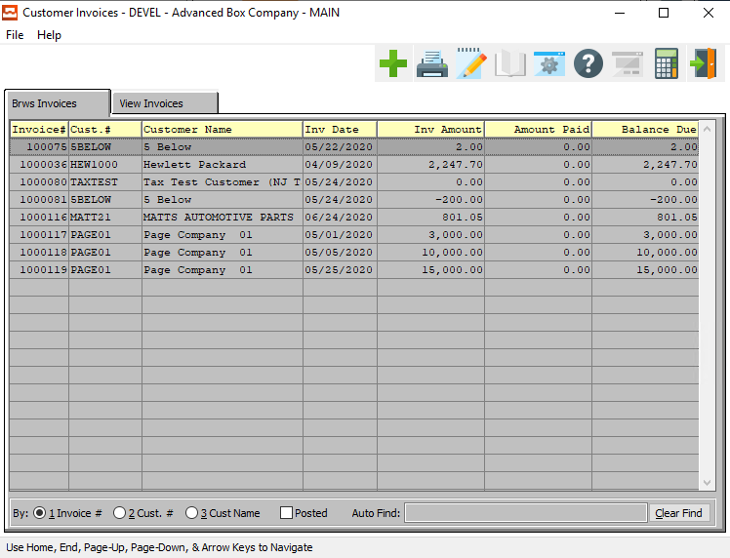

#### ADD

Click the ***“Green + Icon”*** to add a new Invoice.

### View Invoices

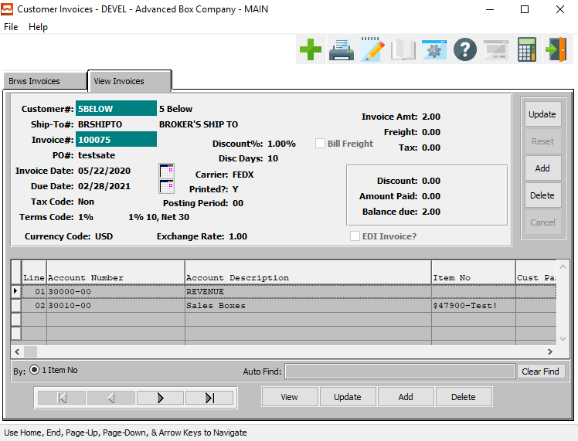

#### UPDATE

To change the currently selected Invoice, simply click the ***“Update***” button to the right of the main information section.

#### ADD

To add a new Invoice, simply click the ***“Green + Icon”*** button at the top of the Customer Invoices screen.

Alternatively, click the ***“Add”*** button to the right of the main information section.

#### DELETE

To delete the currently selected Invoice, simply press the ***"D"*** key. Alternatively, click the ***“Delete”*** button to the right of the main information section.

#### VIEW (Line)

Click the ***“View”*** button to view detailed information about the currently selected invoice line item.

#### UPDATE (Line)

To change the currently selected Invoice Line, simply click the ***“Update***” button at the bottom of the screen.

#### ADD (Line)

Click the ***“Add”*** button at the bottom of the screen to add a new invoice line.

#### DELETE (Line)

To delete the currently selected invoice line, simply press the ***"D"*** key. Alternatively, click the ***“Delete”*** button at the bottom of the screen.

#### NEXT

Press ***"N"*** (Next) to find next invoice to view or modify. Alternatively, press the ***“Right Arrow”*** on the screen.

#### PREVIOUS

Press ***"P"*** (Previous) to find previous invoice to view or modify. Alternatively, press the ***“Left Arrow”*** on the screen.

### Add/Update Invoice

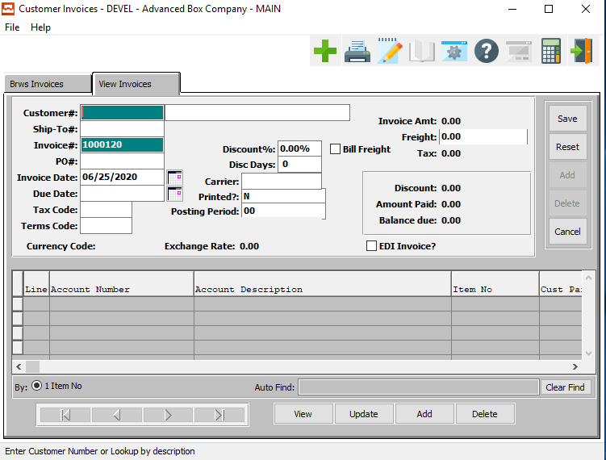

#### SAVE

Click the ***“Save”*** button to save all changes to the current Invoice.

#### RESET

Click the ***“Reset”*** button to reset all fields to their original state.

#### CANCEL

Click the ***“Cancel”*** button to cancel all changes to the Invoice without saving.

#### VIEW (Line)

Click the ***“View”*** button to view detailed information about the currently selected invoice line item.

#### UPDATE (Line)

To change the currently selected Invoice Line, simply click the ***“Update***” button at the bottom of the screen.

#### ADD (Line)

Click the ***“Add”*** button at the bottom of the screen to add a new invoice line.

#### DELETE (Line)

To delete the currently selected invoice line, simply press the ***"D"*** key. Alternatively, click the ***“Delete”*** button at the bottom of the screen.

### Add/Update Invoice Field Definitions

#### Customer #

Enter a valid customer number. Press ***“F1”*** to select, or press the ***“Page Up” / “Page Down”*** keys to scroll through the customer file.

#### Customer Name

The customer name will transfer from the customer file as soon as the user enters or chooses a valid Customer number.

#### Ship-To #

Enter a location that has been defined in this customer’s Ship-To file. Press ***“F1”*** to search for a valid Ship-To for that customer.

#### Invoice #

This field defaults to the next available invoice number, which is controlled in the order processing control file.

#### Invoice Date

Enter the invoice date. This field defaults to the current system date.

#### Due Date

Enter the date that payment is due from the customer. The due date defaults to the terms set up in the customer file. For example, net 30 will default to 30 days from the date of invoice.

#### Tax Code

Displays the Sales Tax Group entered in the customer file. Sales Tax groups are defined in Tax Codes.

#### Terms Code

Enter a valid terms code from the terms file, or Press ***“F1”*** to search.

#### Discount %

Enter the customer's discount percentage for this invoice. The system defaults to the Discount Percentage entered in the Customer file.

#### Discount Days

Enter the number of days, from the invoice date, that you allow the customer a payment discount. The system defaults to the Discount days entered in the Customer file.

#### Carrier

Enter a valid carrier for this invoice or press ***“F1”*** to search.

#### Bill Freight? – Toggle Box

To Bill the Freight on this invoice, make sure that the Bill Freight toggle box is checked.

#### Printed?

If this invoice has been printed, this field should be set to ***“Y”***. If it has not, this field should be ***“N”***.

#### EDI Invoice? – Toggle Box

To mark this Vendor as using an Electronic Data Interchange, make sure that the EDI Invoice toggle box is checked.

### Add/Update Invoice Item

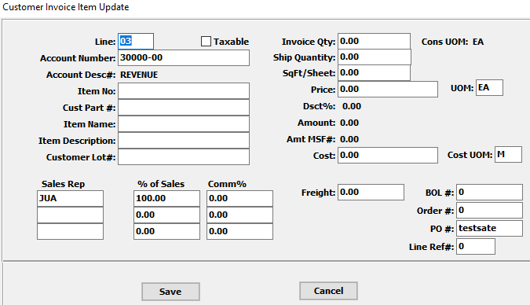

#### SAVE

Click the ***“Save”*** button to save all changes to the current invoice item.

#### CANCEL

Click the ***“Cancel”*** button to cancel all changes to the invoice item without saving.

### Add/Update Invoice Item Field Definitions

#### Line Number

The system default for the next line number to use is as follows; first line number, next unused sequential line number, or user entered line number.

#### Taxable – Toggle Box

To mark this invoice item as taxable, make sure that the Taxable toggle box is checked.

#### Account Number

Enter a valid G/L account number, press the ***“F1”*** to search through, or press the ***“Page Up” / “Page Down”*** keys to scroll through the G/L Accounts file. Press the ***“Enter”*** key to accept the G/L account displayed on the screen.

#### Account Description

The account description will transfer from the account file as soon as the user enters or chooses a valid account number.

#### Item Number

Enter the Finished Good Item number in this field.

#### Customer Part Number

Enter a valid customer part number for this invoice item.

#### Item Name

Enter an item name or description for this line item. This Description will print on first description line on the invoice outputted.

#### Item Description

Enter a description for this line item. This Description will print on the second description line on the invoice outputted.

#### Invoice Quantity

Enter the quantity per the unit of measure (UOM) ordered for this line item. The unit of measure defaults to EA for each.

#### Square Feet / Sheet

This field is optional. Enter the square feet per item (sheet or blank) for this line item. The total MSF will be calculated automatically and recorded in the invoice history file for sales history reporting.

#### Price

Enter the price per unit of measure (UOM) for this line item. Prices may be entered per each, per thousand, per thousand square feet and per lot. You can enter a negative price in this field if you need to enter a negative invoice or a negative line item.

#### UOM (Price)

Enter the pricing unit of measure (UOM) ordered for this line item. The unit of measure defaults to EA for each, however LOT, MSF and M are also valid.

#### Cost

Enter the cost per unit of measure for the invoice item.

#### Cost UOM

The sell price unit of measure defaults to M for per thousand, however this may be modified. Each unit of measure will yield a different total selling price.

Valid Units of Measure are:

|  |  |
| --- | --- |
| C | Per Hundred |
| CS | Per Case |
| EA | Per Each |
| L | Per Lot |
| M | Per Thousand |

#### Sales Rep

Enter salesman code who entered this order you can also use the pop-up menu by selecting the ***“F1”*** key.

#### % of Sales

Enter the percentage of sales which will be multiplied by the total sales value then by the commission percentage.

#### Commission %

The commission percentage defined on the order will automatically transfer, but may be modified for each order. The commission can be set by customer, customer type and product category and may be calculated on the selling price or gross profit as defined in the salesman matrix file.

#### BOL #

The Bill of Lading defaults from the order processing control file. To add multiple orders to a single Bill of Lading number, type over the Bill of Lading number to add another order number. To search for a valid Bill of Lading number, press ***“F1”*** or ***“Page Up” / “Page Down”***. Highlight the desired order number and press Enter to add a release for that order.

#### Order #

Enter the order number.

#### PO #

Enter a valid purchase order number for this invoice item.

#### Line Reference Number

This number is used to manually change the line number to match a customer PO number or for other purposes to arrange the items on the invoice in a defined order based on this line number. If left blank, lines will print in the sequence the order was entered.

## AR Invoice Edit List [AU2]

### Overview

This register function of the Accounts Receivable module prints all unposted invoices by customer by invoice number. Whenever a new invoice is to be printed, the system prints the invoice number, the invoice date, and the net amount of the invoice.

For each line item of the invoice, the line number the description of the line item, and the total amount of the line item are printed. Also, if a second description entered for this particular line item then this description is printed on the next line. Totals by customer, and batch totals are also printed.

In the second section of the Invoice Edit List, the invoice line items are sorted by G/L account numbers and printed. After the line item G/L Account numbers print the Freight account and the Sales Tax account numbers print. The system provides totals by account number and batch totals.

### Selection Parameters

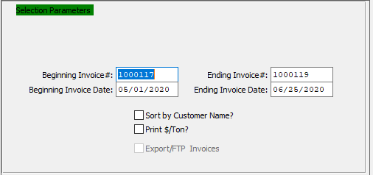

#### Beginning Invoice # / Ending Invoice #

Enter the beginning and ending Invoice Number to run the Accounts Receivable edit list for.

#### Beginning Invoice Date / Ending Invoice Date

Enter the beginning and ending Invoice Date to run the Accounts Receivable edit list for.

#### Sort by Customer Name? – Toggle Box

To sort the edit list by customer name, make sure that the Sort by Customer Name toggle box is checked.

#### Print $/Ton? – Toggle Box

To print the price by the ton, make sure that this toggle box is checked.

### Outlook Destination

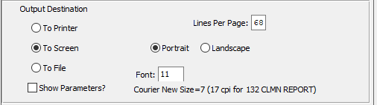

#### Destination Choice

To choose the destination where the document should be printed, please make sure that desired output destination choice bubble is toggled.

#### Layout Choice

To choose the preferred layout of Landscape vs. Portrait, please make sure the desired option choice bubbled is toggled.

#### Lines Per Page

Lines per page on the report when printing.

#### Font

Enter the font number to use with this report (Font 11 is default).

#### Show Parameters? – Toggle Box

To show parameters, make sure that the toggle box is ‘ticked’ with a checkmark.

## Print AR Invoices [AU3]

### Overview

This A/R function allow s users, before posting, to print one (or more) unposted invoices. Invoices can be printed when needed, and this function does not affect any other processing. The company can print invoices with headings it you are using blank paper or without headings. If you are using pre-printed forms. If you want to use your own custom formatted invoice forms, you will have to provide ASI with formats of your Invoices so that the invoicing program operates correctly.

In order to print headings on blank paper, you must go to the order processing module on the main menu. Then enter the file maintenance, option F, and enter on the order entry control file. Once you are into the order entry control file, answer (Y)es on the field that allows you to print company name on invoices. If you do not want heading to print, then leave this field as (N)o.

### Selection Parameters

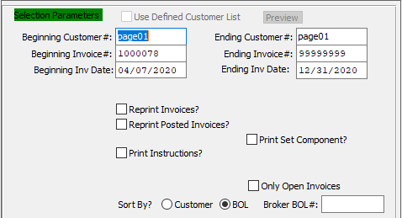

#### Beginning Customer # / Ending Customer #

Enter starting and ending customer number to print in this run.

#### Beginning Invoice # / Ending Invoice #

Enter starting and ending invoice number to print in this run.

#### Beginning Invoice Date / Ending Invoice Date

Enter starting and ending invoice date to print in this run.

#### Reprint Invoices? – Toggle Box

This function allows the user to reprint invoices that have already printed but have not been posted yet.

Say for example, the printer jammed, and you need to reprint just a few of the invoices, or you just simply need another copy of one or more of the invoices. If you need to reprint some of the invoices simply enter the beginning invoice number and the ending invoice number and checkmark this toggle box.

After all invoices have printed correctly, then you may then post. Once these invoices have posted to the general ledger and you need another copy then you will have to use the reprint posted invoices option.

#### Reprint Posted Invoices? – Toggle Box

This function allows the user to reprint invoices that have already been posted and are in the history file. This is used for example if you need another original copy for a customer or if the original copy is lost. If you need to reprint any invoices simply enter the beginning invoice number and the ending invoice number and checkmark this toggle box.

#### Print Set Component? – Toggle Box

To print set component to the invoice, make sure that the Print Set Component toggle box is checked.

#### Print Instructions? – Toggle Box

To print instructions onto the invoice, make sure that the Print Instructions toggle box is checked.

#### Open Only Invoices – Toggle Box

To only print open invoices, make sure that the Only Open Invoices toggle box is checked.

#### Sort By? (Choice)

To choose the preferred sorting method of Customer Number vs. Bill of Lading Number, please make sure the desired option choice bubble is toggled.

#### Broker BOL #

Enter a valid Broker Bill of Lading number.

### Outlook Destination

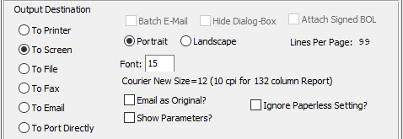

#### Destination Choice

To choose the destination where the document should be printed, please make sure that desired output destination choice bubble is toggled.

#### Layout Choice

To choose the preferred layout of Landscape vs. Portrait, please make sure the desired option choice bubbled is toggled.

#### Show Parameters? – Toggle Box

To show parameters, make sure that the toggle box is ‘ticked’ with a checkmark.

#### Email as Original – Toggle Box

To email a reprinted invoice as the original, make sure that the Email as Original toggle box is checked.

#### Ignore Paperless Setting – Toggle Box

To ignore paperless settings on an invoice, make sure that this toggle box is checked.

## Post AR Invoices [AU4]

### Overview

The posting report provides a printout of all invoices that were printed so that a review can be made to check for data entry errors before posting the invoices. Once the report has been printed the screen will prompt you if you want to post those invoices.

Do not post unless all invoices are correct. At this time all customer files will be updated as well as the general ledger accounts. Also, these will now go into a history file in case the user needs to inquire on an already posted invoice.

### Selection Parameters

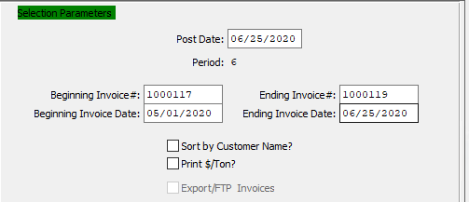

#### Post Date

This defaults to the system date, or you can override with another desired date. Invoices are posted based upon the transaction date. Suppose an invoice batch with invoice dates of January 1, 1993 are entered, and the user enters a transaction date of December 31, 1992. All of the invoices will then be posted to the period associated with December 31, 1992.

#### Period

The system displays the period that contains the transaction date. Note: the fiscal period, not necessarily the calendar period, displays on the screen.

#### Beginning Invoice # / Ending Invoice #

Enter starting and ending invoice number needed for posting or press ***“Enter”*** to default to all.

#### Beginning Invoice Date / Ending Invoice Date

Enter starting and ending invoice date needed for posting or press ***“Enter”*** to default to all.

#### Sort by Customer Name? – Toggle Box

To sort the AR Invoices by Customer Name, make sure that the Sort by Customer Name toggle box is checked.

#### Print $ / Ton? – Toggle Box

To print the price per ton to the invoice, make sure that this toggle box is checked.

### Outlook Destination

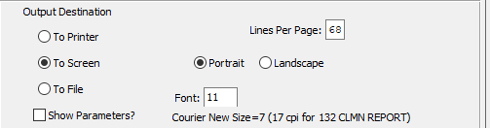

#### Destination Choice

To choose the destination where the document should be printed, please make sure that desired output destination choice bubble is toggled.

#### Layout Choice

To choose the preferred layout of Landscape vs. Portrait, please make sure the desired option choice bubbled is toggled.

#### Lines Per Page

Lines per page on the report when printing.

#### Font

Enter the font number to use with this report (Font 11 is default).

#### Show Parameters? – Toggle Box

To show parameters, make sure that the toggle box is ‘ticked’ with a checkmark.

## Update Posted Invoice Detail [AU5]

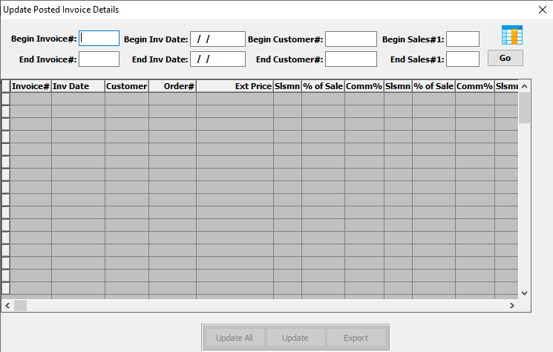

### Field Definitions

#### Beginning Invoice # / Ending Invoice #

Enter the beginning and ending Invoice Number to search for.

#### Beginning Invoice Date / Ending Invoice Date

Enter the beginning and ending Invoice Date to search for.

#### Beginning Customer # / Ending Customer #

Enter the beginning and ending Customer Number to search for.

#### Beginning Sales # 1 / Ending Sales # 1

Enter the beginning and ending First Salesman to search for.

# **Write AR Credit/Debit Memos [AW]**

## Overview

The debit / credit memos may be entered through this process. A credit or debit entered through this function will automatically debit / credit the Accounts Receivable general ledger account number entered as a default on the A/R file maintenance control file screen and debit/credit the sales account entered on the line item part of the screen. It will also update the invoice in the customer file. This function cannot be used to put a credit on account for a certain customer. It is recommended that the user enter a negative A/R invoice to put a credit on account.

When processing a credit for returned goods it is recommended to utilize the returns function from the OP main menu. The returns function simultaneously will credit the invoice amount and receive the Finished Goods amount automatically. This debit / credit memo process does not affect inventory. However, this may be an easier method for processing either credits or debits against another invoice. To add, press the ***"A"*** key and continue, to change press ***"C"***, to delete a transaction press ***"D"***.

## Enter/Edit CR/DB Memos [AW1]

### Browse Memos

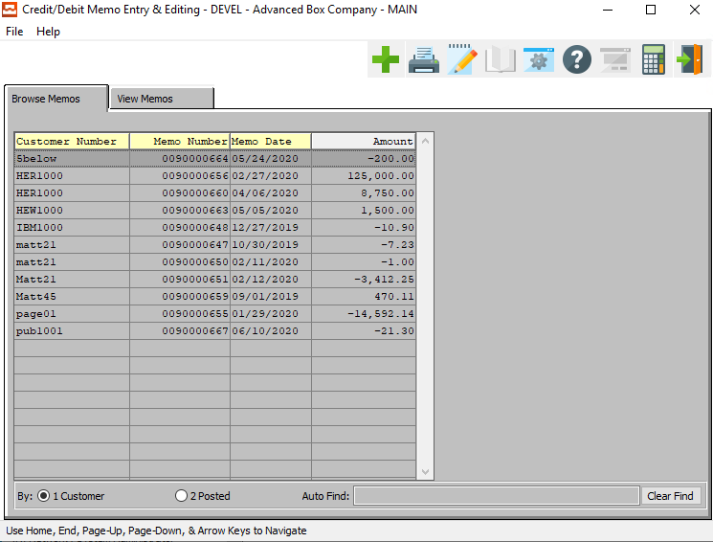

#### ADD

Click the ***“Green + Icon”*** to add a new Credit/Debit Memo.

### View Memos

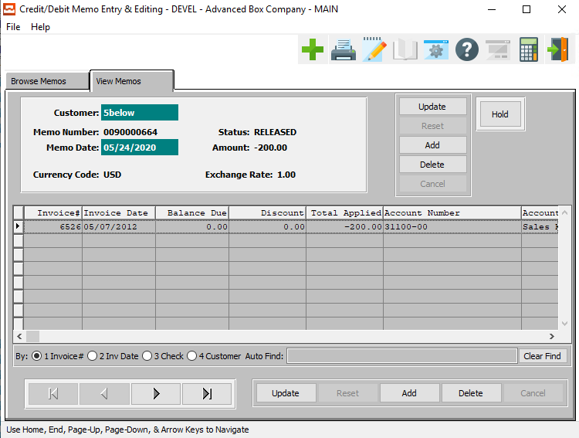

#### UPDATE

To change the currently selected Credit/Debit Memo, simply click the ***“Update***” button to the right of the main memo information.

#### ADD

To add a new Credit/Debit Memo, simply click the ***“Green + Icon”*** button at the top of the Credit/Debit Memo screen.

Alternatively, click the ***“Add”*** button to the right of the main memo information.

#### DELETE

To delete the currently selected Credit/Debit Memo, simply press the ***"D"*** key. Alternatively, click the ***“Delete”*** button to the right of the main memo information.

#### HOLD

Click the ***“Hold”*** button to change the status of the currently selected Credit/Debit Memo from “Released” to “On Hold”.

#### UPDATE (Line)

To change the currently selected Memo Line, simply click the ***“Update***” button at the bottom of the screen.

#### ADD (Line)

Click the ***“Add”*** button at the bottom of the screen to add a new Memo Line.

#### DELETE (Line)

To delete the currently selected Memo Line, simply press the ***"D"*** key. Alternatively, click the ***“Delete”*** button at the bottom of the screen.

#### NEXT

Press ***"N"*** (Next) to find next Credit/Debit Memo to view or modify. Alternatively, press the ***“Right Arrow”*** on the screen.

#### PREVIOUS

Press ***"P"*** (Previous) to find previous Credit/Debit Memo to view or modify. Alternatively, press the ***“Left Arrow”*** on the screen.

### Add/Update Memo

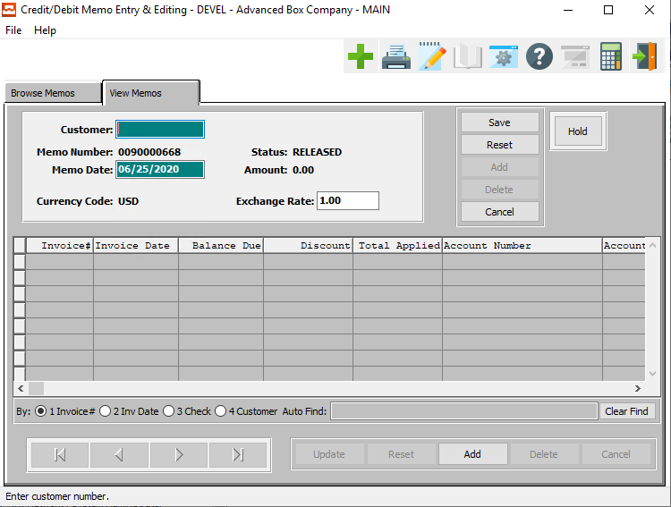

#### SAVE

Click the ***“Save”*** button to save all changes to the current Credit/Debit Memo.

#### CANCEL

Click the ***“Cancel”*** button to cancel all changes to the Credit/Debit Memo without saving.

#### HOLD

Click the ***“Hold”*** button to change the status of the currently selected Credit/Debit Memo from “Released” to “On Hold”.

#### ADD (Line)

Click the ***“Add”*** button at the bottom of the screen to add a new Memo Line.

### Add/Update Memo Field Definitions

#### Customer

Enter the number of the customer for this memo.

#### Memo Date

This defaults to system date; users can override with another desired date. The system posts memos to the period that contains the transaction date.

#### Exchange Rate

Enter the exchange rate.

### Add/Update Memo Invoice Line

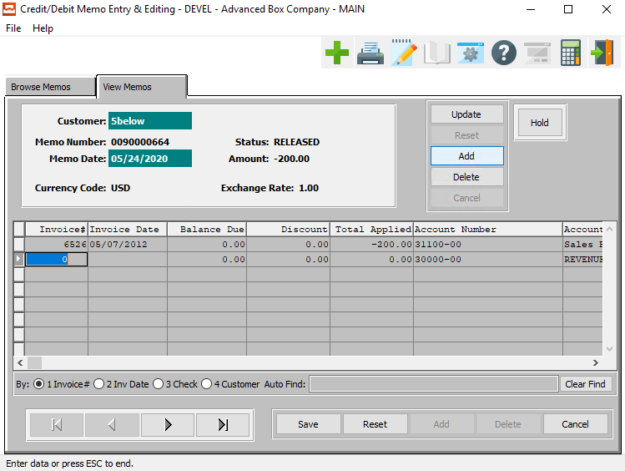

#### UPDATE

To change the currently selected Memo, simply click the ***“Update***” button to the right of the memo’s main information.

#### ADD

To add a new Memo, simply click the ***“Green + Icon”*** button at the top of the Credit/Debit Memo screen.

Alternatively, click the ***“Add”*** button to the right of the memo’s main information.

#### DELETE

To delete the currently selected Memo, simply press the ***"D"*** key. Alternatively, click the ***“Delete”*** button to the right of the memo’s main information.

#### HOLD

Click the ***“Hold”*** button to change the status of the currently selected Memo from “Released” to “On Hold”.

#### SAVE

Click the ***“Save”*** button to save all changes to the current Memo Line.

#### RESET

Click the ***“Reset”*** button to reset all fields to their original state.

#### CANCEL

Click the ***“Cancel”*** button to cancel all changes to the Memo Line without saving.

#### NEXT

Press ***"N"*** (Next) to find next Memo to view or modify. Alternatively, press the ***“Right Arrow”*** on the screen.

#### PREVIOUS

Press ***"P"*** (Previous) to find previous Memo to view or modify. Alternatively, press the ***“Left Arrow”*** on the screen.

### Add/Update Memo Invoice Line Field Definitions

#### Invoice Number

Enter the invoice number the debit or credit applies to. Press ***“F1”*** to search or ***“Page Up” / “Page Down”*** to scroll through invoices, then press enter on selected item.

#### Invoice Date

Enter the date of the debit or credit. The system defaults to the current date.

#### Balance Due

The system displays the remaining balance due on that invoice.

#### Discount

This field shows the discount percentage given to the current invoice.

#### Total Applied

Enter a positive number for a debit or a negative number (minus sign in front of number for the amount of the credit. You will then receive a prompt. Enter a ***“Y”*** (Yes) if you have entered the correct debit or credit. You may then choose another invoice to debit/credit if needed.

#### Account Number

Enter the GL account number to apply the amount to, or press the ***“Page Up” / “Page Down”*** keys to scroll through the GL file and then press ***“Enter”*** to accept the highlighted account number. The account number defaults to the GL account number in the vendor's file.

#### Account Description

Enter a short description of the account.

#### Memo Description

Enter a short description of the memo.

## CR/DB Memo Edit List [AW2]

### Overview

This register provides a listing of the Memos for the system to post. Users issue a Credit Memo to a customer for returned merchandise, or any other adjustment that decreases the invoice amount due. Likewise, users issue a Debit Memo for charges after posting of an invoice, or any other adjustment that increases the invoice amount due. This register is useful as an edit register. It provides an output of all DB/CR Memo transactions entered and ready to post. This allows the transactions that were previously entered to print on an edit register for review and to check for data entry errors prior to posting.

### Selection Parameters

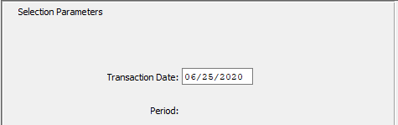

#### Transaction Date

This defaults to system date; users can override with another desired date. The system posts memos to the period that contains the transaction date.

#### Period

The system displays the period that is contains the transaction date. All transactions post to this period.

### Outlook Destination

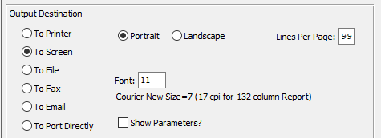

#### Destination Choice

To choose the destination where the document should be printed, please make sure that desired output destination choice bubble is toggled.

#### Layout Choice

To choose the preferred layout of Landscape vs. Portrait, please make sure the desired option choice bubbled is toggled.

#### Show Parameters? – Toggle Box

To show parameters, make sure that the toggle box is ‘ticked’ with a checkmark.

## Print AR Credit/Debit Memos [AW3]

The system will print Debit/Credit Memos on plain paper only or you can order forms. The system Prompts will be for starting and ending (TO) Memo numbers. Once posted, you are unable to reprint a memo.

### Selection Parameters

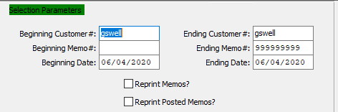

#### Beginning Customer # / Ending Customer #

Enter the beginning and ending Customer Number to run the print report for.

#### Beginning Memo # / Ending Memo #

Enter the beginning and ending Memo Number to run the print report for.

#### Beginning Date / Ending Date

Enter the beginning and ending Date to run the print report for.

#### Reprint Memos? – Toggle Box

To reprint any memos that have previously been printed before, make sure that the Reprint Memos toggle box is checked.

#### Reprint Posted Memos? – Toggle Box

To reprint any memos that have already been posted, make sure that the Reprint Posted Memos toggle box is checked.

### Outlook Destination

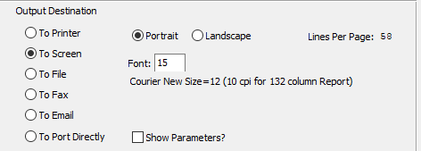

#### Destination Choice

To choose the destination where the document should be printed, please make sure that desired output destination choice bubble is toggled.

#### Layout Choice

To choose the preferred layout of Landscape vs. Portrait, please make sure the desired option choice bubbled is toggled.

#### Lines Per Page

Lines per page on the report when printing.

#### Font

Enter the font number to use with this report (Font 11 is default).

#### Show Parameters? – Toggle Box

To show parameters, make sure that the toggle box is ‘ticked’ with a checkmark.

## Post Credit/Debit Memos [AW4]

### Overview

This register provides a listing of the Memos for the system to post. Users issue a Credit Memo to a customer for returned merchandise, or any other adjustment that decreases the invoice amount due. Likewise, users issue a Debit Memo for charges after posting of an invoice, or any other adjustment that increases the invoice amount due.

This register is useful as an edit and a posting register. It provides an output of all Debit/Credit Memo transactions entered and ready to post. If the user chooses to send the output to the printer, then after printing the system prompts whether or not to post the memos. After posting, the user can't modify or delete memos.

This allows the transactions that were previously entered to print on an edit register for review and to check for data entry errors prior to posting.

### Selection Parameters

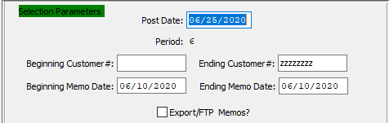

#### Post Date

This defaults to system date; users can override with another desired date. The system posts memos to the period that contains the transaction date.

#### Period

The system displays the period that is contains the transaction date. All transactions post to this period.

#### Beginning Customer # / Ending Customer #

Enter the beginning and ending Customer Number to post memos for.

#### Beginning Memo Date / Ending Memo Date

Enter the beginning and ending Memo Date to post memos for.

#### Export / FTP Memos? – Toggle Box

To export memos, make sure that this toggle box is checked.

### Outlook Destination

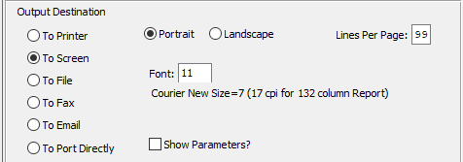

#### Destination Choice

To choose the destination where the document should be printed, please make sure that desired output destination choice bubble is toggled.

#### Layout Choice

To choose the preferred layout of Landscape vs. Portrait, please make sure the desired option choice bubbled is toggled.

#### Lines Per Page

Lines per page on the report when printing.

#### Font

Enter the font number to use with this report (Font 11 is default).

#### Show Parameters? – Toggle Box

To show parameters, make sure that the toggle box is ‘ticked’ with a checkmark.

# **Cash Receipts Processing [AC]**

## Overview

The Enter/Edit Cash Receipts screen allows for applying cash to a particular invoice or applying cash on account for a specific customer. Print a Cash Receipts Register to check for data entry errors, etc. Once all corrections, if any, are made they must be posted. The Register screen will prompt for posting. The Cash Receipts transactions post according to the transaction date entered on the posting screen, not the check date. The system maintains an A/R audit trail.

The Enter Misc. Receipts purpose is to apply miscellaneous cash receipts, so a customer does not need to be created and a posting is created to a particular GL account number as opposed to applying it to a particular customer. Once these transactions are reviewed via a register, they must be posted as well. The Apply on Account allows cash previously posted against a customer to be applied against an invoice.

## Enter/Edit Cash Receipts [AC1]

### Browse Cash

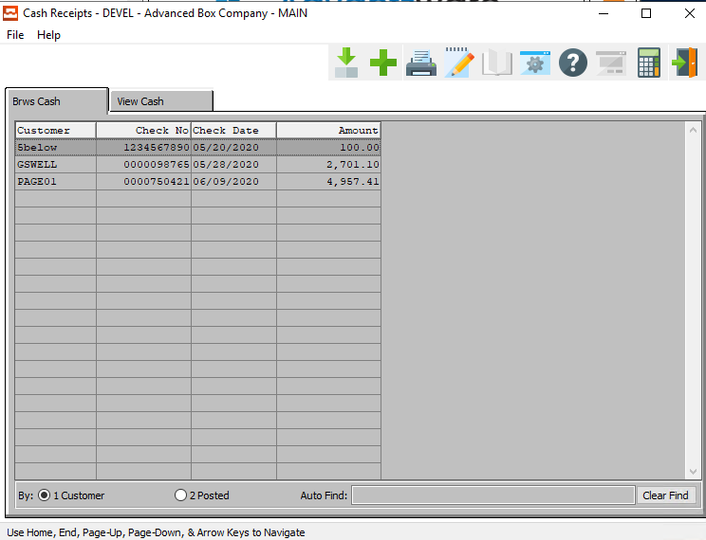

#### ADD

Click the ***“Green + Icon”*** to add a new Cash Receipt.

### View Cash

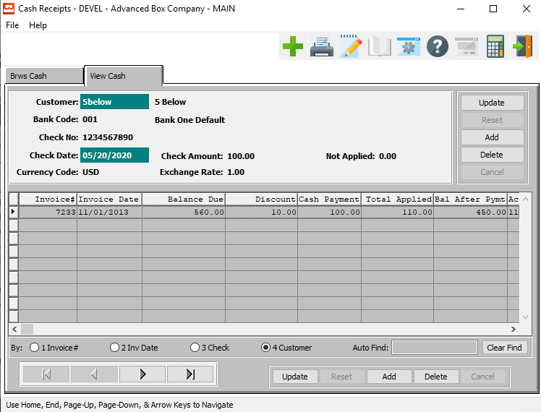

#### UPDATE

To change the currently selected Cash Receipt, simply click the ***“Update***” button to the right of the Cash Receipt main information.

#### ADD

To add a new Cash Receipt, simply click the ***“Green + Icon”*** button at the top of the Cash Receipt screen.

Alternatively, click the ***“Add”*** button to the right of the Cash Receipt main information.

#### DELETE

To delete the currently selected Cash Receipt, simply press the ***"D"*** key. Alternatively, click the ***“Delete”*** button to the right of the Cash Receipt main information.

#### UPDATE (Line)

To change the currently selected Cash Receipt Line, simply click the ***“Update***” button at the bottom of the screen.

#### ADD (Line)

Click the ***“Add”*** button at the bottom of the screen to add a new Cash Receipt Line.

#### DELETE (Line)

To delete the currently selected Cash Receipt Line, simply press the ***"D"*** key. Alternatively, click the ***“Delete”*** button at the bottom of the screen.

#### NEXT

Press ***"N"*** (Next) to find next Cash Receipt to view or modify. Alternatively, press the ***“Right Arrow”*** on the screen.

#### PREVIOUS

Press ***"P"*** (Previous) to find previous Cash Receipt to view or modify. Alternatively, press the ***“Left Arrow”*** on the screen.

### Add/Update Cash

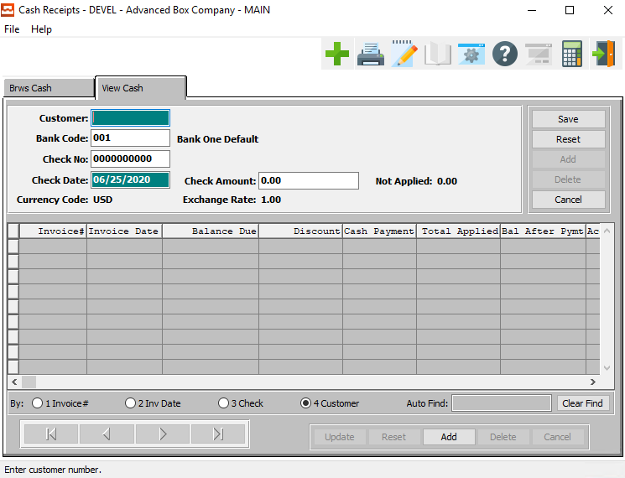

#### SAVE

Click the ***“Save”*** button to save all changes to the current Cash Receipt.

#### RESET

Click the ***“Reset”*** button to reset all fields to their original state.

#### CANCEL

Click the ***“Cancel”*** button to cancel all changes to the Cash Receipt without saving.

#### ADD

Click the ***“Add”*** button at the bottom of the screen to add a new Cash Receipt Line.

### Add/Update Cash Field Definitions

#### Customer

Enter a valid Customer number from the Customer file. Optionally, press the ***“F1”*** to search through, or the ***“Page Up” / “Page Down”*** keys to scroll through the file. Press the ***“Enter”*** key to accept the customer displayed on the screen. This will automatically bring up the customer name.

#### Bank Code

Use the code for the bank where the Cash Receipts were (will be) deposited. Enter the valid Bank Code from the Bank file. Optionally, press the ***“F1”*** to search through, or the ***“Page Up” / “Page Down”*** keys to scroll through the file. Press the ***“Enter”*** key to accept the bank displayed on the screen. This will automatically bring up the bank's name.

#### Check Number

Enter the number of the check received. Optionally, press the ***“F1”*** key to search through, or the ***“Page Up” / “Page Down”*** keys to scroll through the Check file to find existing Cash Receipts. Press the ***“Enter”*** key to accept the check number. If the Check exists and is posted, then the check disbursement displays on the screen; the user can't perform any changes or deletion. If the check isn't posted, then the user can modify the check date and amount fields.

#### Check Date

Enter the date of the check, or at the company's option, the date received.

#### Check Amount

Enter the amount of the check received.

### Add/Update Cash Line

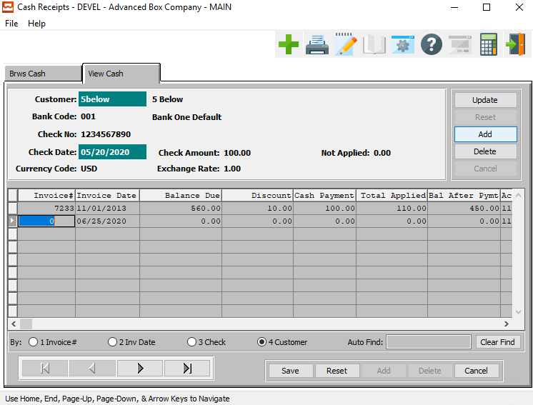

#### UPDATE

To change the currently selected Cash Receipt, simply click the ***“Update***” button to the right of the Cash Receipt main information.

#### DELETE

To delete the currently selected Cash Receipt, simply press the ***"D"*** key. Alternatively, click the ***“Delete”*** button to the right of the Cash Receipt main information.

#### SAVE

Click the ***“Save”*** button to save all changes to the current Cash Receipt Line.

#### RESET

Click the ***“Reset”*** button to reset all fields to their original state.

#### CANCEL

Click the ***“Cancel”*** button to cancel all changes to the Cash Receipt Line without saving.

#### NEXT

Press ***"N"*** (Next) to find next Cash Receipt to view or modify. Alternatively, press the ***“Right Arrow”*** on the screen.

#### PREVIOUS

Press ***"P"*** (Previous) to find previous Cash Receipt to view or modify. Alternatively, press the ***“Left Arrow”*** on the screen.

### Add/Update Cash Line Field Definitions

#### Invoice Number

Enter a valid posted invoice number. Optionally, press the ***“F1”*** key to search through, or the ***“Page Up” / “Page Down”*** keys to scroll through the A/R Invoice file. Press the ***“Enter”*** key to accept the invoice displayed on the screen.

#### Invoice Date

The system displays the invoice date of the selected invoice.

#### Balance Due

The system displays the balance due on the selected invoice.

#### Discount

Enter the discount amount to apply against this invoice. The amount, when posted, will decrease the invoice balance due, and update the customer and G/L accounts period-to-date and year-to-date totals. The A/R Control file contains the Receivables and Discount account numbers that the receipts post to.

#### Cash Payment

The system updates this field by displaying the amount just applied to this invoice.

#### Total Applied

Enter the amount to pay against this invoice. The amount decreases the not applied field at the top of the screen. If the user completes applying C/R against invoices and an unapplied balance exists, then the unapplied amount is 'Put on account'.

The amount, when posted, will decrease the invoice balance due, and update the customer and G/L accounts period-to-date and year-to-date totals. The A/R Control file contains the G/L account number that the Receivables account posts to. The Bank File contains the G/L account number that the receipts posts to.

#### Balance After Payment

The system displays the balance due on the selected invoice after this current payment has been paid.

#### Account Number

Enter a valid G/L account number, press the ***“F1”*** key to search through, or the ***“Page Up” / “Page Down”*** keys to scroll through the G/L accounts file. Press the ***“Enter”*** key to accept the G/L account number of the Bank Account. The system defaults to the G/L account number located in the Bank file.

#### Account Description

The account description will transfer from the account file as soon as the user enters or chooses a valid account number.

## Edit/Post AR Cash Receipts [AC2]

### Overview

This function of Cash Receipts outputs the unposted Cash Receipts in customer order. Included on the report is the customer number and name, the invoice particulars, the amount paid, and the discounts allowed. After printing, the system prompts for posting.

The Posting update Cash in Bank, the Customer, and the General Ledger files. The Customer and the G/L files update both period-to-date and the year-to-date amounts and balances. The Cash Receipts transactions post according to the transaction date, not the check date. The system maintains an A/R audit trail.

### Selection Parameters

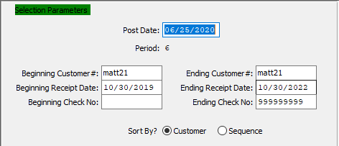

#### Post Date

This defaults to system date; users can override with another desired date. The system posts transactions to the period that contains the transaction date.

#### Period

The system displays the period that contains the transaction date. All transactions post to this period.

#### Beginning Customer # / Ending Customer #

Enter the beginning and ending Customer Number to edit or post cash receipts for.

#### Beginning Receipt Date / Ending Receipt Date

Enter the beginning and ending Receipt Date to edit or post cash receipts for.

#### Beginning Check Number / Ending Check Number

Enter the beginning and ending Check Number to edit or post cash receipts for.

#### Sort By? (Choice)

To choose the preferred Sorting Method during entry of cash receipts between Customer vs. Sequence, please make sure the desired option choice bubble is toggled.

### Outlook Destination

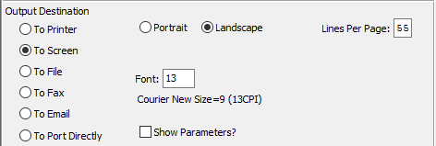

#### Destination Choice

To choose the destination where the document should be printed, please make sure that desired output destination choice bubble is toggled.

#### Layout Choice

To choose the preferred layout of Landscape vs. Portrait, please make sure the desired option choice bubbled is toggled.

#### Lines Per Page

Lines per page on the report when printing.

#### Font

Enter the font number to use with this report (Font 11 is default).

#### Show Parameters? – Toggle Box

To show parameters, make sure that the toggle box is ‘ticked’ with a checkmark.

## Enter Miscellaneous Receipts [AC3]

### Overview

The purpose of this process is to apply misc. cash receipts to a particular GL account number as opposed to applying it to a particular customer. Perhaps misc. income or some type of misc. credit not to be applied to a particular customer.

To add simply press the ***"A"*** key and enter the record number, the bank number, date, amount, who the check is from and apply it to a GL account number. You may change or delete this transaction. Once the entries have been reviewed the transactions must be printed on the register and posted.

### Browse Receipts

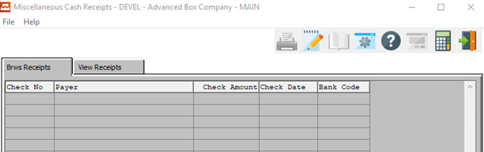

### View Receipts

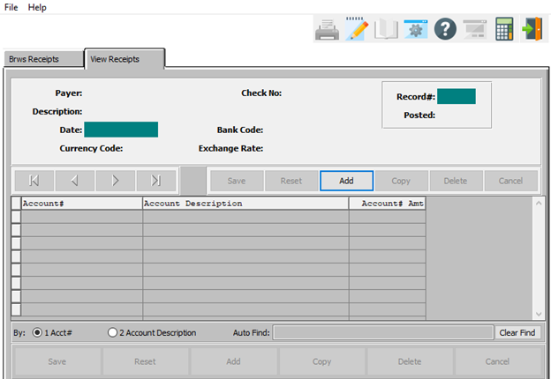

#### ADD

Click the ***“Add”*** button at the top of the screen to add a new Miscellaneous Cash Receipt.

### Add/Update Receipt

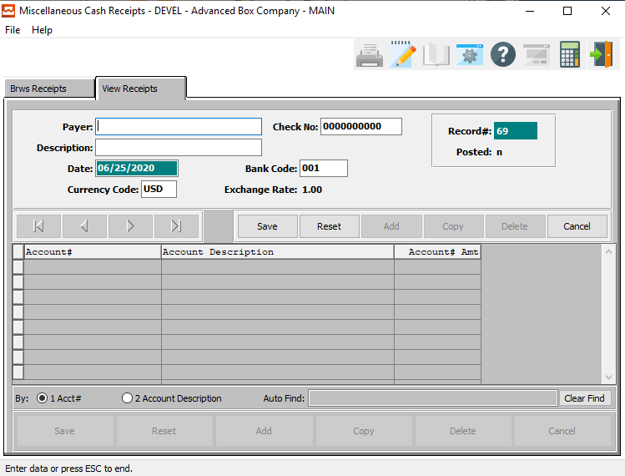

#### SAVE

Click the ***“Save”*** button to save all changes to the current Miscellaneous Cash Receipt.

#### RESET

Click the ***“Reset”*** button to reset all fields to their original state.

#### CANCEL

Click the ***“Cancel”*** button to cancel all changes to the Miscellaneous Cash Receipt without saving.

### Add/Update Receipt Field Definitions

#### Payer

Enter the name of the person the check is from.

#### Description

Enter a description to describe the type.

#### Date

Enter the date of the check.

#### Currency Code

Enter the currency code or you may use the ***“F1”*** key to do a look up of codes.

#### Check Number

Enter the check number for this receipt.

#### Bank Code

Use the code for the bank where the Cash Receipts were (will be) deposited. Enter the valid Bank Code from the Bank file. Optionally, press the ***“F1”*** to search through, or the ***“Page Up” / “Page Down”*** keys to scroll through the file. Press the ***“Enter”*** key to accept the bank displayed on the screen. This will automatically bring up the bank's name.

## Edit/Post AR Miscellaneous Receipts [AC4]

### Overview

This function of Misc. Cash Receipts outputs the unposted Misc. Cash Receipts in customer order. Included on the report is the customer number and name, the invoice particulars, the amount paid, and the discounts allowed. After printing, the system prompts for posting.

The Posting update Cash in Bank, the Customer, and the General Ledger files. The Customer and the G/L files update both period-to-date and the year-to-date amounts and balances. The Misc. Cash Receipts transactions post according to the transaction date, not the check date. The system maintains an A/R audit trail.

### Selection Parameters

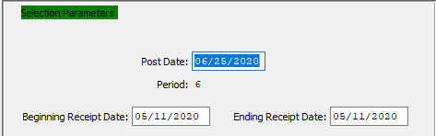

#### Post Date

This defaults to system date; users can override with another desired date. The system posts transactions to the period that contains the transaction date.

#### Period

The system displays the period that contains the transaction date. All transactions post to this period.

#### Beginning Receipt Date / Ending Receipt Date

Enter the beginning and ending Receipt Date to edit or post miscellaneous receipts for.

### Outlook Destination

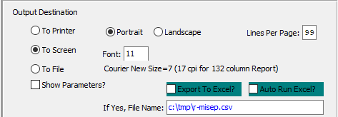

#### Destination Choice

To choose the destination where the document should be printed, please make sure that desired output destination choice bubble is toggled.

#### Layout Choice

To choose the preferred layout of Landscape vs. Portrait, please make sure the desired option choice bubbled is toggled.

#### Lines Per Page

Lines per page on the report when printing.

#### Font

Enter the font number to use with this report (Font 11 is default).

#### Show Parameters? – Toggle Box

To show parameters, make sure that the toggle box is ‘ticked’ with a checkmark.

#### Export to Excel? – Toggle Box

To export the printed file to an excel document, make sure that the Export to Excel toggle box is checked.

#### Auto Run Excel? – Toggle Box

To automatically open the new excel document, make sure that the Auto Run Excel toggle box is checked.

#### If Yes, File Name

If exporting the file to Excel, enter the desired file name.

## Apply/Reapply Cash Memos [AC5]

The purpose of this function is to apply cash received, but not applied to any invoice as of yet. For example, you may have received a deposit check and applied that check on the customer's account.

### Browse On Account

This function outputs the unposted Applications in customer order. Included on the report is the customer number and name, the invoice particulars, the amount paid, and the discounts allowed. After printing, the system prompts for posting. The Posting updates the customer’s account file only. The Customer’s account updates both period-to-date and the year-to-date amounts and balances on the customer totals screen.

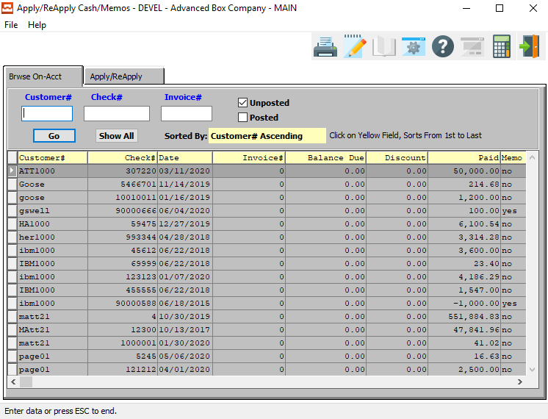

#### Customer #

Enter the customer number to apply the cash on account to.

#### Check #

Enter the check # of the cash transaction needed to apply. Use the ***“F1”*** key to search for open transactions on this customer or use the ***“Page Up” / “Page Down”*** keys.

#### Invoice #

Enter the invoice number to be applied to. You will need to use the ***“C”*** (Change) function in order to select an invoice. Use the ***“F1”*** key to search for open transactions on this customer or use the ***“Page Up” / “Page Down”*** keys.

#### Unposted – Toggle Box

To search for unposted memos, make sure that the Unposted toggle box is checked.

#### Posted – Toggle Box

To search for posted memos, make sure that the Posted toggle box is checked.

### Apply/Reapply

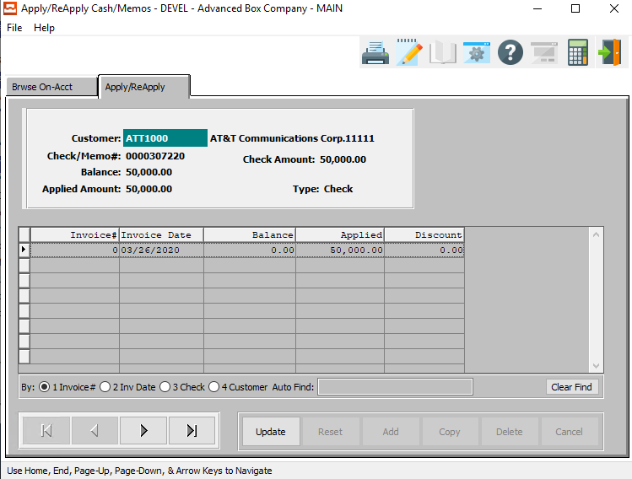

#### UPDATE

To change the currently selected Cash/Memo, simply click the ***“Update***” button at the bottom of the screen.

#### NEXT

Press ***"N"*** (Next) to find next Cash/Memo to view or modify. Alternatively, press the ***“Right Arrow”*** on the screen.

#### PREVIOUS

Press ***"P"*** (Previous) to find previous Cash/Memo to view or modify. Alternatively, press the ***“Left Arrow”*** on the screen.

### Update Apply/Reapply

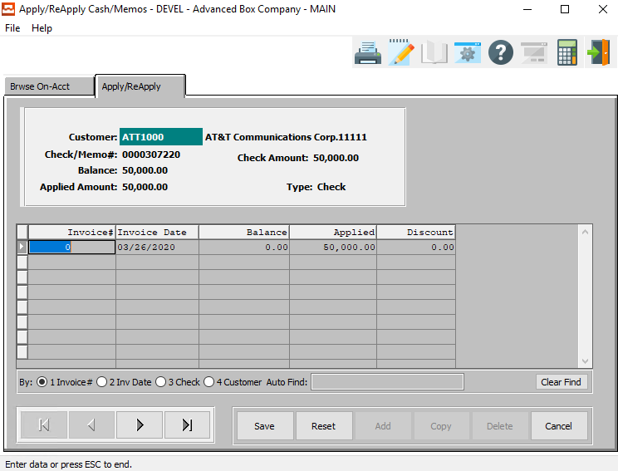

#### SAVE

Click the ***“Save”*** button to save all changes to the current Cash/Memo.

#### RESET

Click the ***“Reset”*** button to reset all fields to their original state.

#### CANCEL

Click the ***“Cancel”*** button to cancel all changes to the Cash/Memo without saving.

#### NEXT

Press ***"N"*** (Next) to find next Cash/Memo to view or modify. Alternatively, press the ***“Right Arrow”*** on the screen.

#### PREVIOUS

Press ***"P"*** (Previous) to find previous Cash/Memo to view or modify. Alternatively, press the ***“Left Arrow”*** on the screen.

### Update Apply/Reapply Field Definitions

#### Invoice Number

Enter the invoice number that this memo is for.

#### Invoice Date

This defaults to system date; users can override with another desired date.

#### Balance

The current balance of the chosen invoice.

#### Applied

The applied payment from this memo to the current chosen invoice.

#### Discount

The current discount applied to this memo.

## Edit/Post AR Applied Items [AC6]

### Selection Parameters

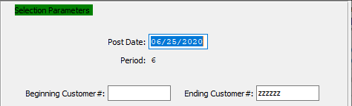

#### Post Date

This defaults to the system date, or you can override with another desired date. Invoices are posted based upon the transaction date.

#### Period

The system displays the period that contains the transaction date. Note: the fiscal period, not necessarily the calendar period, displays on the screen.

#### Beginning Customer # / Ending Customer #

Enter the beginning and ending Customer Number to edit or post applied items for.

### Outlook Destination

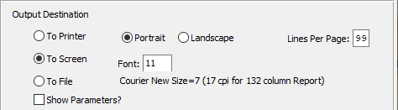

#### Destination Choice

To choose the destination where the document should be printed, please make sure that desired output destination choice bubble is toggled.

#### Layout Choice

To choose the preferred layout of Landscape vs. Portrait, please make sure the desired option choice bubbled is toggled.

#### Lines Per Page

Lines per page on the report when printing.

#### Font

Enter the font number to use with this report (Font 11 is default).

#### Show Parameters? – Toggle Box

To show parameters, make sure that the toggle box is ‘ticked’ with a checkmark.

## Void Cash Receipts [AC7]

### View Cash

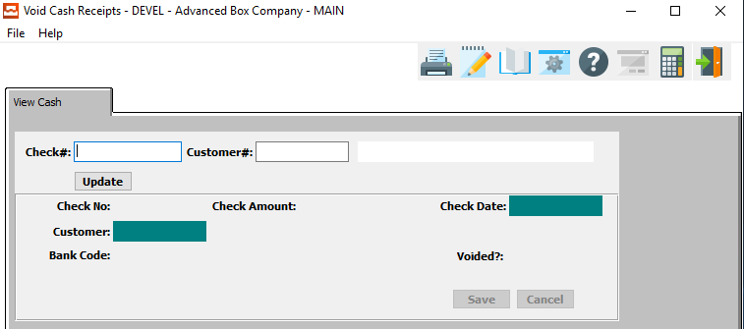

#### Check #

Enter a check number that you would like to use.

#### Customer #

Enter the customer number for this receipt.

#### Customer Name

The customer name will transfer from the customer file as soon as the user enters or chooses a valid customer number.

## Voided Cash Receipt Registers [AC8]

### Selection Parameters

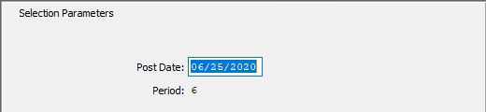

#### Post Date

This defaults to the system date, or you can override with another desired date. Invoices are posted based upon the transaction date.

#### Period

The system displays the period that contains the transaction date. Note: the fiscal period, not necessarily the calendar period, displays on the screen.

### Outlook Destination

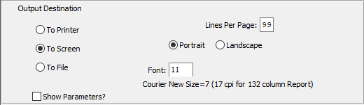

#### Destination Choice

To choose the destination where the document should be printed, please make sure that desired output destination choice bubble is toggled.

#### Layout Choice

To choose the preferred layout of Landscape vs. Portrait, please make sure the desired option choice bubbled is toggled.

#### Lines Per Page

Lines per page on the report when printing.

#### Font

Enter the font number to use with this report (Font 11 is default).

#### Show Parameters? – Toggle Box

To show parameters, make sure that the toggle box is ‘ticked’ with a checkmark.

# **Bill Finance Charges [AB]**

This function creates finance charge invoices for those customers set up to be charged. In order to mark a customer to receive finance charge, the flag labeled (Fin. Chrgs.) needs to be set to yes in their customer file screen. An invoice will then be created if the customer invoice is past due of the “as of” date entered on the screen. You then set the finance charge percent to charge on each invoice. This procedure creates the A/R invoices which then needs to be printed and posted.

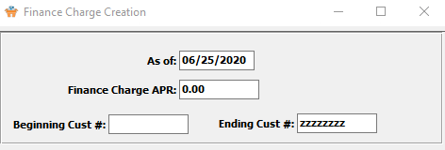

#### As Of

Enter the date you would like to charge finance charges as of. This will select any invoice that is past due as of this date.

#### Finance Charge APR

Enter the finance charge percent to be charged for each invoice.

#### Beginning Customer # / Ending Customer #

Enter the beginning and ending Customer Number to bill finance charges for.

# **Query Accounts Receivables [AQ]**

## AR Invoice Inquiry [AQ1]

### Browse Invoices

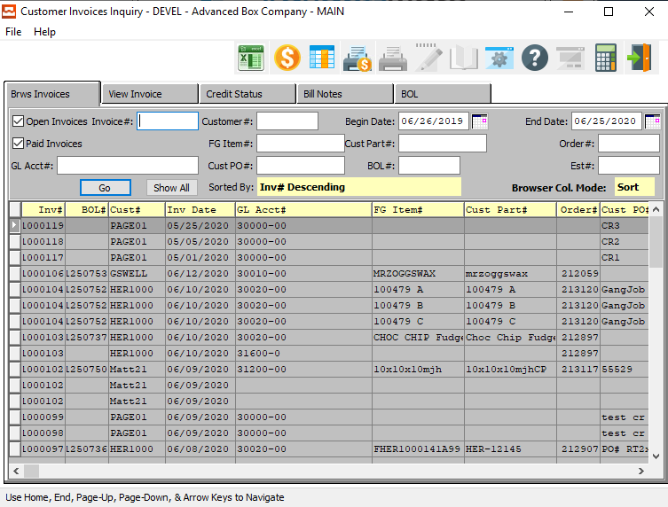

### Browse Invoices Field Definitions

#### Open Invoices – Toggle Box

To search for Open Invoices, make sure that the Open Invoices toggle box is checked.

#### Paid Invoices – Toggle Box

To search for Closed Invoices, make sure that the Closed Invoices toggle box is checked.

#### GL Account #

Enter a General Ledger account number to search for.

#### Invoice #

Enter an invoice number to search for.

#### Customer #

Enter customer number or you may use the ***“F1”*** look-up. A partial description may be typed into any field or data may be entered into multiple fields followed by pressing the ***“Go”*** button to sort the fields by the criteria that was entered. Once the data is presented on the screen the YELLOW column heading may be clicked to sort that specific column in ascending or descending order.

#### FG Item #

Enter the FG item number or you may use the ***“F1”*** look-up. A partial description may be typed into any field or data may be entered into multiple fields followed by pressing the ***“Go”*** button to sort the fields by the criteria that was entered. Once the data is presented on the screen, the YELLOW column heading may be clicked to sort that specific column in ascending or descending order.

#### Customer PO #

Enter the PO number for a look-up of a customer or you may use the ***“F1”*** key to find the customer. A partial description may be typed into any field or data may be entered into multiple fields followed by pressing the ***“Go”*** button to sort the fields by the criteria that was entered. Once the data is presented on the screen, the YELLOW column heading may be clicked to sort that specific column in ascending or descending order.

#### Beginning Date / Ending Date

Enter the beginning and ending Date to search for.

#### Customer Part #

Enter the customer part number. A partial description may be typed into any field or data may be entered into multiple fields followed by pressing the ***“Go”*** button to sort the fields by the criteria that was entered. Once the data is presented on the screen, the YELLOW column heading may be clicked to sort that specific column in ascending or descending order.

#### BOL #

Enter a Bill of Lading account number to search for.

#### Order #

Enter order number or you may use the ***“F1”*** look-up. A partial description may be typed into any field or data may be entered into multiple fields followed by pressing the ***“Go”*** button to sort the fields by the criteria that was entered. Once the data is presented on the screen, the YELLOW column heading may be clicked to sort that specific column in ascending or descending order.

#### Estimate #

Enter the estimate number or you may use the ***“F1”*** look-up. A partial description may be typed into any field or data may be entered into multiple fields followed by pressing the ***“Go”*** button to sort the fields by the criteria that was entered. Once the data is presented on the screen, the YELLOW column heading may be clicked to sort that specific column in ascending or descending order.

### View Invoices

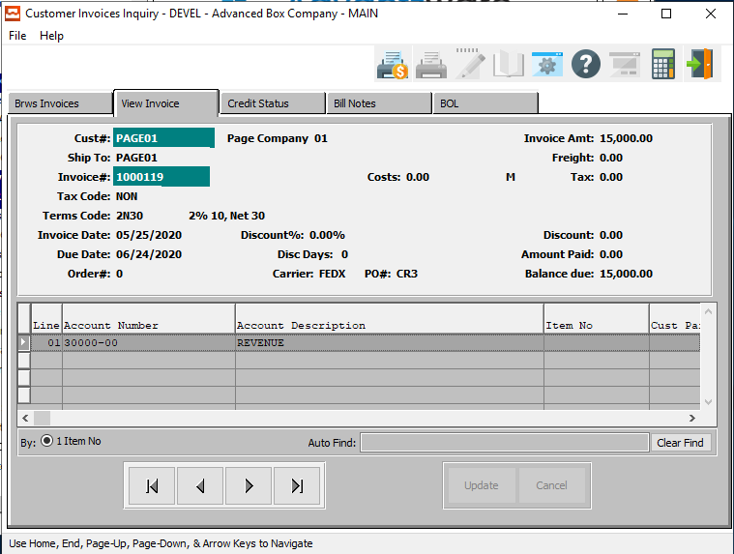

#### NEXT

Press ***"N"*** (Next) to find next Invoice to view or modify. Alternatively, press the ***“Right Arrow”*** on the screen.

#### PREVIOUS

Press ***"P"*** (Previous) to find previous Invoice to view or modify. Alternatively, press the ***“Left Arrow”*** on the screen.

### Credit Status

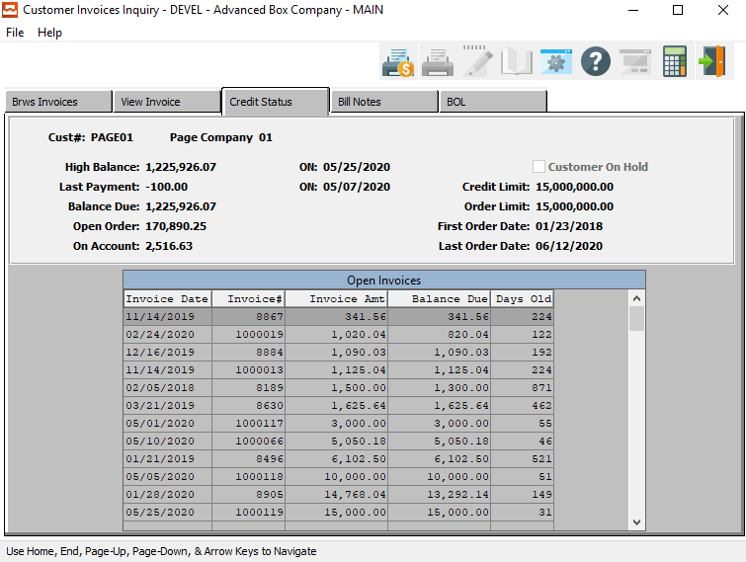

The Credit Status screen allows the user to view the current status of all of a company’s open invoices. In order to view a different customer, the user must highlight their chosen customer in the Browse Invoices screen.

### Bill Notes

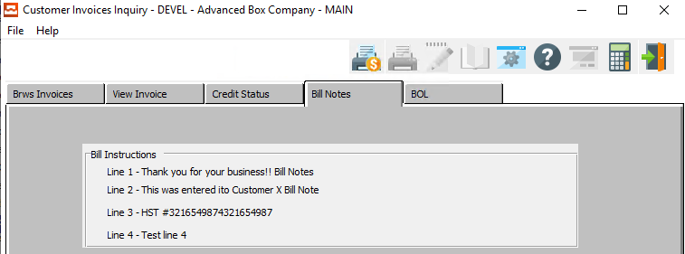

The Bill Notes screen allows the user to view the any billing notes connected to a specific company. In order to view a different customer, the user must highlight their chosen customer in the Browse Invoices screen.

If this screen is blank, then there are no billing notes for this customer.

### BOL

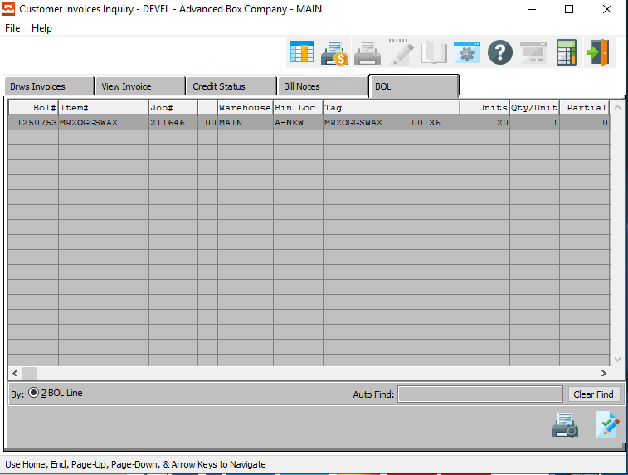

The Bill of Lading (BOL) screen allows the user to view and Bills of Lading sent to a specific company. In order to view a different customer, the user must highlight their chosen customer in the Browse Invoices screen.

#### PRINT BOL

Click the ***“Printer Icon”*** at the bottom of the screen to print the selected Bill of Lading.

#### PRINT SIGNED BOL

Click the ***“Paper and Pencil Icon”*** to print a selected Signed Bill of Lading”

From this screen, the signed Bill of Lading can be printed or displayed. Hence, invoice payment cannot be delayed because the customer cannot find the Bill of Lading or the inventory. Someone from their company signed, which means they received the goods.

## Customer Inquiry [AQ2]

### Overview

The customer activity inquiry shows all activity or outstanding invoices for a particular customer. You may view an activity by a range of certain invoices from an invoice up to a certain invoice and for invoices up to 30 days old or you can specify the number of days old. Therefore, if you only wanted to see invoices up to 30 days old or calling for outstanding invoices you can plug in 30 days. It shows the balance due and all of the activity, the checks, credits, and invoices for that particular customer.

### AR Invoices

Use this option if you need to view each invoice individually, or a range of invoices, for a certain customer. This option displays all detail, such as each payment made and the check number.

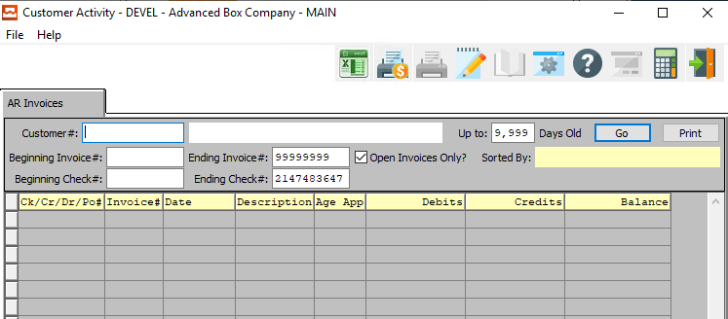

#### Customer #

Enter a valid customer number whose account you want to view. The customer's name will appear next to the number entered. Press F1 to search through, or the backspace or page up / down keys to scroll through the customer list. Press the [Enter] key to accept the customer displayed on the screen.

#### Customer Name

The Customer Name will transfer from the customer file once a user enters or chooses a valid customer number.

#### Beginning Invoice # / Ending Invoice #

Enter your desired starting and ending invoice number for this query. The system default is 0 (Zero) as the starting invoice, and 999,999 as the ending invoice.

#### Beginning Check # / Ending Check #

Enter the beginning and ending Check Number to search for.

#### Number of Days

Enter the amount of days old desired for range of invoices selected in this query. Enter '90' to display all invoices ninety days old (or less). The system default is thirty days old.

#### Open Invoices Only? – Toggle Box

To only search for open invoices, make sure that the Open Invoices Only toggle box is checked.

## AR Credit/Debit Memos [AQ3]

### Browse CR/DB

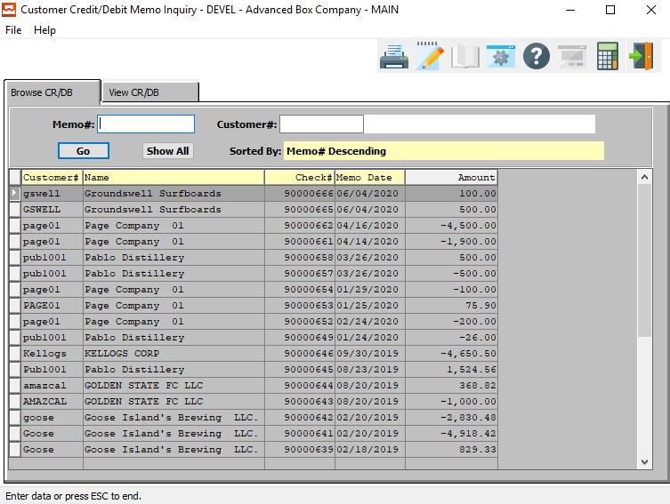

#### Memo #

Enter a memo number that you would like to use. Alternatively, press the ***“F1”*** button to choose a memo number from a list of valid Memos.

#### Customer #

Enter a Customer Number to search for. Alternatively, press the ***“F1”*** button to choose a customer number from a list of valid Customers.

#### Customer Name

The customer name will transfer from the customer file as soon as the user enters or chooses a valid customer number.

### View CR/DB

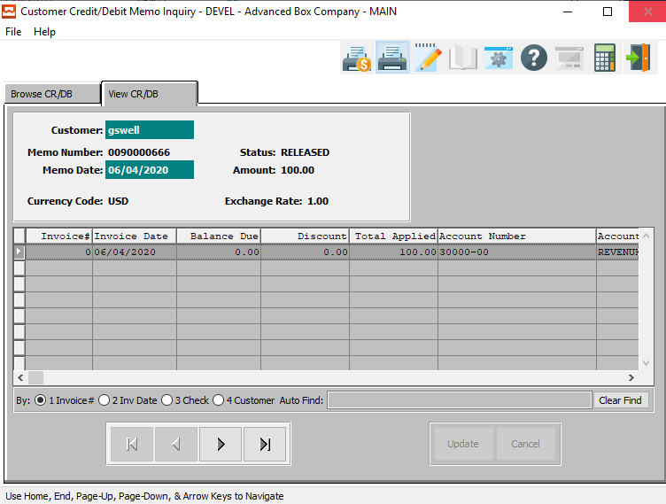

#### NEXT

Press ***"N"*** (Next) to find next Credit/Debit Memo to view or modify. Alternatively, press the ***“Right Arrow”*** on the screen.

#### PREVIOUS

Press ***"P"*** (Previous) to find previous Credit/Debit Memo to view or modify. Alternatively, press the ***“Left Arrow”*** on the screen.

## Cash Receipts [AQ4]

### Browse Cash

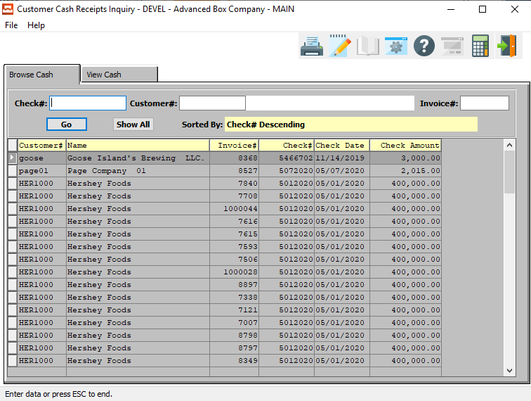

#### Check #

Enter a check number to search for.

#### Customer #

Enter a Customer Number to search for. Alternatively, press the ***“F1”*** button to choose a customer number from a list of valid Customers.

#### Customer Name

The customer name will transfer from the customer file as soon as the user enters or chooses a valid customer number.

#### Invoice #

Enter an invoice number to search for.

### View Cash

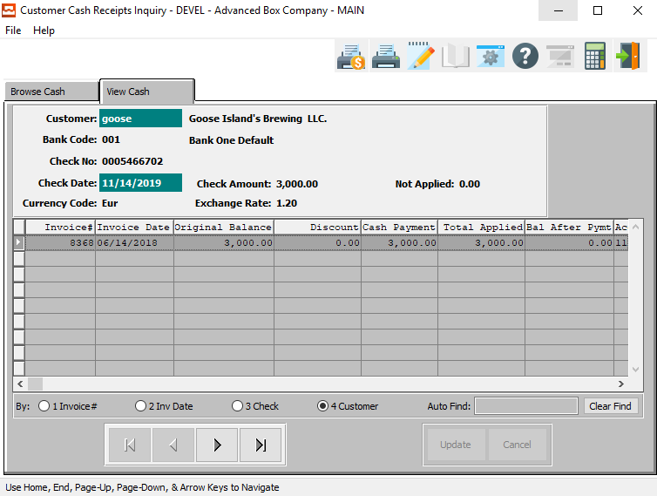

#### NEXT

Press ***"N"*** (Next) to find next Cash Receipt to view or modify. Alternatively, press the ***“Right Arrow”*** on the screen.

#### PREVIOUS

Press ***"P"*** (Previous) to find previous Cash Receipt to view or modify. Alternatively, press the ***“Left Arrow”*** on the screen.

## Ship-To Inquiry [AQ5]

### Browse Ship-To

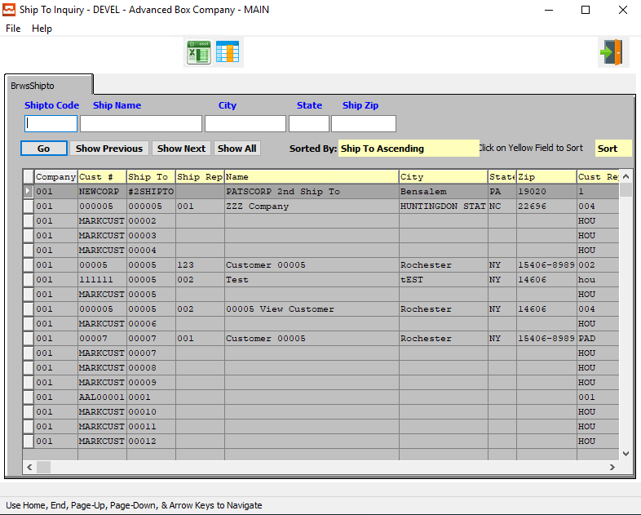

#### Ship-To Code

Enter a Ship-To code to search for. Alternatively, press the ***“F1”*** button to choose a XXX from a list of valid options.

#### Ship Name

Enter the Ship-To name that you want to search for. Alternatively, press the ***“F1”*** button to choose a Ship Name from a list of valid options.

#### City

Enter a City to search for.

#### State

Enter a State to search for.

#### Zip Code

Enter a zip code to search for.

# **Reports for Receivables [AR]**

## Customer List [AR1]

The Customer List will show customers for the range entered. You can also print lists by locations and types.

### Selection Parameters

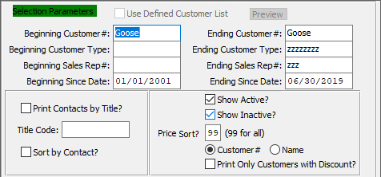

#### Beginning Customer # / Ending Customer #

Enter the beginning and ending Customer Number to run the report for.

#### Beginning Customer Type / Ending Customer Type

Enter the beginning and ending Customer Type to run the report for.

#### Beginning Sales Rep # / Ending Sales Rep #

Enter the beginning and ending Sales Rep Number to run the report for.

#### Beginning Since Date / Ending Since Date

Enter the beginning and ending Since Date to run the report for.

#### Print Contacts by Title? – Toggle Box

To print contacts to the report by their title, make sure that the Print Contacts by Title toggle box is checked.

#### Sort by Contact? – Toggle Box

To sort the report by contacts, make sure that the Sort by Contact toggle box is checked.

#### Show Active? – Toggle Box

To show active customers on the report, make sure that the Show Active toggle box is checked.

#### Show Inactive? – Toggle Box

To show inactive customers on the report, make sure that the Show Inactive toggle box is checked.

#### Customer Sort (Choice)

To choose the preferred sorting method of Customer Number vs. Customer Name, please make sure the desired option choice bubble is toggled.

#### Print Only Customers with Discount? – Toggle Box

To only print customers that have been given a discount orders, make sure that this toggle box is checked.

### Available Columns

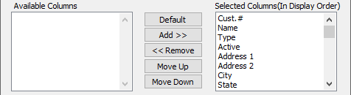

#### Available Columns

The user may choose which columns they wish to have on the report printout. As the user selects their choices, they will appear on the ‘*Selected Columns’* list.

#### Selected Columns (In Display Order)

The columns that the user has chosen from the ‘*Available Columns’* list. The order that these columns are displayed in here is the order in which they will print on the report.

#### Default

Click the ***“Default****”* button to sort the ‘*Selected Columns’* list by the default system parameters.

#### Add >>

Click on the selected item from the ‘*Available Columns’* list to highlight it, then click the ***“Add”*** button to add the selected column to the ‘*Selected Columns’* list.

#### << Remove

Click on the selected item from the ‘*Selected Columns’* list to highlight it, then click the ***“Remove”*** button to remove the selected column to the ‘*Selected Columns’* list.

#### Move Up

Within the ‘*Selected Columns’* list, the user may choose the order they wish the selected columns to print in. In order to change the order of the columns, the user can click on a selection to highlight it. By then clicking the ***“Move Up***” button, the user can change its position on the report.

#### Move Down

Within the ‘*Selected Columns’* list, the user may choose the order they wish the selected columns to print in. In order to change the order of the columns, the user can click on a selection to highlight it. By then clicking the ***“Move Down***” button, the user can change its position on the report.

### Outlook Destination

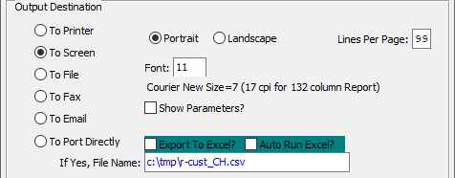

#### Destination Choice

To choose the destination where the document should be printed, please make sure that desired output destination choice bubble is toggled.

#### Layout Choice

To choose the preferred layout of Landscape vs. Portrait, please make sure the desired option choice bubbled is toggled.

#### Lines Per Page

Lines per page on the report when printing.

#### Font

Enter the font number to use with this report (Font 11 is default).

#### Show Parameters? – Toggle Box

To show parameters, make sure that the toggle box is ‘ticked’ with a checkmark.

#### Export to Excel? – Toggle Box

To export the printed file to an excel document, make sure that the Export to Excel toggle box is checked.

#### Auto Run Excel? – Toggle Box

To automatically open the new excel document, make sure that the Auto Run Excel toggle box is checked.

#### If Yes, File Name

If exporting the file to Excel, enter the desired file name.

## Carrier List [AR2]

The Carrier List will perform the same functions as the Customer List, listing for Company, Location, OR Carrier.

### Selection Parameters

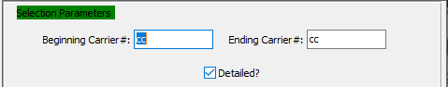

#### Beginning Carrier # / Ending Carrier #

Enter the starting and ending carrier codes. Optionally, press the [F1] key to search through, or the page up / down keys to scroll through the carrier file. Press the [Enter] key to accept the carrier displayed on the screen.

#### Detailed? – Toggle Box

To print a detailed report on each carrier, make sure that the Detailed toggle box is checked.

### Available Columns

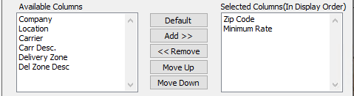

#### Available Columns

The user may choose which columns they wish to have on the report printout. As the user selects their choices, they will appear on the ‘*Selected Columns’* list.

#### Selected Columns (In Display Order)

The columns that the user has chosen from the ‘*Available Columns’* list. The order that these columns are displayed in here is the order in which they will print on the report.

#### Default

Click the ***“Default****”* button to sort the ‘*Selected Columns’* list by the default system parameters.

#### Add >>

Click on the selected item from the ‘*Available Columns’* list to highlight it, then click the ***“Add”*** button to add the selected column to the ‘*Selected Columns’* list.

#### << Remove

Click on the selected item from the ‘*Selected Columns’* list to highlight it, then click the ***“Remove”*** button to remove the selected column to the ‘*Selected Columns’* list.

#### Move Up

Within the ‘*Selected Columns’* list, the user may choose the order they wish the selected columns to print in. In order to change the order of the columns, the user can click on a selection to highlight it. By then clicking the ***“Move Up***” button, the user can change its position on the report.

#### Move Down

Within the ‘*Selected Columns’* list, the user may choose the order they wish the selected columns to print in. In order to change the order of the columns, the user can click on a selection to highlight it. By then clicking the ***“Move Down***” button, the user can change its position on the report.

### Outlook Destination

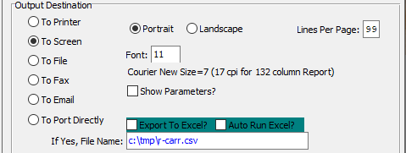

#### Destination Choice

To choose the destination where the document should be printed, please make sure that desired output destination choice bubble is toggled.

#### Layout Choice

To choose the preferred layout of Landscape vs. Portrait, please make sure the desired option choice bubbled is toggled.

#### Lines Per Page

Lines per page on the report when printing.

#### Font

Enter the font number to use with this report (Font 11 is default).

#### Show Parameters? – Toggle Box

To show parameters, make sure that the toggle box is ‘ticked’ with a checkmark.

#### Export to Excel? – Toggle Box

To export the printed file to an excel document, make sure that the Export to Excel toggle box is checked.

#### Auto Run Excel? – Toggle Box

To automatically open the new excel document, make sure that the Auto Run Excel toggle box is checked.

#### If Yes, File Name

If exporting the file to Excel, enter the desired file name.

## Sales Tax Code [AR3]

The Sales Tax Codes List will list the range of tax codes of groups entered.

### Selection Parameters



#### Beginning Sales Tax Group / Ending Sales Tax Group

Enter the first and last group numbers to print. Optionally, press the [F1] key to search through, or the page up / down keys to scroll through the Sales Tax file. Press the [Enter] key to accept the sales tax group.

### Available Columns

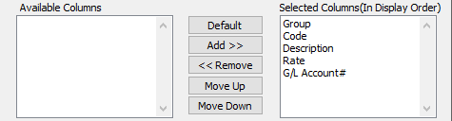

#### Available Columns

The user may choose which columns they wish to have on the report printout. As the user selects their choices, they will appear on the ‘*Selected Columns’* list.

#### Selected Columns (In Display Order)

The columns that the user has chosen from the ‘*Available Columns’* list. The order that these columns are displayed in here is the order in which they will print on the report.

#### Default

Click the ***“Default****”* button to sort the ‘*Selected Columns’* list by the default system parameters.

#### Add >>

Click on the selected item from the ‘*Available Columns’* list to highlight it, then click the ***“Add”*** button to add the selected column to the ‘*Selected Columns’* list.

#### << Remove

Click on the selected item from the ‘*Selected Columns’* list to highlight it, then click the ***“Remove”*** button to remove the selected column to the ‘*Selected Columns’* list.

#### Move Up

Within the ‘*Selected Columns’* list, the user may choose the order they wish the selected columns to print in. In order to change the order of the columns, the user can click on a selection to highlight it. By then clicking the ***“Move Up***” button, the user can change its position on the report.

#### Move Down

Within the ‘*Selected Columns’* list, the user may choose the order they wish the selected columns to print in. In order to change the order of the columns, the user can click on a selection to highlight it. By then clicking the ***“Move Down***” button, the user can change its position on the report.

### Outlook Destination

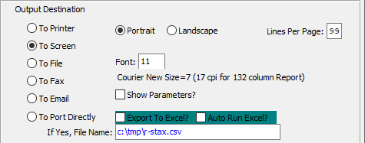

#### Destination Choice

To choose the destination where the document should be printed, please make sure that desired output destination choice bubble is toggled.

#### Layout Choice

To choose the preferred layout of Landscape vs. Portrait, please make sure the desired option choice bubbled is toggled.

#### Lines Per Page

Lines per page on the report when printing.

#### Font

Enter the font number to use with this report (Font 11 is default).

#### Show Parameters? – Toggle Box

To show parameters, make sure that the toggle box is ‘ticked’ with a checkmark.

#### Export to Excel? – Toggle Box

To export the printed file to an excel document, make sure that the Export to Excel toggle box is checked.

#### Auto Run Excel? – Toggle Box

To automatically open the new excel document, make sure that the Auto Run Excel toggle box is checked.

#### If Yes, File Name

If exporting the file to Excel, enter the desired file name.

## Statements [AR4]

Statements will print for a range of Customers and lists all open invoices.

### Selection Parameters

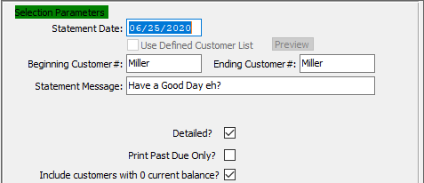

#### Statement Date

Enter the Statement Date.

#### Beginning Customer # / Ending Customer #

Enter a valid starting and ending Customer number from the Customer file. Optionally, press the [F1] key to search through, or the page up / down keys to scroll through the file. Press the [Enter] key to accept the customer displayed on the screen. This will automatically bring up the customer name.

#### Statement Message

Type in a message for the Statement.

#### Detailed? – Toggle Box

To print a detailed report for each customer statement, make sure that the Detailed toggle box is checked.

#### Print Past Due Only? – Toggle Box

To print only customers who have past due payments, make sure that the Print Past Due Only toggle box is checked.

#### Include Customers with 0 Current Balance? – Toggle Box

To include customers that have a current balance of zero, and thus neither owe nor are owed fees, make sure that this toggle box is checked.

### Outlook Destination

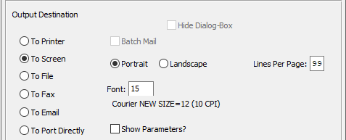

#### Destination Choice

To choose the destination where the document should be printed, please make sure that desired output destination choice bubble is toggled.

#### Layout Choice

To choose the preferred layout of Landscape vs. Portrait, please make sure the desired option choice bubbled is toggled.

#### Lines Per Page

Lines per page on the report when printing.

#### Font

Enter the font number to use with this report (Font 11 is default).

#### Show Parameters? – Toggle Box

To show parameters, make sure that the toggle box is ‘ticked’ with a checkmark.

## Aged Receivables [AR5]

Aged Receivables can be listed for a range of Customers showing either Summaries or Details. It can be printed as of any specific month in the current year.

### Selection Parameters

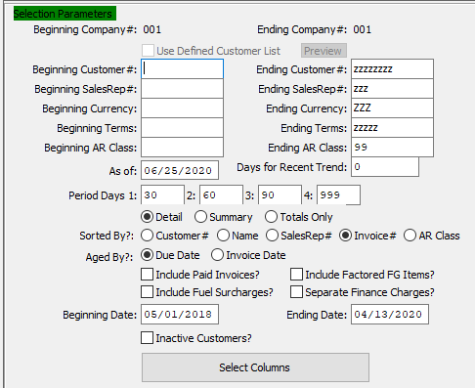

#### Beginning Customer # / Ending Customer #

Enter a valid starting and ending Customer number from the Customer file.

#### Beginning Sales Rep # / Ending Sales Rep #

Enter starting and ending number. This function is used if you want a receivables report printed for a specific salesman only.

#### Beginning Currency / Ending Currency

Enter the beginning and ending Currency Code to run the aged receivables report for.

#### Beginning Terms / Ending Terms

Enter the beginning and ending Terms to run the aged receivables report for.

#### Beginning AR Class / Ending AR Class

Enter the beginning and ending Accounts Receivable Class to run the aged receivables report for.

#### As Of

Enter the ending date desired for report. The 'As of' field defaults to the current system date.

#### Print Option (Choice)

To choose the preferred printing method of Detailed Report vs. Summary Report vs. Totals Only, please make sure the desired option choice bubble is toggled.

#### Sorted By? (Choice)

To choose the preferred sorting method, please make sure the desired option choice bubble is toggled.

#### Aged By? (Choice)

To choose the preferred aging option of Due Date vs. Invoice Date, please make sure the desired option choice bubble is toggled.

#### Include Paid Invoices? – Toggle Box

To include invoices that have already been paid in the aging report, make sure that the Include Paid Invoices toggle box is checked.

#### Include Factored FG Items? – Toggle Box

To include factored Finished Good items in the aging report, make sure that this toggle box is checked.

#### Include Fuel Surcharges? – Toggle Box

To include fuel surcharges in the aging report, make sure that the Include Fuel Surcharges toggle box is checked.

#### Separate Finance Charges? – Toggle Box

To separate finance charges in the aging report, make sure that the Separate Finance Charges toggle box is checked.

#### Beginning Date / Ending Date

Enter the beginning and ending Date to run the aged receivables report for.

#### Inactive Customers? – Toggle Box

To include Inactive Customers in the aging report, make sure that the Inactive Customers toggle box is checked.

### Available Columns

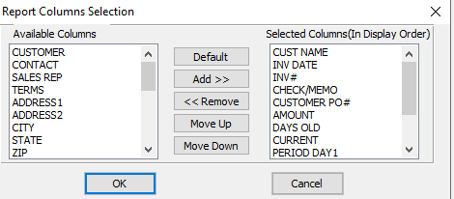

#### Available Columns

The user may choose which columns they wish to have on the report printout. As the user selects their choices, they will appear on the ‘*Selected Columns’* list.

#### Selected Columns (In Display Order)

The columns that the user has chosen from the ‘*Available Columns’* list. The order that these columns are displayed in here is the order in which they will print on the report.

#### Default

Click the ***“Default****”* button to sort the ‘*Selected Columns’* list by the default system parameters.

#### Add >>

Click on the selected item from the ‘*Available Columns’* list to highlight it, then click the ***“Add”*** button to add the selected column to the ‘*Selected Columns’* list.

#### << Remove

Click on the selected item from the ‘*Selected Columns’* list to highlight it, then click the ***“Remove”*** button to remove the selected column to the ‘*Selected Columns’* list.

#### Move Up

Within the ‘*Selected Columns’* list, the user may choose the order they wish the selected columns to print in. In order to change the order of the columns, the user can click on a selection to highlight it. By then clicking the ***“Move Up***” button, the user can change its position on the report.

#### Move Down

Within the ‘*Selected Columns’* list, the user may choose the order they wish the selected columns to print in. In order to change the order of the columns, the user can click on a selection to highlight it. By then clicking the ***“Move Down***” button, the user can change its position on the report.

### Outlook Destination

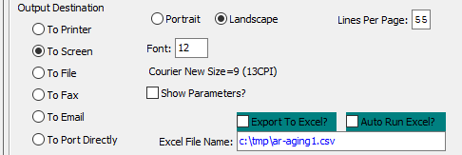

#### Destination Choice

To choose the destination where the document should be printed, please make sure that desired output destination choice bubble is toggled.

#### Layout Choice

To choose the preferred layout of Landscape vs. Portrait, please make sure the desired option choice bubbled is toggled.

#### Lines Per Page

Lines per page on the report when printing.

#### Font

Enter the font number to use with this report (Font 11 is default).

#### Show Parameters? – Toggle Box

To show parameters, make sure that the toggle box is ‘ticked’ with a checkmark.

#### Export to Excel? – Toggle Box

To export the printed file to an excel document, make sure that the Export to Excel toggle box is checked.

#### Auto Run Excel? – Toggle Box

To automatically open the new excel document, make sure that the Auto Run Excel toggle box is checked.

#### If Yes, File Name

If exporting the file to Excel, enter the desired file name.

## Customer Ship-To List [AR6]

Customer Ship-To List will list all ship to address’s for customer range selected.

This report displays all Ship-To addresses for all customers selected in range. It includes the ship to Id #, Name of customer and all ship to addresses for customers selected. This is used to get a printout of a range of customer selected.

### Selection Parameters

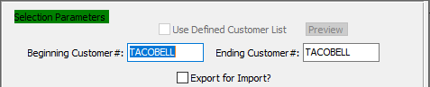

#### Beginning Customer # / Ending Customer #

Enter a valid starting and ending Customer number from the Customer file. Optionally, press the [F1] key to search through, or the page up / down keys to scroll through the file. Press the [Enter] key to accept the customer displayed on the screen.

#### Export for Import? – Toggle Box

To export from import, make sure that this toggle box is checked.

### Available Columns

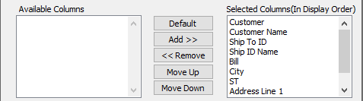

#### Available Columns

The user may choose which columns they wish to have on the report printout. As the user selects their choices, they will appear on the ‘*Selected Columns’* list.

#### Selected Columns (In Display Order)

The columns that the user has chosen from the ‘*Available Columns’* list. The order that these columns are displayed in here is the order in which they will print on the report.

#### Default

Click the ***“Default****”* button to sort the ‘*Selected Columns’* list by the default system parameters.

#### Add >>

Click on the selected item from the ‘*Available Columns’* list to highlight it, then click the ***“Add”*** button to add the selected column to the ‘*Selected Columns’* list.

#### << Remove

Click on the selected item from the ‘*Selected Columns’* list to highlight it, then click the ***“Remove”*** button to remove the selected column to the ‘*Selected Columns’* list.

#### Move Up

Within the ‘*Selected Columns’* list, the user may choose the order they wish the selected columns to print in. In order to change the order of the columns, the user can click on a selection to highlight it. By then clicking the ***“Move Up***” button, the user can change its position on the report.

#### Move Down

Within the ‘*Selected Columns’* list, the user may choose the order they wish the selected columns to print in. In order to change the order of the columns, the user can click on a selection to highlight it. By then clicking the ***“Move Down***” button, the user can change its position on the report.

### Outlook Destination

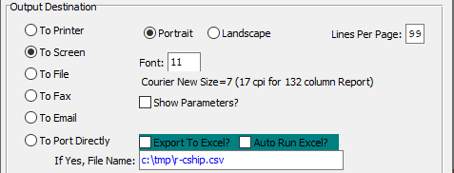

#### Destination Choice

To choose the destination where the document should be printed, please make sure that desired output destination choice bubble is toggled.

#### Layout Choice

To choose the preferred layout of Landscape vs. Portrait, please make sure the desired option choice bubbled is toggled.

#### Show Parameters? – Toggle Box

To show parameters, make sure that the toggle box is ‘ticked’ with a checkmark.

#### Export to Excel? – Toggle Box

To export the printed file to an excel document, make sure that the Export to Excel toggle box is checked.

#### Auto Run Excel? – Toggle Box

To automatically open the new excel document, make sure that the Auto Run Excel toggle box is checked.

#### If Yes, File Name

If exporting the file to Excel, enter the desired file name.

## AR Mailing List [AR7]

The Mailing List can be used to print labels or can be printed on paper for a range of states, types, salesmen or status selected.

### Selection Parameters

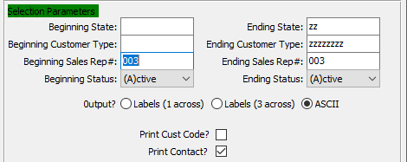

#### Beginning State / Ending State

Enter a valid beginning and ending state for search.

#### Beginning Customer Type / Ending Customer Type

Enter a valid beginning and ending customer type for search.

#### Beginning Sales Rep # / Ending Sales Rep #

Enter a valid beginning and ending sales rep number for search.

#### Beginning Status / Ending Status

Enter a valid beginning and ending status for search.

#### Output? (Choice)

To choose the preferred output option, please make sure the desired option choice bubble is toggled.

#### Print Customer Code? – Toggle Box

To print the customer code on the report, make sure that the Print Customer Code toggle box is checked.

#### Print Contact? – Toggle Box

To print the contact name for each customer account, make sure that the Print Contact toggle box is checked.

### Available Columns

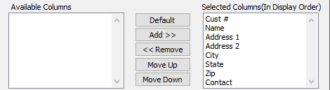

#### Available Columns

The user may choose which columns they wish to have on the report printout. As the user selects their choices, they will appear on the ‘*Selected Columns’* list.

#### Selected Columns (In Display Order)

The columns that the user has chosen from the ‘*Available Columns’* list. The order that these columns are displayed in here is the order in which they will print on the report.

#### Default

Click the ***“Default****”* button to sort the ‘*Selected Columns’* list by the default system parameters.

#### Add >>

Click on the selected item from the ‘*Available Columns’* list to highlight it, then click the ***“Add”*** button to add the selected column to the ‘*Selected Columns’* list.

#### << Remove

Click on the selected item from the ‘*Selected Columns’* list to highlight it, then click the ***“Remove”*** button to remove the selected column to the ‘*Selected Columns’* list.

#### Move Up

Within the ‘*Selected Columns’* list, the user may choose the order they wish the selected columns to print in. In order to change the order of the columns, the user can click on a selection to highlight it. By then clicking the ***“Move Up***” button, the user can change its position on the report.

#### Move Down

Within the ‘*Selected Columns’* list, the user may choose the order they wish the selected columns to print in. In order to change the order of the columns, the user can click on a selection to highlight it. By then clicking the ***“Move Down***” button, the user can change its position on the report.

### Outlook Destination

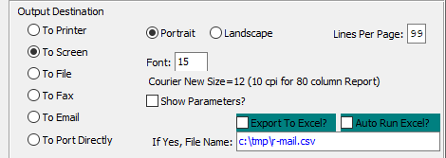

#### Destination Choice

To choose the destination where the document should be printed, please make sure that desired output destination choice bubble is toggled.

#### Layout Choice

To choose the preferred layout of Landscape vs. Portrait, please make sure the desired option choice bubbled is toggled.

#### Lines Per Page

Lines per page on the report when printing.

#### Font

Enter the font number to use with this report (Font 11 is default).

#### Show Parameters? – Toggle Box

To show parameters, make sure that the toggle box is ‘ticked’ with a checkmark.

#### Export to Excel? – Toggle Box

To export the printed file to an excel document, make sure that the Export to Excel toggle box is checked.

#### Auto Run Excel? – Toggle Box

To automatically open the new excel document, make sure that the Auto Run Excel toggle box is checked.

#### If Yes, File Name

If exporting the file to Excel, enter the desired file name.

## Bank Deposit Report [AR8]

The Bank Deposit Report shows all cash receipts for a particular date range selected, sorted by bank code. This report is used typically for reconciling each days or months bank deposits.

### Selection Parameters

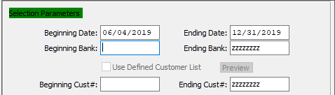

#### Beginning Date / Ending Date

Enter the beginning and ending date for search.

#### Beginning Bank / Ending Bank

Enter the beginning and ending bank code for search.

#### Beginning Customer # / Ending Customer #

Enter the beginning and ending customer number for search.

### Available Columns

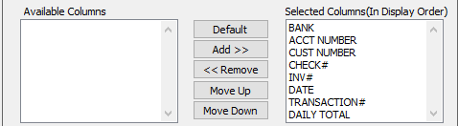

#### Available Columns

The user may choose which columns they wish to have on the report printout. As the user selects their choices, they will appear on the ‘*Selected Columns’* list.

#### Selected Columns (In Display Order)

The columns that the user has chosen from the ‘*Available Columns’* list. The order that these columns are displayed in here is the order in which they will print on the report.

#### Default

Click the ***“Default****”* button to sort the ‘*Selected Columns’* list by the default system parameters.

#### Add >>

Click on the selected item from the ‘*Available Columns’* list to highlight it, then click the ***“Add”*** button to add the selected column to the ‘*Selected Columns’* list.

#### << Remove

Click on the selected item from the ‘*Selected Columns’* list to highlight it, then click the ***“Remove”*** button to remove the selected column to the ‘*Selected Columns’* list.

#### Move Up

Within the ‘*Selected Columns’* list, the user may choose the order they wish the selected columns to print in. In order to change the order of the columns, the user can click on a selection to highlight it. By then clicking the ***“Move Up***” button, the user can change its position on the report.

#### Move Down

Within the ‘*Selected Columns’* list, the user may choose the order they wish the selected columns to print in. In order to change the order of the columns, the user can click on a selection to highlight it. By then clicking the ***“Move Down***” button, the user can change its position on the report.

### Outlook Destination

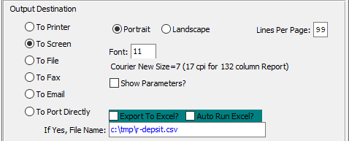

#### Destination Choice

To choose the destination where the document should be printed, please make sure that desired output destination choice bubble is toggled.

#### Layout Choice

To choose the preferred layout of Landscape vs. Portrait, please make sure the desired option choice bubbled is toggled.

#### Lines Per Page

Lines per page on the report when printing.

#### Font

Enter the font number to use with this report (Font 11 is default).

#### Show Parameters? – Toggle Box

To show parameters, make sure that the toggle box is ‘ticked’ with a checkmark.

#### Export to Excel? – Toggle Box

To export the printed file to an excel document, make sure that the Export to Excel toggle box is checked.

#### Auto Run Excel? – Toggle Box

To automatically open the new excel document, make sure that the Auto Run Excel toggle box is checked.

#### If Yes, File Name

If exporting the file to Excel, enter the desired file name.

## Cash Receipts by Sales Rep [AR9]

The Cash Receipts by Salesman report shows all cash receipts for the date range and salesman range selected. It shows the customer name, date of the cash receipt, invoice number associated with the receipt, and the amount of the cash receipt.

### Selection Parameters

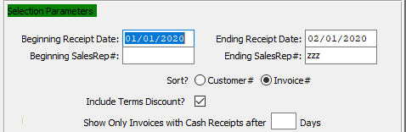

#### Beginning Receipt Date / Ending Receipt Date

Enter the beginning and ending date for search or default for all. This will print all receipts entered between the dates selected sorted by salesman.

#### Beginning Sale Rep # / Ending Sales Rep #

Enter the beginning and ending salesman for search or default to print all salesmen. The report is printed in salesman order.

#### Sort? (Choice)

To choose the preferred sorting method of Customer Number vs. Invoice Number, please make sure the desired option choice bubble is toggled.

#### Include Terms Discount? – Toggle Box

To include the terms discount on the report, make sure that the Include Terms Discount toggle box is checked.

#### Number of Days

The user may enter a number of days in this field. Only invoices that have cash receipts by at least this number of days will be reported.

### Available Columns

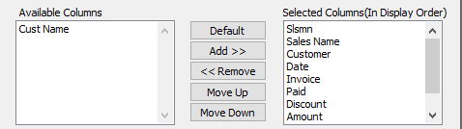

#### Available Columns

The user may choose which columns they wish to have on the report printout. As the user selects their choices, they will appear on the ‘*Selected Columns’* list.

#### Selected Columns (In Display Order)

The columns that the user has chosen from the ‘*Available Columns’* list. The order that these columns are displayed in here is the order in which they will print on the report.

#### Default

Click the ***“Default****”* button to sort the ‘*Selected Columns’* list by the default system parameters.

#### Add >>

Click on the selected item from the ‘*Available Columns’* list to highlight it, then click the ***“Add”*** button to add the selected column to the ‘*Selected Columns’* list.

#### << Remove

Click on the selected item from the ‘*Selected Columns’* list to highlight it, then click the ***“Remove”*** button to remove the selected column to the ‘*Selected Columns’* list.

#### Move Up

Within the ‘*Selected Columns’* list, the user may choose the order they wish the selected columns to print in. In order to change the order of the columns, the user can click on a selection to highlight it. By then clicking the ***“Move Up***” button, the user can change its position on the report.

#### Move Down

Within the ‘*Selected Columns’* list, the user may choose the order they wish the selected columns to print in. In order to change the order of the columns, the user can click on a selection to highlight it. By then clicking the ***“Move Down***” button, the user can change its position on the report.

### Outlook Destination

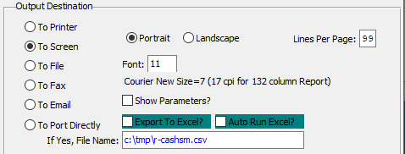

#### Destination Choice

To choose the destination where the document should be printed, please make sure that desired output destination choice bubble is toggled.

#### Layout Choice

To choose the preferred layout of Landscape vs. Portrait, please make sure the desired option choice bubbled is toggled.

#### Lines Per Page

Lines per page on the report when printing.

#### Font

Enter the font number to use with this report (Font 11 is default).

#### Show Parameters? – Toggle Box

To show parameters, make sure that the toggle box is ‘ticked’ with a checkmark.

#### Export to Excel? – Toggle Box

To export the printed file to an excel document, make sure that the Export to Excel toggle box is checked.

#### Auto Run Excel? – Toggle Box

To automatically open the new excel document, make sure that the Auto Run Excel toggle box is checked.

#### If Yes, File Name

If exporting the file to Excel, enter the desired file name.

## AR Accounts by Customer [AR)]

### Selection Parameters

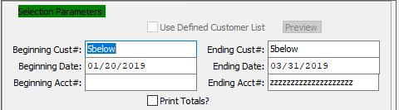

#### Beginning Customer # / Ending Customer #

Enter the beginning and ending Customer Number to run the AR Account report for.

#### Beginning Date / Ending Date

Enter the beginning and ending Date to run the AR Account report for.

#### Beginning Account # / Ending Account #

Enter the beginning and ending Account Number to run the AR Account report for.

#### Print Totals? – Toggle Box

To print totals on the AR Account report, make sure that the Print Totals toggle box is checked.

### Available Columns

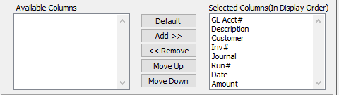

#### Available Columns

The user may choose which columns they wish to have on the report printout. As the user selects their choices, they will appear on the ‘*Selected Columns’* list.

#### Selected Columns (In Display Order)

The columns that the user has chosen from the ‘*Available Columns’* list. The order that these columns are displayed in here is the order in which they will print on the report.

#### Default

Click the ***“Default****”* button to sort the ‘*Selected Columns’* list by the default system parameters.

#### Add >>

Click on the selected item from the ‘*Available Columns’* list to highlight it, then click the ***“Add”*** button to add the selected column to the ‘*Selected Columns’* list.

#### << Remove

Click on the selected item from the ‘*Selected Columns’* list to highlight it, then click the ***“Remove”*** button to remove the selected column to the ‘*Selected Columns’* list.

#### Move Up

Within the ‘*Selected Columns’* list, the user may choose the order they wish the selected columns to print in. In order to change the order of the columns, the user can click on a selection to highlight it. By then clicking the ***“Move Up***” button, the user can change its position on the report.

#### Move Down

Within the ‘*Selected Columns’* list, the user may choose the order they wish the selected columns to print in. In order to change the order of the columns, the user can click on a selection to highlight it. By then clicking the ***“Move Down***” button, the user can change its position on the report.

### Outlook Destination

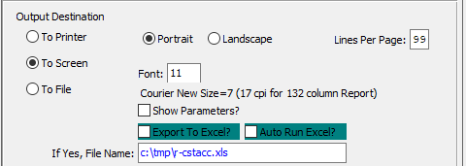

#### Destination Choice

To choose the destination where the document should be printed, please make sure that desired output destination choice bubble is toggled.

#### Layout Choice

To choose the preferred layout of Landscape vs. Portrait, please make sure the desired option choice bubbled is toggled.

#### Lines Per Page

Lines per page on the report when printing.

#### Font

Enter the font number to use with this report (Font 11 is default).

#### Show Parameters? – Toggle Box

To show parameters, make sure that the toggle box is ‘ticked’ with a checkmark.

#### Export to Excel? – Toggle Box

To export the printed file to an excel document, make sure that the Export to Excel toggle box is checked.

#### Auto Run Excel? – Toggle Box

To automatically open the new excel document, make sure that the Auto Run Excel toggle box is checked.

#### If Yes, File Name

If exporting the file to Excel, enter the desired file name.

## Past Due Aging [AR!]

### Selection Parameters

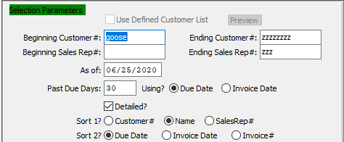

#### Beginning Customer # / Ending Customer #

Enter the beginning and ending Customer Number to run the Past Due Aging report for.

#### Beginning Sale Rep # / Ending Sales Rep #

Enter the beginning and ending Sales Rep Number to run the Past Due Aging report for.

#### As Of

Enter the date you would like to report past due aging as of. This will select any invoice that is past due as of this date.

#### Past Due Days

The user may enter a number of days in this field. Only payments that are past due by at least this number of days will be reported.

#### Using? (Choice)

To choose the preferred past due date option of Due Date vs. Invoice Date, please make sure the desired option choice bubble is toggled.

#### Detailed? – Toggle Box

To print a detailed report, make sure that the Detailed toggle box is checked.

#### Sort 1? (Choice)

To choose the preferred first sorting option, please make sure the desired option choice bubble is toggled.

#### Sort 2? (Choice)

To choose the preferred second sorting option, please make sure the desired option choice bubble is toggled.

### Available Columns

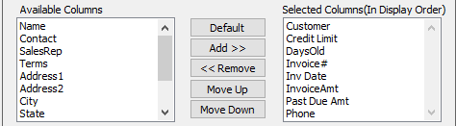

#### Available Columns

The user may choose which columns they wish to have on the report printout. As the user selects their choices, they will appear on the ‘*Selected Columns’* list.

#### Selected Columns (In Display Order)

The columns that the user has chosen from the ‘*Available Columns’* list. The order that these columns are displayed in here is the order in which they will print on the report.

#### Default

Click the ***“Default****”* button to sort the ‘*Selected Columns’* list by the default system parameters.

#### Add >>

Click on the selected item from the ‘*Available Columns’* list to highlight it, then click the ***“Add”*** button to add the selected column to the ‘*Selected Columns’* list.

#### << Remove

Click on the selected item from the ‘*Selected Columns’* list to highlight it, then click the ***“Remove”*** button to remove the selected column to the ‘*Selected Columns’* list.

#### Move Up

Within the ‘*Selected Columns’* list, the user may choose the order they wish the selected columns to print in. In order to change the order of the columns, the user can click on a selection to highlight it. By then clicking the ***“Move Up***” button, the user can change its position on the report.

#### Move Down

Within the ‘*Selected Columns’* list, the user may choose the order they wish the selected columns to print in. In order to change the order of the columns, the user can click on a selection to highlight it. By then clicking the ***“Move Down***” button, the user can change its position on the report.

### Outlook Destination

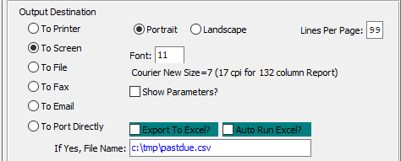

#### Destination Choice

To choose the destination where the document should be printed, please make sure that desired output destination choice bubble is toggled.

#### Layout Choice

To choose the preferred layout of Landscape vs. Portrait, please make sure the desired option choice bubbled is toggled.

#### Lines Per Page

Lines per page on the report when printing.

#### Font

Enter the font number to use with this report (Font 11 is default).

#### Show Parameters? – Toggle Box

To show parameters, make sure that the toggle box is ‘ticked’ with a checkmark.

#### Export to Excel? – Toggle Box

To export the printed file to an excel document, make sure that the Export to Excel toggle box is checked.

#### Auto Run Excel? – Toggle Box

To automatically open the new excel document, make sure that the Auto Run Excel toggle box is checked.

#### If Yes, File Name

If exporting the file to Excel, enter the desired file name.

## Customer Snapshot Totals [AR@]

### Selection Parameters

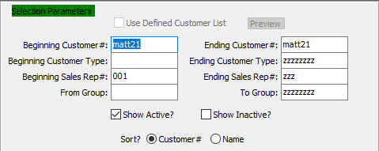

#### Beginning Customer # / Ending Customer #

Enter the beginning and ending Customer Number to run the report for.

#### Beginning Customer Type / Ending Customer Type

Enter the beginning and ending Customer Type to run the report for.

#### Beginning Sales Rep # / Ending Sales Rep #

Enter the beginning and ending Sales Rep Number to run the report for.

#### From Group / To Group

Enter the beginning and ending Sales Group to run the report for.

#### Show Active? – Toggle Box

To show active customers and sales representatives, make sure that the Show Active toggle box is checked.

#### Show Inactive? – Toggle Box

To show inactive customers and sales representatives, make sure that the Show Inactive toggle box is checked.

#### Sort? (Choice)

To choose the preferred sorting method of Customer Number vs. Customer Name, please make sure the desired option choice bubble is toggled.

### Available Columns

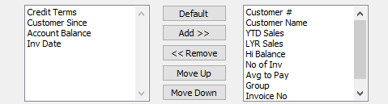

#### Available Columns

The user may choose which columns they wish to have on the report printout. As the user selects their choices, they will appear on the ‘*Selected Columns’* list.

#### Selected Columns (In Display Order)

The columns that the user has chosen from the ‘*Available Columns’* list. The order that these columns are displayed in here is the order in which they will print on the report.

#### Default

Click the ***“Default****”* button to sort the ‘*Selected Columns’* list by the default system parameters.

#### Add >>

Click on the selected item from the ‘*Available Columns’* list to highlight it, then click the ***“Add”*** button to add the selected column to the ‘*Selected Columns’* list.

#### << Remove

Click on the selected item from the ‘*Selected Columns’* list to highlight it, then click the ***“Remove”*** button to remove the selected column to the ‘*Selected Columns’* list.

#### Move Up

Within the ‘*Selected Columns’* list, the user may choose the order they wish the selected columns to print in. In order to change the order of the columns, the user can click on a selection to highlight it. By then clicking the ***“Move Up***” button, the user can change its position on the report.

#### Move Down

Within the ‘*Selected Columns’* list, the user may choose the order they wish the selected columns to print in. In order to change the order of the columns, the user can click on a selection to highlight it. By then clicking the ***“Move Down***” button, the user can change its position on the report.

### Outlook Destination

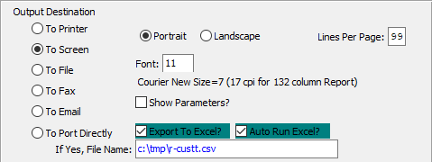

#### Destination Choice

To choose the destination where the document should be printed, please make sure that desired output destination choice bubble is toggled.

#### Layout Choice

To choose the preferred layout of Landscape vs. Portrait, please make sure the desired option choice bubbled is toggled.

#### Lines Per Page

Lines per page on the report when printing.

#### Font

Enter the font number to use with this report (Font 11 is default).

#### Show Parameters? – Toggle Box

To show parameters, make sure that the toggle box is ‘ticked’ with a checkmark.

#### Export to Excel? – Toggle Box

To export the printed file to an excel document, make sure that the Export to Excel toggle box is checked.

#### Auto Run Excel? – Toggle Box

To automatically open the new excel document, make sure that the Auto Run Excel toggle box is checked.

#### If Yes, File Name

If exporting the file to Excel, enter the desired file name.

## Customer Ship-To List [AR#]

### Selection Parameters

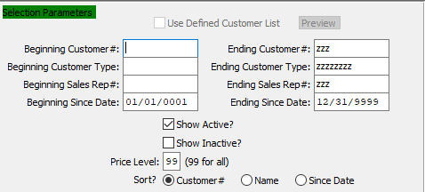

#### Beginning Customer # / Ending Customer #

Enter the beginning and ending Customer Number to run the report for.

#### Beginning Customer Type / Ending Customer Type

Enter the beginning and ending Customer Type to run the report for.

#### Beginning Sales Rep # / Ending Sales Rep #

Enter the beginning and ending Sales Rep Number to run the report for.

#### Beginning Since Date / Ending Since Date

Enter the beginning and ending Since Date to run the report for.

#### Show Active? – Toggle Box

To show active customers and sales representatives, make sure that the Show Active toggle box is checked.

#### Show Inactive? – Toggle Vox

To show active customers and sales representatives, make sure that the Show Inactive toggle box is checked.

#### Sort? (Choice)

To choose the preferred sorting method of Customer Number vs. Customer Name vs. Since Date, please make sure the desired option choice bubble is toggled.

### Available Columns

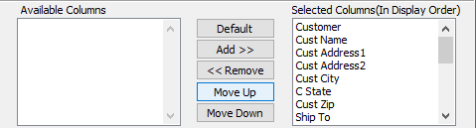

#### Available Columns

The user may choose which columns they wish to have on the report printout. As the user selects their choices, they will appear on the ‘*Selected Columns’* list.

#### Selected Columns (In Display Order)

The columns that the user has chosen from the ‘*Available Columns’* list. The order that these columns are displayed in here is the order in which they will print on the report.

#### Default

Click the ***“Default****”* button to sort the ‘*Selected Columns’* list by the default system parameters.

#### Add >>

Click on the selected item from the ‘*Available Columns’* list to highlight it, then click the ***“Add”*** button to add the selected column to the ‘*Selected Columns’* list.

#### << Remove

Click on the selected item from the ‘*Selected Columns’* list to highlight it, then click the ***“Remove”*** button to remove the selected column to the ‘*Selected Columns’* list.

#### Move Up

Within the ‘*Selected Columns’* list, the user may choose the order they wish the selected columns to print in. In order to change the order of the columns, the user can click on a selection to highlight it. By then clicking the ***“Move Up***” button, the user can change its position on the report.

#### Move Down

Within the ‘*Selected Columns’* list, the user may choose the order they wish the selected columns to print in. In order to change the order of the columns, the user can click on a selection to highlight it. By then clicking the ***“Move Down***” button, the user can change its position on the report.

### Outlook Destination

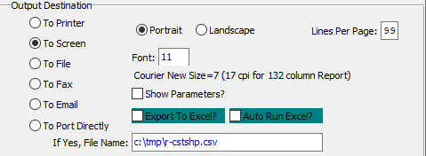

#### Destination Choice

To choose the destination where the document should be printed, please make sure that desired output destination choice bubble is toggled.

#### Layout Choice

To choose the preferred layout of Landscape vs. Portrait, please make sure the desired option choice bubbled is toggled.

#### Lines Per Page

Lines per page on the report when printing.

#### Font

Enter the font number to use with this report (Font 11 is default).

#### Show Parameters? – Toggle Box

To show parameters, make sure that the toggle box is ‘ticked’ with a checkmark.

#### Export to Excel? – Toggle Box

To export the printed file to an excel document, make sure that the Export to Excel toggle box is checked.

#### Auto Run Excel? – Toggle Box

To automatically open the new excel document, make sure that the Auto Run Excel toggle box is checked.

#### If Yes, File Name

If exporting the file to Excel, enter the desired file name.

## Cash Forecast Report [AR$]

### Selection Parameters

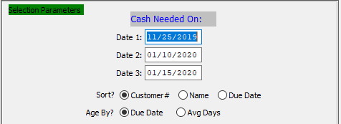

#### Date 1-3

Enter the first, second, and third date to run the report for.

#### Sort? (Choice)

To choose the preferred sorting method of Customer Number vs. Customer Name vs. Due Date, please make sure the desired option choice bubble is toggled.

#### Age By? (Choice)

To choose the preferred aging option of Due Date vs. Average Days, please make sure the desired option choice bubble is toggled.

### Available Columns

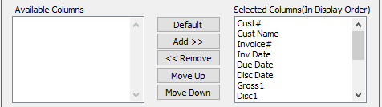

#### Available Columns

The user may choose which columns they wish to have on the report printout. As the user selects their choices, they will appear on the ‘*Selected Columns’* list.

#### Selected Columns (In Display Order)

The columns that the user has chosen from the ‘*Available Columns’* list. The order that these columns are displayed in here is the order in which they will print on the report.

#### Default

Click the ***“Default****”* button to sort the ‘*Selected Columns’* list by the default system parameters.

#### Add >>

Click on the selected item from the ‘*Available Columns’* list to highlight it, then click the ***“Add”*** button to add the selected column to the ‘*Selected Columns’* list.

#### << Remove

Click on the selected item from the ‘*Selected Columns’* list to highlight it, then click the ***“Remove”*** button to remove the selected column to the ‘*Selected Columns’* list.

#### Move Up

Within the ‘*Selected Columns’* list, the user may choose the order they wish the selected columns to print in. In order to change the order of the columns, the user can click on a selection to highlight it. By then clicking the ***“Move Up***” button, the user can change its position on the report.

#### Move Down

Within the ‘*Selected Columns’* list, the user may choose the order they wish the selected columns to print in. In order to change the order of the columns, the user can click on a selection to highlight it. By then clicking the ***“Move Down***” button, the user can change its position on the report.

### Outlook Destination

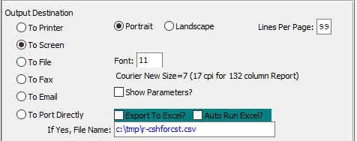

#### Destination Choice

To choose the destination where the document should be printed, please make sure that desired output destination choice bubble is toggled.

#### Layout Choice

To choose the preferred layout of Landscape vs. Portrait, please make sure the desired option choice bubbled is toggled.

#### Lines Per Page

Lines per page on the report when printing.

#### Font

Enter the font number to use with this report (Font 11 is default).

#### Show Parameters? – Toggle Box

To show parameters, make sure that the toggle box is ‘ticked’ with a checkmark.

#### Export to Excel? – Toggle Box

To export the printed file to an excel document, make sure that the Export to Excel toggle box is checked.

#### Auto Run Excel? – Toggle Box

To automatically open the new excel document, make sure that the Auto Run Excel toggle box is checked.

## Commission Cash Receipt [AR%]

### Selection Parameters

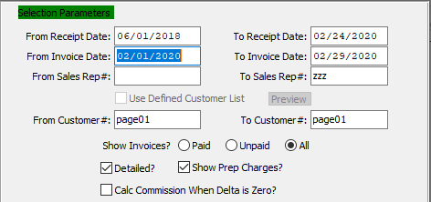

#### From Receipt Date / To Receipt Date

Enter the beginning and ending Receipt Date to run the report for.

#### From Invoice Date / To Invoice Date

Enter the beginning and ending Invoice Date to run the report for.

#### From Sales Rep # / To Sales Rep #

Enter the beginning and ending Sales Rep Number to run the report for.

#### From Customer # / To Customer #

Enter the beginning and ending Customer Number to run the report for.

#### Show Invoices? (Choice)

To choose the preferred Invoice option of Paid vs. Unpaid (Or All), please make sure the desired option choice bubble is toggled.

#### Detailed? – Toggle Box

To print a detailed cash receipt, make sure that the Detailed toggle box is checked.

#### Show Prep Charges? – Toggle Box

To show prep charges on the report, make sure that the Show Prep Charges toggle box is checked.

#### Calculated Commission when Delta is Zero? – Toggle Box

To calculate commissions when the delta of each receipt is zero, make sure that this toggle box is checked.

### Available Columns

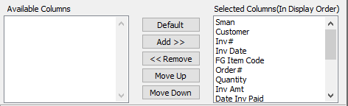

#### Available Columns

The user may choose which columns they wish to have on the report printout. As the user selects their choices, they will appear on the ‘*Selected Columns’* list.

#### Selected Columns (In Display Order)

The columns that the user has chosen from the ‘*Available Columns’* list. The order that these columns are displayed in here is the order in which they will print on the report.

#### Default

Click the ***“Default****”* button to sort the ‘*Selected Columns’* list by the default system parameters.

#### Add >>

Click on the selected item from the ‘*Available Columns’* list to highlight it, then click the ***“Add”*** button to add the selected column to the ‘*Selected Columns’* list.

#### << Remove

Click on the selected item from the ‘*Selected Columns’* list to highlight it, then click the ***“Remove”*** button to remove the selected column to the ‘*Selected Columns’* list.

#### Move Up

Within the ‘*Selected Columns’* list, the user may choose the order they wish the selected columns to print in. In order to change the order of the columns, the user can click on a selection to highlight it. By then clicking the ***“Move Up***” button, the user can change its position on the report.

#### Move Down

Within the ‘*Selected Columns’* list, the user may choose the order they wish the selected columns to print in. In order to change the order of the columns, the user can click on a selection to highlight it. By then clicking the ***“Move Down***” button, the user can change its position on the report.

### Outlook Destination

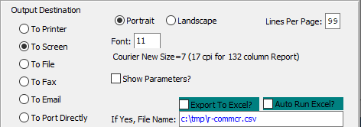

#### Destination Choice

To choose the destination where the document should be printed, please make sure that desired output destination choice bubble is toggled.

#### Layout Choice

To choose the preferred layout of Landscape vs. Portrait, please make sure the desired option choice bubbled is toggled.

#### Lines Per Page

Lines per page on the report when printing.

#### Font

Enter the font number to use with this report (Font 11 is default).

#### Show Parameters? – Toggle Box

To show parameters, make sure that the toggle box is ‘ticked’ with a checkmark.

#### Export to Excel? – Toggle Box

To export the printed file to an excel document, make sure that the Export to Excel toggle box is checked.

#### Auto Run Excel? – Toggle Box

To automatically open the new excel document, make sure that the Auto Run Excel toggle box is checked.

#### If Yes, File Name

If exporting the file to Excel, enter the desired file name.

## Cash Receipts by Sales Rep [AR^]

### Selection Parameters

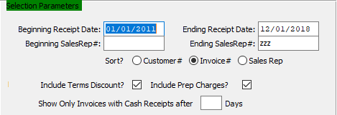

#### Beginning Receipt Date / Ending Receipt Date

Enter the beginning and ending Receipt Date to run the report for.

#### Beginning Sales Rep # / Ending Sales Rep #

Enter the beginning and ending Sales Rep Number to run the report for.

#### Sort? (Choice)

To choose the preferred sorting method of Customer Number vs. Invoice Number vs. Sales Representative, please make sure the desired option choice bubble is toggled.

#### Include Terms Discount? – Toggle Box

To include any terms discounts for the selected parameters, make sure that the Include Terms Discount toggle box is checked.

#### Include Prep Charges? – Toggle Box

To include any prep charges for the selected parameters, make sure that the Include Prep Charges toggle box is checked.

#### Number of Days

The user may enter a number of days in this field. Only invoices that have cash receipts by at least this number of days will be reported.

### Available Columns

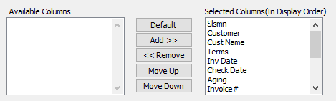

#### Available Columns

The user may choose which columns they wish to have on the report printout. As the user selects their choices, they will appear on the ‘*Selected Columns’* list.

#### Selected Columns (In Display Order)

The columns that the user has chosen from the ‘*Available Columns’* list. The order that these columns are displayed in here is the order in which they will print on the report.

#### Default

Click the ***“Default****”* button to sort the ‘*Selected Columns’* list by the default system parameters.

#### Add >>

Click on the selected item from the ‘*Available Columns’* list to highlight it, then click the ***“Add”*** button to add the selected column to the ‘*Selected Columns’* list.

#### << Remove

Click on the selected item from the ‘*Selected Columns’* list to highlight it, then click the ***“Remove”*** button to remove the selected column to the ‘*Selected Columns’* list.

#### Move Up

Within the ‘*Selected Columns’* list, the user may choose the order they wish the selected columns to print in. In order to change the order of the columns, the user can click on a selection to highlight it. By then clicking the ***“Move Up***” button, the user can change its position on the report.

#### Move Down

Within the ‘*Selected Columns’* list, the user may choose the order they wish the selected columns to print in. In order to change the order of the columns, the user can click on a selection to highlight it. By then clicking the ***“Move Down***” button, the user can change its position on the report.

### Outlook Destination

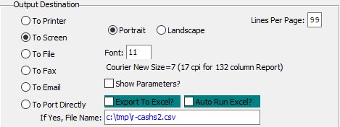

#### Destination Choice

To choose the destination where the document should be printed, please make sure that desired output destination choice bubble is toggled.

#### Layout Choice

To choose the preferred layout of Landscape vs. Portrait, please make sure the desired option choice bubbled is toggled.

#### Lines Per Page

Lines per page on the report when printing.

#### Font

Enter the font number to use with this report (Font 11 is default).

#### Show Parameters? – Toggle Box

To show parameters, make sure that the toggle box is ‘ticked’ with a checkmark.

#### Export to Excel? – Toggle Box

To export the printed file to an excel document, make sure that the Export to Excel toggle box is checked.

#### Auto Run Excel? – Toggle Box

To automatically open the new excel document, make sure that the Auto Run Excel toggle box is checked.

#### If Yes, File Name

If exporting the file to Excel, enter the desired file name.

# **List More Reports for Receivables [AL]**

## Detail Cash History Report [AL1]

### Selection Parameters

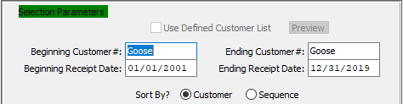

#### Beginning Customer # / Ending Customer #

Enter the beginning and ending Customer Number to run the report for.

#### Beginning Receipt Date / Ending Receipt Date

Enter the beginning and ending Receipt Date to run the report for.

#### Sort By? (Choice)

To choose the preferred sorting method of Customer Number vs. Sequence Number, please make sure the desired option choice bubble is toggled.

### Available Columns

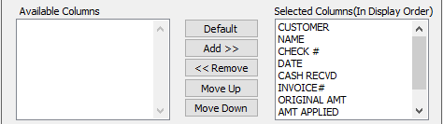

#### Available Columns

The user may choose which columns they wish to have on the report printout. As the user selects their choices, they will appear on the ‘*Selected Columns’* list.

#### Selected Columns (In Display Order)

The columns that the user has chosen from the ‘*Available Columns’* list. The order that these columns are displayed in here is the order in which they will print on the report.

#### Default

Click the ***“Default****”* button to sort the ‘*Selected Columns’* list by the default system parameters.

#### Add >>

Click on the selected item from the ‘*Available Columns’* list to highlight it, then click the ***“Add”*** button to add the selected column to the ‘*Selected Columns’* list.

#### << Remove

Click on the selected item from the ‘*Selected Columns’* list to highlight it, then click the ***“Remove”*** button to remove the selected column to the ‘*Selected Columns’* list.

#### Move Up

Within the ‘*Selected Columns’* list, the user may choose the order they wish the selected columns to print in. In order to change the order of the columns, the user can click on a selection to highlight it. By then clicking the ***“Move Up***” button, the user can change its position on the report.

#### Move Down

Within the ‘*Selected Columns’* list, the user may choose the order they wish the selected columns to print in. In order to change the order of the columns, the user can click on a selection to highlight it. By then clicking the ***“Move Down***” button, the user can change its position on the report.

### Outlook Destination

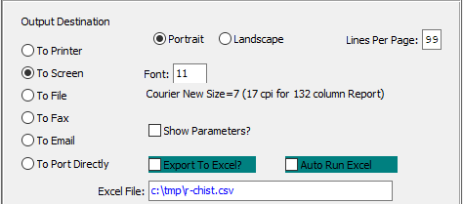

#### Destination Choice

To choose the destination where the document should be printed, please make sure that desired output destination choice bubble is toggled.

#### Layout Choice

To choose the preferred layout of Landscape vs. Portrait, please make sure the desired option choice bubbled is toggled.

#### Lines Per Page

Lines per page on the report when printing.

#### Font

Enter the font number to use with this report (Font 11 is default).

#### Show Parameters? – Toggle Box

To show parameters, make sure that the toggle box is ‘ticked’ with a checkmark.

#### Export to Excel? – Toggle Box

To export the printed file to an excel document, make sure that the Export to Excel toggle box is checked.

#### Auto Run Excel? – Toggle Box

To automatically open the new excel document, make sure that the Auto Run Excel toggle box is checked.

#### If Yes, File Name

If exporting the file to Excel, enter the desired file name.

## Detail Miscellaneous Cash History Report [AL2]

### Selection Parameters

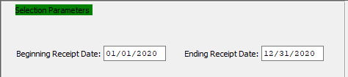

#### Beginning Receipt Date / Ending Receipt Date

Enter the beginning and ending Receipt Date to run the report for.

### Available Columns

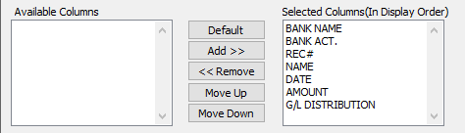

#### Available Columns

The user may choose which columns they wish to have on the report printout. As the user selects their choices, they will appear on the ‘*Selected Columns’* list.

#### Selected Columns (In Display Order)

The columns that the user has chosen from the ‘*Available Columns’* list. The order that these columns are displayed in here is the order in which they will print on the report.

#### Default

Click the ***“Default****”* button to sort the ‘*Selected Columns’* list by the default system parameters.

#### Add >>

Click on the selected item from the ‘*Available Columns’* list to highlight it, then click the ***“Add”*** button to add the selected column to the ‘*Selected Columns’* list.

#### << Remove

Click on the selected item from the ‘*Selected Columns’* list to highlight it, then click the ***“Remove”*** button to remove the selected column to the ‘*Selected Columns’* list.

#### Move Up

Within the ‘*Selected Columns’* list, the user may choose the order they wish the selected columns to print in. In order to change the order of the columns, the user can click on a selection to highlight it. By then clicking the ***“Move Up***” button, the user can change its position on the report.

#### Move Down

Within the ‘*Selected Columns’* list, the user may choose the order they wish the selected columns to print in. In order to change the order of the columns, the user can click on a selection to highlight it. By then clicking the ***“Move Down***” button, the user can change its position on the report.

### Outlook Destination

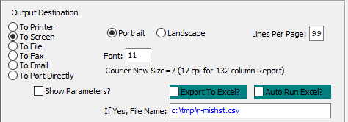

#### Destination Choice

To choose the destination where the document should be printed, please make sure that desired output destination choice bubble is toggled.

#### Layout Choice

To choose the preferred layout of Landscape vs. Portrait, please make sure the desired option choice bubbled is toggled.

#### Lines Per Page

Lines per page on the report when printing.

#### Font

Enter the font number to use with this report (Font 11 is default).

#### Show Parameters? – Toggle Box

To show parameters, make sure that the toggle box is ‘ticked’ with a checkmark.

#### Export to Excel? – Toggle Box

To export the printed file to an excel document, make sure that the Export to Excel toggle box is checked.

#### Auto Run Excel? – Toggle Box

To automatically open the new excel document, make sure that the Auto Run Excel toggle box is checked.

#### If Yes, File Name

If exporting the file to Excel, enter the desired file name.

## Detail Invoice Report [AL3]

### Selection Parameters

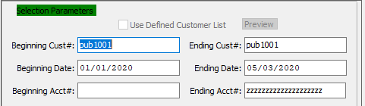

#### Beginning Customer # / Ending Customer #

Enter the beginning and ending Customer Number to run the report for.

#### Beginning Date / Ending Date

Enter the beginning and ending Invoice Date to run the report for.

#### Beginning Account # / Ending Account #

Enter the beginning and ending Account Number to run the report for.

### Available Columns

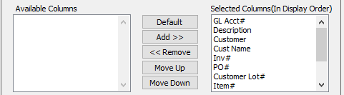

#### Available Columns

The user may choose which columns they wish to have on the report printout. As the user selects their choices, they will appear on the ‘*Selected Columns’* list.

#### Selected Columns (In Display Order)

The columns that the user has chosen from the ‘*Available Columns’* list. The order that these columns are displayed in here is the order in which they will print on the report.

#### Default

Click the ***“Default****”* button to sort the ‘*Selected Columns’* list by the default system parameters.

#### Add >>

Click on the selected item from the ‘*Available Columns’* list to highlight it, then click the ***“Add”*** button to add the selected column to the ‘*Selected Columns’* list.

#### << Remove

Click on the selected item from the ‘*Selected Columns’* list to highlight it, then click the ***“Remove”*** button to remove the selected column to the ‘*Selected Columns’* list.

#### Move Up

Within the ‘*Selected Columns’* list, the user may choose the order they wish the selected columns to print in. In order to change the order of the columns, the user can click on a selection to highlight it. By then clicking the ***“Move Up***” button, the user can change its position on the report.

#### Move Down

Within the ‘*Selected Columns’* list, the user may choose the order they wish the selected columns to print in. In order to change the order of the columns, the user can click on a selection to highlight it. By then clicking the ***“Move Down***” button, the user can change its position on the report.

### Outlook Destination

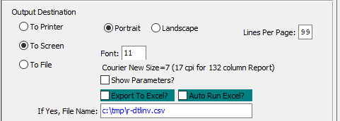

#### Destination Choice

To choose the destination where the document should be printed, please make sure that desired output destination choice bubble is toggled.

#### Layout Choice

To choose the preferred layout of Landscape vs. Portrait, please make sure the desired option choice bubbled is toggled.

#### Lines Per Page

Lines per page on the report when printing.

#### Font

Enter the font number to use with this report (Font 11 is default).

#### Show Parameters? – Toggle Box

To show parameters, make sure that the toggle box is ‘ticked’ with a checkmark.

#### Export to Excel? – Toggle Box

To export the printed file to an excel document, make sure that the Export to Excel toggle box is checked.

#### Auto Run Excel? – Toggle Box

To automatically open the new excel document, make sure that the Auto Run Excel toggle box is checked.

#### If Yes, File Name

If exporting the file to Excel, enter the desired file name.

# **File Maintenance for Customers [AF]**

## Customers [AF1]

### Overview

The Customer Header File contains the basic information about the customer. The Header Totals screen is automatically updated by processes throughout the system such as AR Invoicing, Order Entry Invoicing, and Cash Receipts. Credit Limits and Order Limits are automatically checked when processing an order. If either is exceeded at the time, it will be placed on Hold status and must be approved before additional processing of that order takes place. The screen Totals shows the total activity for a specific customer.

The Ship-To File is where the shipping address for a customer per order is entered. On every order entered, the ship to address, and special instructions transfer automatically to the order and are printed on the Bill of Lading. The Enter/Edit Order function in Order Entry allows for editing of such instructions. The Sold To file is used when selling to a broker who does not want to disclose the original manufacturer. The Sold To will print on the Bill of Lading with the broker appearing to be the original manufacturer.

### Browse Customer

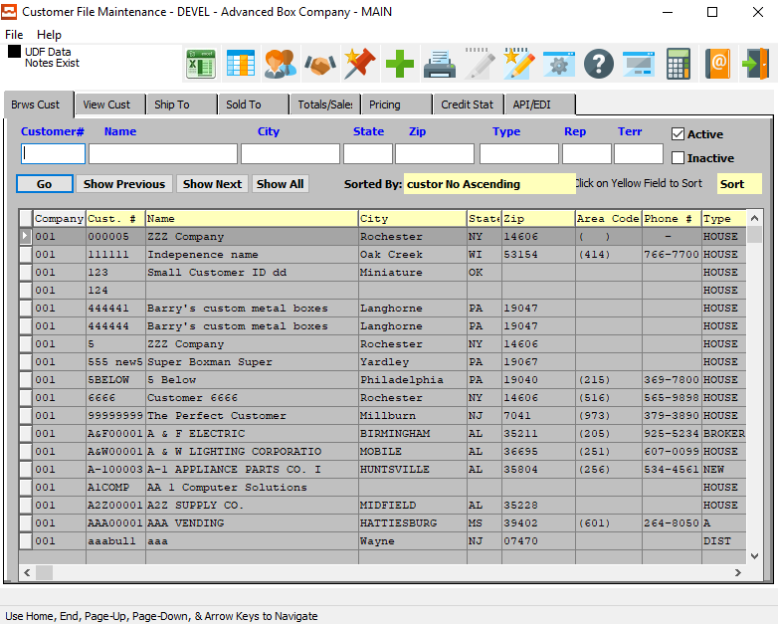

#### ADD

Click the ***“Green + Icon”*** to add a new Customer File.

### Browse Customer Field Definitions

#### Customer #

Enter customer number or you may use the ***“F1”*** look-up. A partial description may be typed into any field or data may be entered into multiple fields followed by pressing the ***“Go”*** button to sort the fields by the criteria that was entered. Once the data is presented on the screen, the YELLOW column heading may be clicked to sort that specific column in ascending or descending order.

#### Name

Enter the Finished Good name that you want to search for.

#### City

Enter a city to search for.

#### State

Enter a state to search for.

#### Zip Code

Enter a zip code to search for.

#### Type

Enter an order type to search for.

#### Rep

Enter a sales rep to search for.

#### Terr

Enter a territory to search for.

#### Active – Toggle Box

To search for active customers, make sure that the Active toggle box is checked.

#### Inactive – Toggle Box

To search for inactive customers, make sure that the Inactive toggle box is checked.

### View Customer

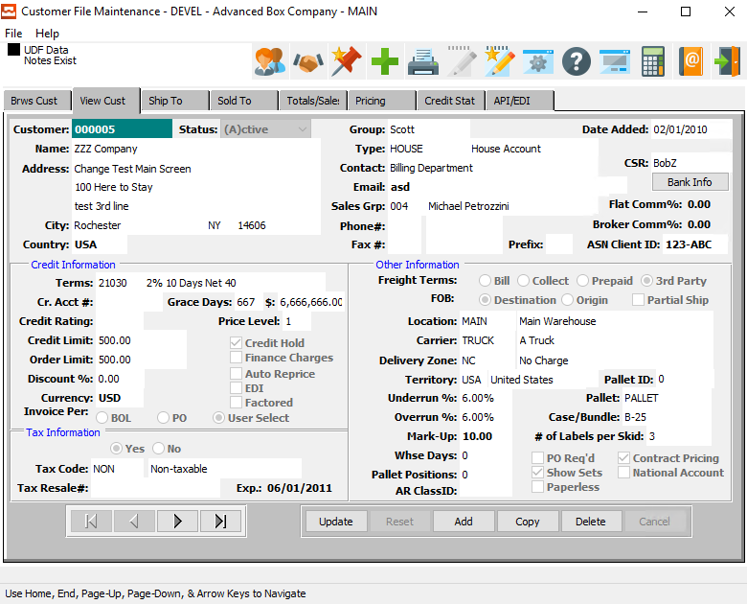

#### UPDATE

To change the currently selected Customer, simply click the ***“Update***” button at the bottom of the screen.

#### ADD

To add a new Customer, simply click the ***“Green + Icon”*** button at the top of the Customer File Maintenance screen.

Alternatively, click the ***“Add”*** button at the bottom of the screen.

#### COPY

Click the ***“Copy”*** button to copy information from the currently selected Customer.

#### DELETE

To delete the currently selected Customer, simply press the ***"D"*** key. Alternatively, click the ***“Delete”*** button at the bottom of the screen.

### Add/Update Customer

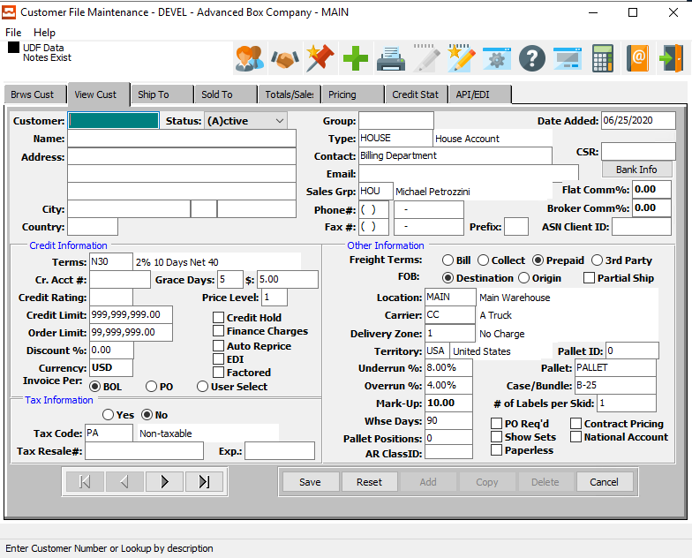

#### SAVE

Click the ***“Save”*** button to save all changes to the current Customer.

#### RESET

Click the ***“Reset”*** button to reset all fields to their original state.

#### CANCEL

Click the ***“Cancel”*** button to cancel all changes to the Customer without saving.

#### NEXT

Press ***"N"*** (Next) to find next Customer to view or modify. Alternatively, press the ***“Right Arrow”*** on the screen.

#### PREVIOUS

Press ***"P"*** (Previous) to find previous Customer to view or modify. Alternatively, press the ***“Left Arrow”*** on the screen.

### Add/Update Customer Field Definitions: Customer Information

#### Customer Number

Enter a unique customer number. The customer name, address, city, state, zip, salesman, common carrier and delivery zone will transfer to Estimating, Order Entry, and Accounts Receivable modules. When entering an order, for this estimate, this information would transfer to the items record so that customer, inventory reporting, and sales analysis are available.

#### Customer Status

Enter ***"A"*** if this is an Active customer or ***"I"*** for Inactive. Enter ***"X"*** for inhouse if this customer's address information is used for XPRINT forms. Options include Active, Inactive, In-House, Statement, E-Service, X-Transfer Orders and Default for Adding and Warehouse and Bin.

X-Type: When adding a new customer, the data fields will transfer from the customer defined as X. There should be only one customer X. This customer is also used for warehouse transfers via order entry and for the company heading for forms defined as XPRINT. Also, when adding a new Ship-To address for any customer in the customer ship to file, the warehouse and the bin location will transfer from the customer ship to file for the customer defined as type X.

E-Service type customers work with the N-K-1 parameter called FGEMAILS. FG post to automatically Email Customer Service for Hot Customers. The character version will dictate the method when emails are automatically distributed. Option 1 is NONE, which will turn off this feature. UNDERRUN this will automatically create Emails whenever the Quantity received is less than the Jobs allowable underrun.

For example, the job is for 100,000 with 10% under run, hence if we receive 50,000 on Friday and stop work for the day, an email will be sent. On Monday when they finished another 55,000 the job will close, but no email will be sent because the total receipt quantity is greater than 90,000. If the character value is RECEIPTS, then any FG receipt will create an email.

There must be a new customer status code called E for E-SERVICE in addition to existing codes called Active, Inactive, X House or Statement. Also, a new title code called EHOTS with description of E Mail Customer Service which may be added to the customer phone ICON for all service representative that should receive the email notice when the Finished Goods Items have been received and posted to finished goods on hand. Unlimited service representatives and/or customers will receive the email notice as to what was received.

The Email Topic line will show the Job#, Item# and quantity Received to Inventory. The message will read, Finished Goods Receipts have been Posted.

#### Customer Name

Enter the customer name. This transfers to the estimate and order.

#### Address

Enter the customer's address. This transfers to the estimate and order.

#### Date Added

Enter the first date that this customer file was added. This defaults to the system date, but may be modified by the user.

#### Type

Enter a valid customer type from the 'Customer Type' file. Optionally, Press the ***“F1”*** key to search, or press the ***“Page Up” / “Page Down”*** keys to scroll through the 'Customer Type' file. When the correct customer type appears on the screen, press the ***“Enter”*** key to accept. You may use the customer type field for calculating commissions, discounts and special pricing by grouping common customers by customer type. Also, sales reports will sort by customer type.

#### Contact

Enter the person to contact for collection calls. This name will print on the aging report.

#### Contact

Enter the person to contact for collection calls. This name will print on the aging report.

#### Email

Enter the email address for the customer contact.

#### Sales Group

Enter the salesman's code for this customer. Optionally press the ***“F1”*** key to search, or the ***“Page Up” / “Page Down*** keys to scroll though the salesman file. When the correct salesman displays on the screen, press the ***“Enter”*** key to accept. This will transfer to the estimate and order for calculating the commission rate and cost.

#### Phone Number

Enter the customer's phone number.

#### Fax Number

Enter the customers fax number.

#### Fax Prefix

Enter the prefix code or country code when faxing to this customer. Some fax machines may require a 1 or 9 when calling a local or long-distance phone number.

#### Flat Commission %

Flat Commission for Corrugated and Folding estimates

If the A-F-3 menu salesman file has a commission basis set as MARGIN, then the commission percentage will have the following priority for transferring to the estimate spec folder.

First, if FLAT COMM% in customer file is greater than 0, then that is the estimates commission percentage.

Second, if FLAT COMM% = zero and the Customer Markup = Margin on the Matrix.

The program will find the available margin percentage in the salesman matrix and transfer the commission percentage for that margin from the salesman's matrix to the estimate SPECS tab.

If estimates margin calculated is 13%, the commission imported to the estimate will be next lower margin of 4%. If estimates calculated margin is 20% the commission is 6%.

#### Broker Commission %

Broker Commission Percentage - Corrugated Estimates Only

This is a commission in addition to the normal commission field by salesman. PRINT Folder - Calculate Button - Click override GS&A. A toggle box field exists for Broker Commission Percentage. The customer file field called Broker Commission % will transfer to this Field.

If this is zero, the Broker Commission will transfer from the estimate control file via E-B Menu. If the GS&A Toggle box is not checked, the Broker Commission will still be used.

Please Note: once the GS&A broker commission has been added or changed, all future estimate calculations will use this percentage. Therefore, the control file will only be used when this field is set to zero.

### Add/Update Customer Field Definitions: Credit Information

#### Terms

Enter a valid terms code from the terms file. Optionally, press the ***“F1”*** key to search through, or the ***“Page Up” / “Page Down”*** keys to scroll through the Terms file. Press the ***“Enter”*** key to accept the terms code displayed on the screen.

#### Credit Account #

Enter a valid Customer number for credit verification, on the credit limits. The system uses the total corporate credit limit established for this customer. However, each individual customer location, defines the order limit.

#### Grace Days

Enter number of grace days for past due invoices. When this field is zero, this logic is not invoked. When the field is greater than zero, the number of grace days is added to the payment terms days to check past due invoices.

#### $

Enter the dollar amount as an allowance when checking a past due invoice. The grace dollars work with the grace days. When the age of any invoice is older than the due date according to the payment terms plus the grace days, the order or invoice will go on hold. However, if the amount due is under the grace dollars, the credit limit will not be on hold.

For example, an invoice may have been paid short because of freight issue or cash discount of $50. To prevent a credit hold for such as small amount, the grace days will waive the credit hold for any due amount under the grace dollars.

#### Credit Rating

Enter a user defined credit rating.

#### Price Level

This is the starting price level from the price matrix to be used for all items. If an order quantity exceeds the customer price level, then the system will automatically choose the next less expensive sell price. If the order quantity is less than the quantity defined for that price level, the price will be the sell price listed for that price level. Most customers should have a level set to one. However, your best customers may always get the best price by setting the price level at the highest price level defined in the price matrix.

#### Credit Limit

Enter the total credit limit, in dollars, for invoices and unshipped orders. The system immediately checks the total credit limit, upon creating an order, and before and after entering line items. If the unpaid balance is greater than the credit limit, the system will ask if you wish to abort the order. If you choose to proceed, and enter line items on the order, the system will flag the order as "On Credit Held". A credit manager must release the order from the 'Credit Held' file before a factory ticket will print.

Please Note: If entering a credit account #, the system will not use this credit limit; it will use the corporate credit limit.

#### Order Limit

Enter, in dollars, the total order limit for this customer location. The system immediately checks order limits after entering line items. In cases where the total order value is greater than the order limit, the system will ask if you wish to abort the order. If you proceed and enter line items on the order, the system will flag the order "On Credit Held". A credit manager must release the order from credit hold before a factory ticket will print.

Please Note: if entering a credit account #, the system still uses this order limit.

#### Discount %

Enter the customer's discount percentage on list price of stock boxes. As an alternative, establish a pricing matrix in the order processing module where prices may set by customer, customer type, product category and item. The system allows the user to base Price upon a specific price or on a discount off list price in the Order Entry Pricing Matrix.

#### Currency

Enter the currency code. You may use the ***“F1”*** key to do a look-up of codes.

#### Invoice Per (Choice)

Group by BOL will create invoice duplicating all the orders and items on the bill of lading. Even if many orders and unique purchase orders are on the bill of lading, this will create just one single invoice.

Group by PO will create a separate invoice for each purchase order on the bill of lading. If the bill of lading has many orders with unique purchase orders, the invoice creating ***“O”-“B”-“4”*** will create a separate invoice for each purchase order on the bill of lading.

Group by Date option allows shipping many bills of lading over a period of time but to create just one invoice. When you ship multiple deliveries per day to the same customer, they may complain they are getting too many invoices. This option alleviates this problem. When a bill of lading is posted, this creates a new invoice record with a status of HOLD, which prevents printing the invoice. Pressing the

#### Credit Hold – Toggle Box

To place this customer on a credit hold, make sure that the Credit Hold toggle box is checked.

#### Finance Charges – Toggle Box

To set this customer for finance charges, make sure that the Finance Charges toggle box is checked.

#### Auto Reprice – Toggle Box

To Automatically Reprice this customer, make sure that the Auto Reprice toggle box is checked.

#### EDI – Toggle Box

To set this customer to receive electronic digital invoices, make sure that the EDI toggle box is checked.

#### Factored – Toggle Box

Factored invoices for factored items will be collected by the Collection Agency / Bank. Please note, when an invoice has both factored and non-factored items, then the aging will include that invoice. Only items that are checked will be downloaded to the CIT batch file when the invoice is posting and the Download to CIT box is checked. Currently, the invoice posting program requires a field called Download to CIT. This new logic will automatically create the file for items checked as factored.

Please Note: This logic is only for OE invoice since the AR invoice does not have an FG item code. Also, item in the Finished Goods Item file for each FG item called Factor Invoice. When posting invoices, the Box called Export to CIT must be CHECKED. This will create a file for factored items only.

This will create a file for ONLY the finished goods items that are checked. On AR Aging report, the toggle box called Include Factored FG Items? Checking this box will use this new logic. Unchecked, will then create an AR aging for only invoices with non-factored items which are invoiced items that must be collected by customer.

### Add/Update Customer Field Definitions: Tax Information

#### Taxable? (Choice)

To choose the preferred tax option of Yes (Taxable) vs. No (Not Taxable), please make sure the desired option choice bubble is toggled.

#### Tax Code

Enter a valid sales tax group from the tax file. Optionally, press the ***“F1”*** key to search through, or the ***“Page Up” / “Page Down*** keys to scroll through the Sales Tax file. Press the ***“Enter”***] key to accept the Sales Tax group displayed on the screen.

#### Tax Resale #

Enter the sales tax resale ID#, if the customer is tax exempt.

#### Expiration

Enter the date that the tax exemption license from the government will expire.

### Add/Update Customer Field Definitions: Other Information

#### Freight Terms (Choice)

To choose the preferred freight terms for this customer, please make sure the desired option choice bubble is toggled.

#### FOB (Choice)

To choose the preferred FOB for this customer of Destination vs. Origin, please make sure the desired option choice bubble is toggled.

#### Partial Ship – Toggle Box

To set this customer to receive partial shipments, make sure that the Partial Ship toggle box is checked.

#### Location

Enter the primary plant/warehouse FOB shipping location for inventory to this customer. This location will transfer to the order.

#### Carrier

Enter the normal common carrier for shipments to this customer. Optionally, press the ***“F1”*** key to search through, or press the ***“Page Up” / “Page Down*** keys to scroll through the carrier file. Press the ***“Enter”*** key to accept the Carrier displayed on the screen.

The carrier entered will automatically transfer to the estimate, if the user inputs the ship-to. The system calculates the freight cost based on the total weight of an estimate quantity, by the delivery zones freight rates matrix. This matrix is located in the common carrier file.

#### Delivery Zone

Enter a valid Delivery Zone from the common carrier file. To determine the freight rate, from the carrier file, enter this field in customer file or customer ship to file. You may use a zip code, state code or any logical naming convention to categorize your delivery zones.

#### Territory

Enter a valid territory from the user defined territory file. Optionally, press the ***“F1”*** key to search through, or the ***“Page Up” / “Page Down*** keys to scroll through the territory file. Press the ***“Enter”*** key to accept the territory displayed on the screen.

#### Underrun %

Enter an allowable underrun percentage for this order. This defaults from the customer file, but may be modified. Warning messages will display when this limit is exceeded when entering Finished Goods Receipts & Releases for shipments.

#### Overrun %

Enter an allowable overrun percentage for this order. This defaults from the customer file, but may be modified. Warning messages will display when this limit is exceeded when entering Finished Goods Receipts & Releases for shipments.

#### Mark-Up

Enter a percentage that will be the default markup percentage when calculating an estimate.

#### Warehouse Days

Enter the maximum number of days that you will stock the customer's inventory in your warehouse. When adding and order, the order entry date plus warehouse days are added together to determine the due date. See N-K-1 LastShip parameter for more options.

#### Pallet Position

Purpose - This allows tracking of stocked inventory by customer. When this field is populated, the system will look at all items for this customer that are marked in the Finish goods file as "stocked." The system will then calculate how many total pallets are on hand for this customer. If the number on hand exceeds the number entered into "Pallet Position" when adding a new order/w job for a stocked item, the order will be placed on hold.

#### Pallet ID

This is a counter field that can be set per customer. This number will be incremented for each Load Tag printed for this customer. Leave this field set to 0 if you don't wish to utilize this counter. You will be prompted to reset the Pallet ID when the last six digits reach 999999.

#### Pallet

Enter a valid pallet code from the raw materials file to default to estimating page three. This allows customers with unique pallet restrictions to have a pallet default for unitizing, shipping, and freight cost calculation. If the pallet code is left blank, then the pallet will default from the estimate control file.

#### Case/Bundle

Enter a valid corrugated case or bundle count code to be used as a default in estimating for this customer. If left blank, the case/bundle code will default from the estimating control file. The case/bundle code is used for packing and costing of corrugated or bundles.

#### # of Labels per Skid

Enter the number of load tags.

#### PO Required – Toggle Box

To set this customer as requiring a Purchase Order, make sure that the PO Required toggle box is checked.

#### Show Sets – Toggle Box

To set this customer file to show sets, make sure that the Show Sets toggle box is checked.

#### Paperless – Toggle Box

To set this customer as paperless, make sure that the Paperless toggle box is checked.

#### Contract Pricing – Toggle Box

To set this customer to receive contract pricing, make sure that the Contract Pricing toggle box is checked.

#### National Account – Toggle Box

To mark this customer as a national account, make sure that the National Account toggle box is checked.

### Ship-To

The system allows up to 99999999 separate Ship-To locations for each customer. Optionally, the Ship To code could be a customer code defined in the customer file so that the ship code destination will become the bill to for invoicing. The ship-to location, in conjunction with the carrier code defined on the estimate, will cause automatic calculation of freight charges based on the carrier rate matrix by shipping zone.

On every order entered, for this customer's ship to address, the special instructions automatically transfer to the order and printed on the Bill of Lading, saving time and data entry errors. The 'Enter/Edit Order' function of the Order Entry module allows modification of the special instructions.

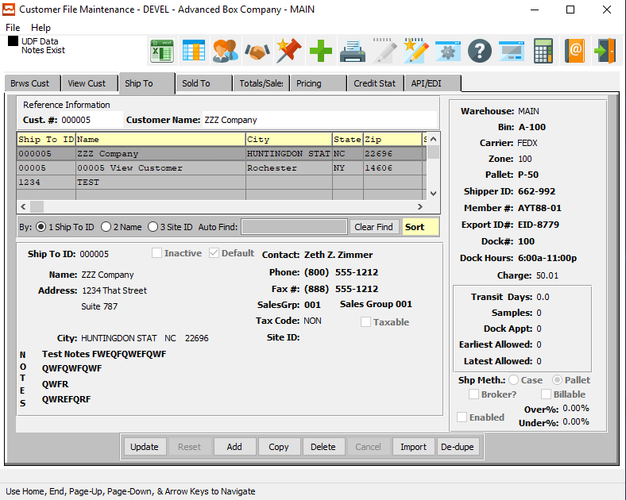

#### UPDATE

To change the currently selected Ship-To information, simply click the ***“Update***” button at the bottom of the screen.

#### ADD

Click the ***“Add”*** button at the bottom of the screen to add a new Ship-To file.

#### COPY

Click the ***“Copy”*** button to copy information from the currently selected Ship-To file.

#### DELETE

To delete the currently selected Ship-To file, simply press the ***"D"*** key. Alternatively, click the ***“Delete”*** button at the bottom of the screen.

#### IMPORT

To import a Ship-To file from an existing document, click the ***“Import”*** button.

#### DE-DUPE

To change the selected Ship-To IDs for a specific customer, click the ***“De-Dupe”*** button.

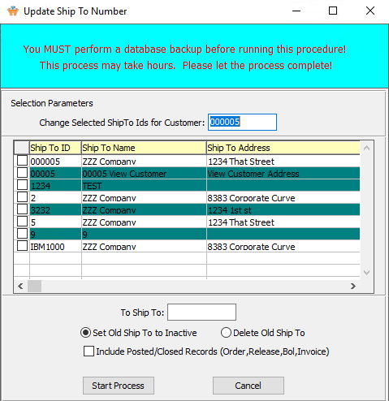

### Add/Update Ship-To

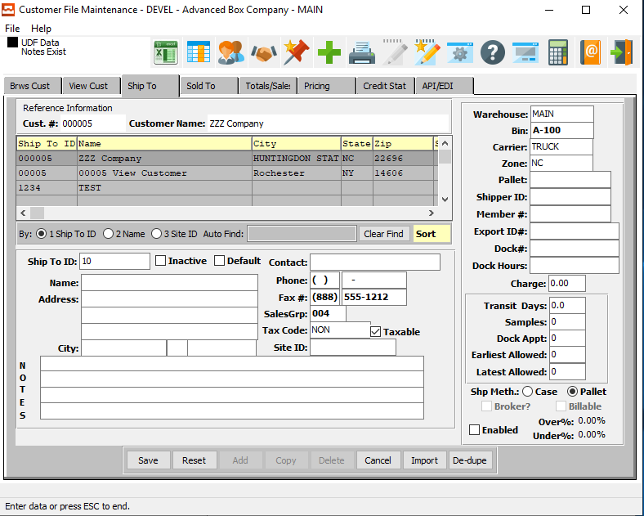

#### SAVE

Click the ***“Save”*** button to save all changes to the current Ship-To file.

#### RESET

Click the ***“Reset”*** button to reset all fields to their original state.

#### CANCEL

Click the ***“Cancel”*** button to cancel all changes to the Ship-To file without saving.

#### IMPORT

To import a Ship-To file from an existing document, click the ***“Import”*** button.

#### DE-DUPE

To change the selected Ship-To IDs for a specific customer, click the ***“De-Dupe”*** button.

### Add/Update Ship-To Field Definitions: Ship-To Information

#### Ship-To ID

Enter a ship to code or a customer code from the customer file. Do not enter a customer code unless this ship to will be invoiced. The ship-to file provides unlimited ship-to addresses per customer. During estimating or order processing, if the user enters this ship-to number, the ship to name, address, city, state, zip, common carrier and delivery zone will transfer automatically.

#### Inactive – Toggle Box

To mark this Ship-To file as inactive, make sure that the Inactive toggle box is checked.

#### Default – Toggle Box

To set this Ship-To file as the default for this customer, make sure that the Default toggle box is checked.

#### Ship-To Name

Enter the customer's ship-to name. The ship-to names defaults to the Customer's Name from screen number 1 of the customer file. The ship-to name transfers to the estimate and order, when the user enters the ship-to number.

#### Ship-To Address

Enter the customer's ship-to address. This transfers to the estimate and order when the user enters the ship-to number.

#### Ship-To Contact Name

The contact that you sent the quote to.

#### Phone Number

Enter the phone number of the customer.

#### Fax Number

Enter the fax number for this customer.

#### Sales Group

Enter a names for this sales group.

#### Tax Code

Enter a valid tax group from the sales tax file. Optionally, press the ***“F1”*** key to search through, or the ***“Page Up” / “Page Down”*** keys to scroll through the Sales Tax code file. Press the ***“Enter”*** key to accept the Sales tax group displayed on the screen.

#### Taxable – Toggle Box

To set this shipping information as taxable, make sure that the Taxable toggle box is checked.

#### Notes

Enter any special shipping information notes needed for this ship-to file.

### Add/Update Ship-To Field Definitions: Warehouse Information

#### Warehouse Code

Enter the plant/warehouse location where shipments originate. Press ***“F1”*** to search for valid locations.

#### Bin

To list the exact tag, bin and warehouse on the Release ticket, the bin location may be entered, otherwise leave blank. The bin location may be searched by pressing the ***“F1”*** key or Page Up/Page Down keys.

#### Carrier

Enter the normal common carrier for shipments to this customer's ship-to address. The ship to carrier entered will automatically transfer to the estimate, and to the order, if the user enters the ship-to number. The system calculates the freight cost based on the total weight of an estimate (or order) quantity by the delivery zones freight rates matrix. The user defines this matrix in the common carrier file.

#### Zone

Enter a valid Delivery Zone from the Common Carrier file for this ship to location. Optionally, press the ***“F1”*** key to search through, or the ***“Page Up” / “Page Down”*** keys to scroll through the Common Carrier file. In order to determine the freight rate from the carrier file, enter the delivery Zone. You may use a zip code, state code, or any logical naming convention to categorize your delivery zones.

#### Pallet

Enter a valid pallet code such as pallet or bale. By pressing ***“F1”*** you can scroll through a list of valid options.

#### Shipper ID

Enter a valid shipper Id code for this Warehouse.

#### Member #

Enter a valid Member number for this Warehouse.

#### Export ID #

Enter a valid export identification number for this Warehouse.

#### Dock #

Enter a valid dock number for this Warehouse.

#### Dock Hours

Enter the hours that this dock is open for shipments.

#### Charge

Enter an additional charge beyond the normal freight charge. This is useful for adding dollars to local deliveries, in order to compensate for city traffic. Currently, this field is not used in any calculations. Upon a customer's request, we will add this feature in a future release.

#### Ship Method (Choice)

To choose the preferred shipping method of Case vs. Pallet, please make sure the desired option choice bubble is toggled.

### Sold To

The user can enter up to 9999 sold-to accounts for each customer. Use this file when selling to brokers who do not want their client to know the original manufacturer, you. They want to take the credit for your great work, so we let them. The Sold-To will print on a plain Bill of Lading so the Sold-To vendor appears to be the original manufacturer.

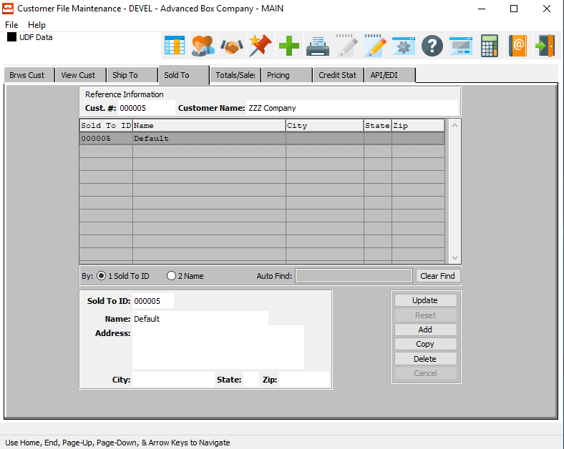

#### UPDATE

To change the currently selected Sold-To file, simply click the ***“Update***” button at the bottom of the screen.

#### ADD

Click the ***“Add”*** button at the bottom of the screen to add a new Sold-To file.

#### COPY

Click the ***“Copy”*** button to copy information from the currently selected Sold-To file.

#### DELETE

To delete the currently selected Sold-To file, simply press the ***"D"*** key. Alternatively, click the ***“Delete”*** button at the bottom of the screen.

### Add/Update Sold To

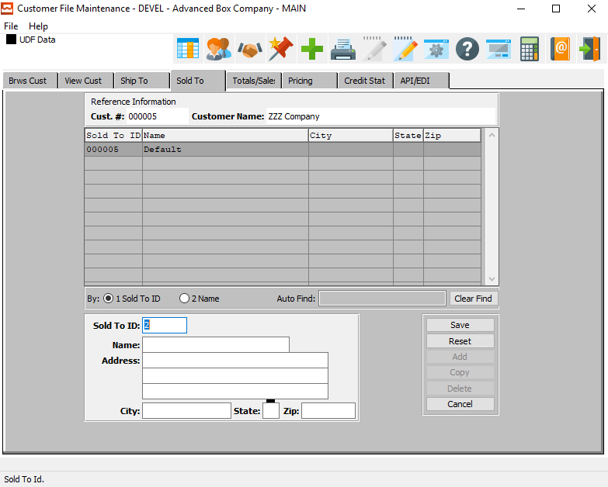

#### SAVE

Click the ***“Save”*** button to save all changes to the current Sold-To file.

#### RESET

Click the ***“Reset”*** button to reset all fields to their original state.

#### CANCEL

Click the ***“Cancel”*** button to cancel all changes to the Sold-To file without saving.

### Add/Update Sold To Field Definitions

#### Sold-To ID

Enter a unique Sold-To number for this customer. The Sold-To file provides up to 999 sold-to addresses per customer. Use the sold-to name and sold-to address for selling to brokers. The Bill of Lading will print the Sold To name and address so that the boxes appear to ship from the broker.

#### Sold-To Name

Enter the customer's (broker's) sold-to company name. When entering the Sold To number, this name transfers to the order.

#### Sold-To Address

Enter the customer's (broker's) sold-to address. When entering the Sold To number, this transfers to the order.

### Total Sales

The totals screen is automatically updated by processes throughout the system such as AR Invoicing, Order Entry Invoicing and Cash Receipts. The PTD, YTD, and Last Year Sales, Costs, and Commissions are automatically updated as well as giving you the highest balance, total number of invoices, and average days to pay.

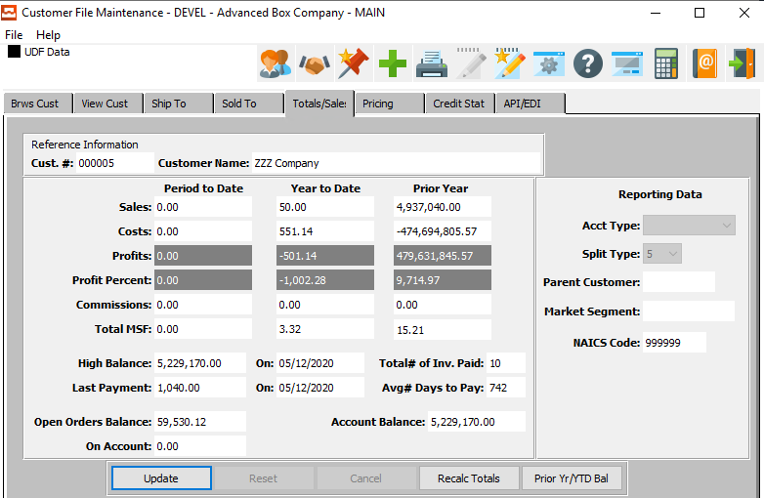

#### UPDATE

To change the currently selected Totals, simply click the ***“Update***” button at the bottom of the screen.

#### RECALC TOTALS

Click the ***“Recalc Totals”*** button to recalculate all totals for the current Totals file after making any changes.

#### PRIOR YEAR / YTD BALANCE

To view and edit the current vendor’s balances from the last year, and the current year to date, click on the ***“Prior YR and YTD Balances”*** button.

### Pricing

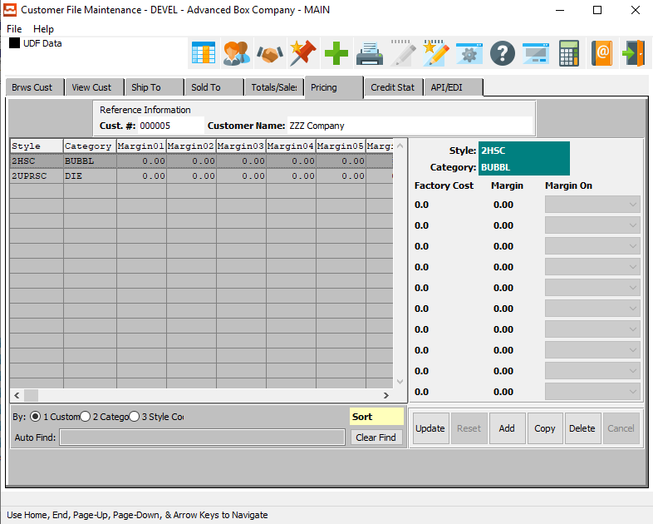

#### UPDATE

To change the currently selected Pricing File, simply click the ***“Update***” button at the bottom of the screen.

#### ADD

Click the ***“Add”*** button at the bottom of the screen to add a new Pricing File.

#### COPY

Click the ***“Copy”*** button to copy information from the currently selected Pricing File.

#### DELETE

To delete the currently selected Pricing File, simply press the ***"D"*** key. Alternatively, click the ***“Delete”*** button at the bottom of the screen.

### Add/Update Pricing

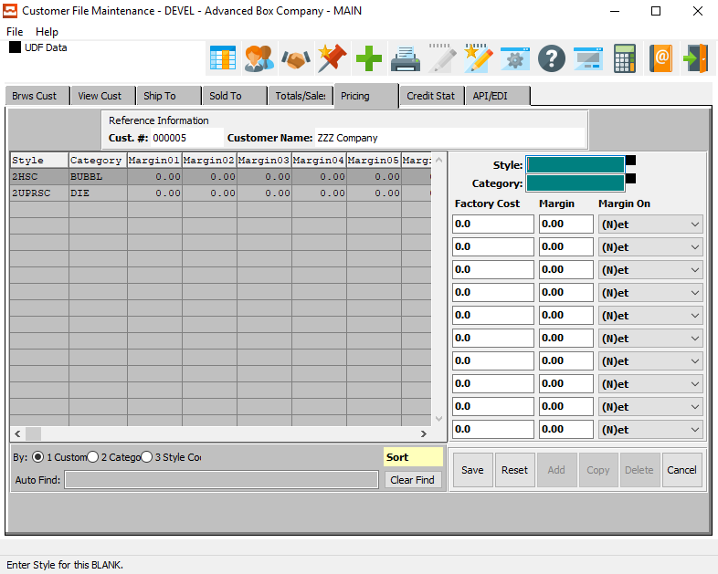

#### SAVE

Click the ***“Save”*** button to save all changes to the current Pricing File.

#### RESET

Click the ***“Reset”*** button to reset all fields to their original state.

#### CANCEL

Click the ***“Cancel”*** button to cancel all changes to the Pricing File without saving.

### Add/Update Pricing Field Definitions

#### Style

Enter a valid Style code for this pricing information. Alternatively, press the ***“F1”*** button to choose a code from a list of valid Style Numbers.

#### Category

Enter a valid Category code for this pricing information. Alternatively, press the ***“F1”*** button to choose a category from a list of valid Category codes.

#### Factory Cost

Enter a valid factory cost for the current style and category pricing.

#### Margin

Enter a percentage that will be the default markup percentage when calculating an estimate.

#### Margin On

Valid Options to Calculate the Margin on are as Follows:

|  |  |
| --- | --- |
| B | Board |
| G | Gross |
| N | Net |

### Credit Status

Credit limits and order limits are automatically checked when processing an order. If either the order limit or credit limit are exceeded at the time of entering an order, it will be placed on Hold status and must be improved before additional processing of that order will take place.

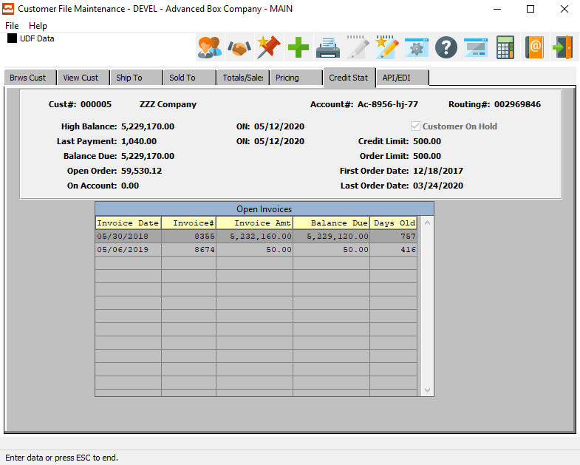

### API/EDI

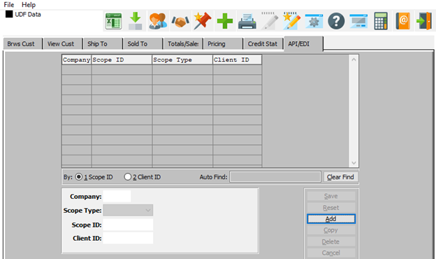

#### ADD

Click the ***“Add”*** button at the bottom of the screen to add a new API/EDI file.

### Add/Update API/EDI

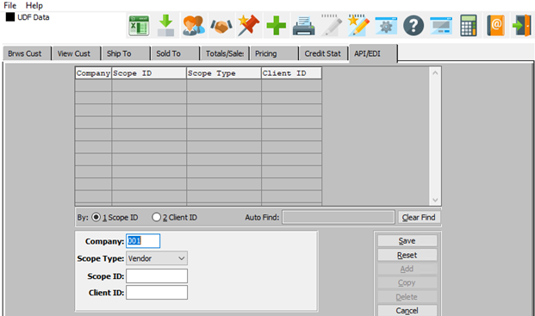

#### SAVE

Click the ***“Save”*** button to save all changes to the current API/EDI file.

#### RESET

Click the ***“Reset”*** button to reset all fields to their original state.

#### CANCEL

Click the ***“Cancel”*** button to cancel all changes to the API/EDI file without saving.

### Add/Update API/EDI Field Definitions

#### Company

Enter the company name for this API/EDI file.

#### Scope Type

Choose the scope type for this API/EDI file.

#### Scope ID

Enter the scope ID for this API/EDI file.

#### Client ID

Enter the Client ID for this API/EDI file.

## Customer Types [AF2]

The Customer Type file is a file that feeds into the Customer File. Numerous customer types may be defined such as broker, wholesale, retail, etc. The customer type field provides commissions and sales analysis reports by customer type; therefore, it is useful to group similar customers in the same category. In addition to the customer type, a discount percentage or a commission percentage may be defined for that customer type so that when entering an order or an invoice the discount or commission will default automatically.

### Browse Types

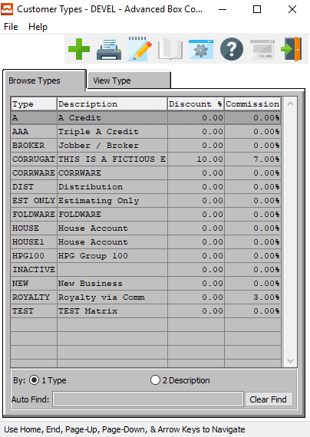

#### ADD

Click the ***“Green + Icon”*** to add a new Customer Type.

### View Type

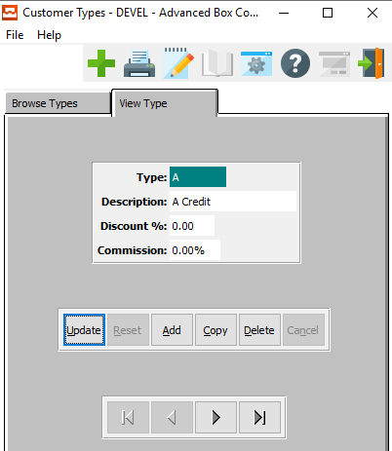

#### UPDATE

To change the currently selected Customer Type, simply click the ***“Update***” button at the bottom of the screen.

#### ADD

To add a new Customer Type, simply click the ***“Green + Icon”*** button at the top of the Customer Type screen.

Alternatively, click the ***“Add”*** button at the bottom of the screen.

#### COPY

Click the ***“Copy”*** button to copy information from the currently selected Customer Type.

#### DELETE

To delete the currently selected Customer Type, simply press the ***"D"*** key. Alternatively, click the ***“Delete”*** button at the bottom of the screen.

#### NEXT

Press ***"N"*** (Next) to find next Customer Type to view or modify. Alternatively, press the ***“Right Arrow”*** on the screen.

#### PREVIOUS

Press ***"P"*** (Previous) to find previous Customer Type to view or modify. Alternatively, press the ***“Left Arrow”*** on the screen.

### Add/Update Type

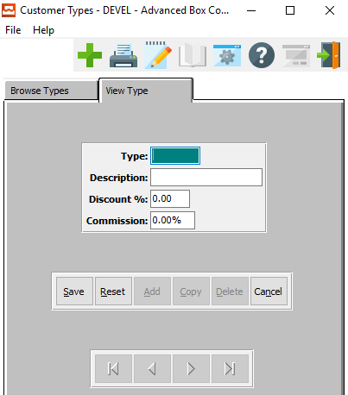

#### SAVE

Click the ***“Save”*** button to save all changes to the current Customer Type.

#### RESET

Click the ***“Reset”*** button to reset all fields to their original state.

#### CANCEL

Click the ***“Cancel”*** button to cancel all changes to the Customer Type without saving.

### Add/Update Type Field Definitions

#### Type

Enter a unique customer type to categorize customers for sales reports, commissions and for special pricing for STOCK BOXES.

#### Description

Enter a description to describe the type.

#### Discount %

Enter the discount percentage for customer type to deduct from stock boxes.

#### Commission %

Enter the salesman's commission for this customer type for all items on all estimates.

## Sales Rep Commissions [AF3]

The Salesman Commission Matrix file is used for calculating the commissions automatically at Order Entry Invoicing time. The Commissions may be calculated on either a gross profit or gross sales price based on basis type.

### Browse Sales Group

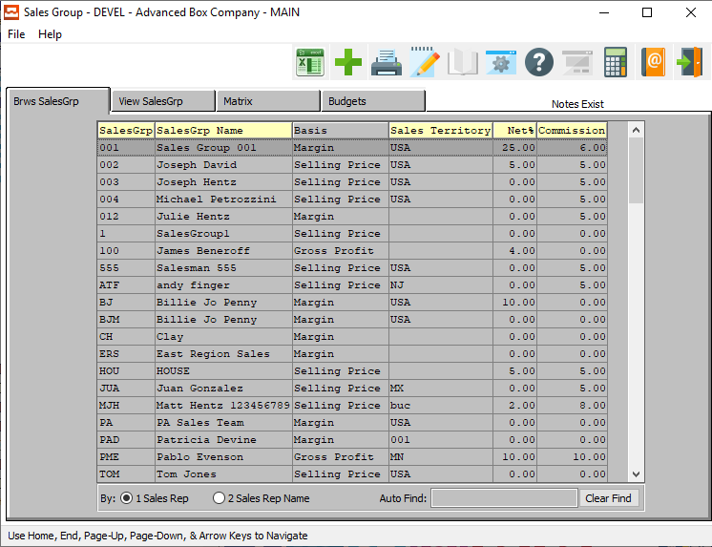

#### ADD

Click the ***“Green + Icon”*** to add a new Sales Group.

### View Sales Group

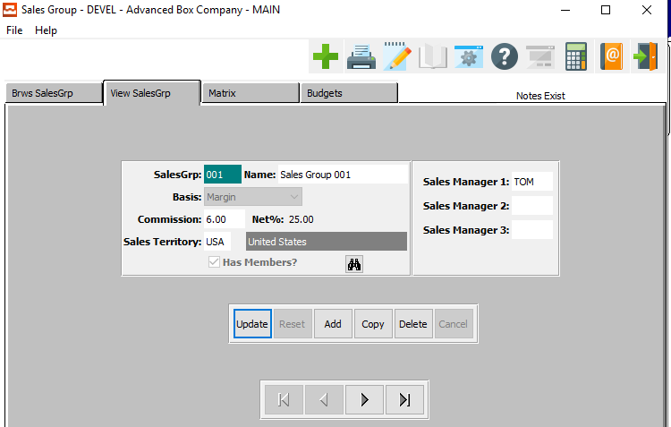

#### UPDATE

To change the currently selected Sales Group, simply click the ***“Update***” button at the bottom of the screen.

#### ADD

To add a new Sales Group, simply click the ***“Green + Icon”*** button at the top of the Sales Group screen.

Alternatively, click the ***“Add”*** button at the bottom of the screen.

#### COPY

Click the ***“Copy”*** button to copy information from the currently selected Sales Group.

#### DELETE

To delete the currently selected Sales Group, simply press the ***"D"*** key. Alternatively, click the ***“Delete”*** button at the bottom of the screen.

#### NEXT

Press ***"N"*** (Next) to find next Sales Group to view or modify. Alternatively, press the ***“Right Arrow”*** on the screen.

#### PREVIOUS

Press ***"P"*** (Previous) to find previous Sales Group to view or modify. Alternatively, press the ***“Left Arrow”*** on the screen.

### Add/Update Sales Group

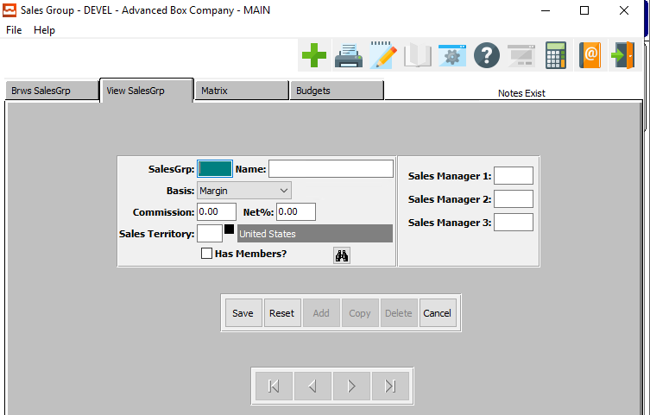

#### SAVE

Click the ***“Save”*** button to save all changes to the current Sales Group.

#### RESET

Click the ***“Reset”*** button to reset all fields to their original state.

#### CANCEL

Click the ***“Cancel”*** button to cancel all changes to the Sales Group without saving.

### Add/Update Sales Group Field Definitions

#### Sales Group

Enter the salesman's initials or code to access this salesman. This salesman's name and commission percentage will transfer to the customer file when entering the salesman's code.

#### Sales Group Name

Enter the salesman's full name. This transfers to the estimate and order when entering this salesman's code.

#### Basis

Enter the commission basis for determining the commission cost. The valid entries are "P" for Gross Profit or "S" for Selling Price. The commission percentage entered will multiply either the gross profit or the selling price, depending upon the basis.

#### Commission %

Enter the salesman's commission percentage to use for all estimates when not using the customer type matrix.

#### Sales Territory

Enter the salesman's territory. Enter the territory, press the ***“F1”*** to search for the territory, or press the ***“Page Up” / “Page Down”*** keys to scroll through the files. Sales report will print by territory.

#### Has Members? – Toggle Box

To mark this sales group as having members, make sure that the Has Members toggle box is checked.

#### Sales Manager (1-3)

Enter a code for each of the sales managers of this sales group.

### Matrix

The salesman commission matrix file is used for calculating the commissions automatically at Order Entry Invoicing time. The commissions may be calculated on either a gross profit or gross sales price based on the basis type. A default commissions percentage may be assigned by salesman, customer type, or further broken down by product category.

The product category must first be defined in the Finished Goods File Maintenance. Once the product categories are defined, they will default automatically to the salesman commissions matrix so that different commissions percentages may be assigned by product category within the customer type.

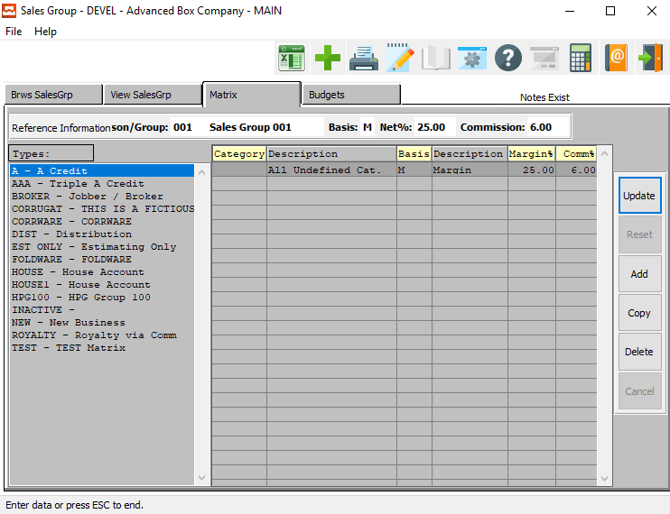

#### UPDATE

To change the currently selected Sales Group Matrix, simply click the ***“Update***” button at the bottom of the screen.

#### ADD

Click the ***“Add”*** button at the bottom of the screen to add a new Sales Group Matrix.

#### COPY

Click the ***“Copy”*** button to copy information from the currently selected Sales Group Matrix.

#### DELETE

To delete the currently selected Sales Group Matrix, simply press the ***"D"*** key. Alternatively, click the ***“Delete”*** button at the bottom of the screen.

### Add/Update Matrix

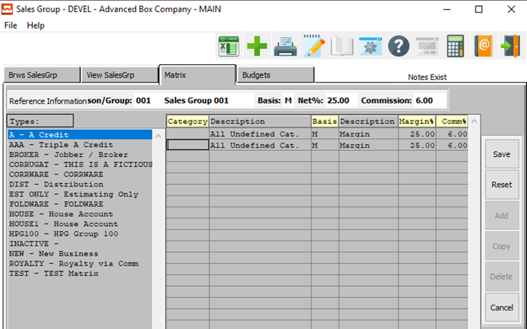

#### SAVE

Click the ***“Save”*** button to save all changes to the current Sales Group Matrix.

#### RESET

Click the ***“Reset”*** button to reset all fields to their original state.

#### CANCEL

Click the ***“Cancel”*** button to cancel all changes to the Sales Group Matrix without saving.

### Add/Update Matrix Field Definitions

#### Type

Enter a valid customer type from the customer type file. Optionally, you can establish Commissions by product categories for each unique customer type. For example, the salesman's commission percentage may vary from a House Account, Jobber or End User. Since the user defines customer types, the possibility exists for many different customer types.

#### Category

Enter a valid product category from the finished goods product category file. Each category may have a unique commission percentage defined by customer type.

#### Description (Category)

This transfers for the product category defined above.

#### Commission %

Enter the salesman's commission percentage to use for this product category by this customer type. Categories not listed will utilize the default commission percentage defined by customer type.

### Budgets

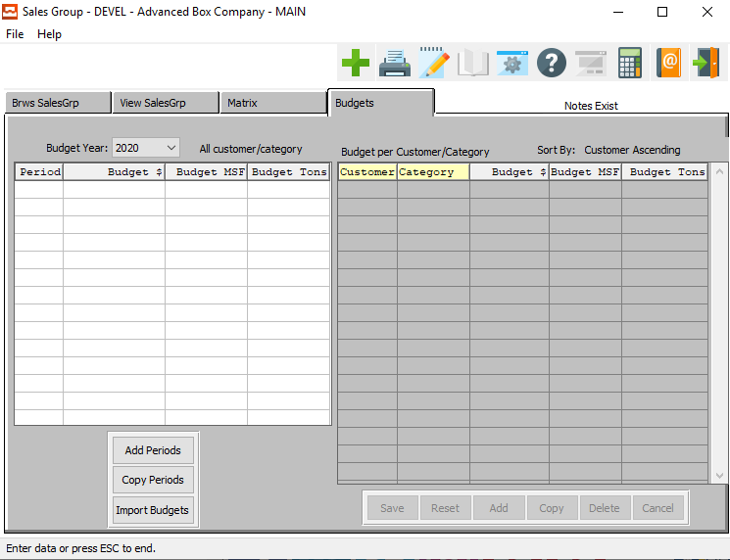

#### ADD PERIODS

Click the ***“Add Periods”*** button to add a new budget period.

#### COPY PERIODS

Click the ***“Copy Periods”*** button to copy information from the currently selected budget period.

#### IMPORT BUDGETS

To import budgets from an existing file, click the ***“Import Budgets”*** button.

### Add/Update Period

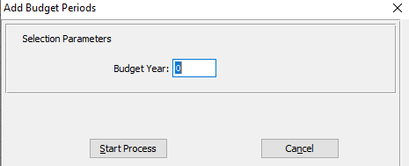

#### Budget Year

Enter a valid year for the new budget.

## Payment Terms [AF4]

The Terms File feeds the customer file as well as the Order Entry and Invoicing programs. By default, the terms entered on the customer file will transfer to the order. The terms file is user defined with any number of codes desired. Each terms code allows the capability of entering a discount percentage, the total allowable days, and the days on which a discount will apply.

### Browse Terms

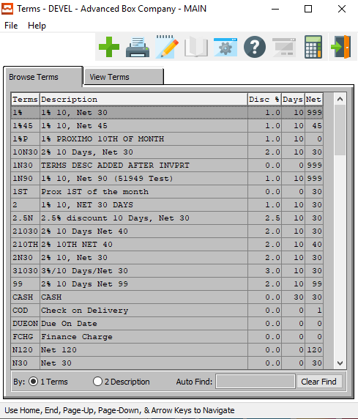

#### ADD

Click the ***“Green + Icon”*** to add a new Payment Term.

### View Terms

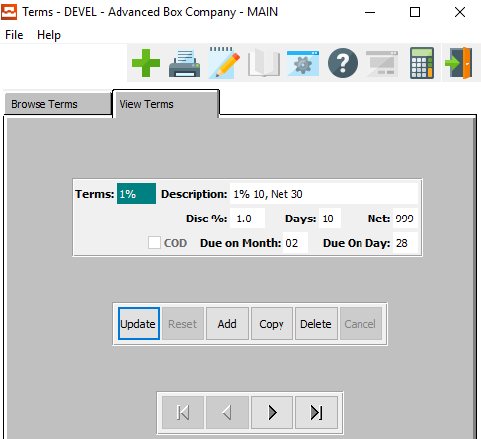

#### UPDATE

To change the currently selected Payment Term, simply click the ***“Update***” button at the bottom of the screen.

#### ADD

To add a new Payment Term, simply click the ***“Green + Icon”*** button at the top of the Payment Term screen.

Alternatively, click the ***“Add”*** button at the bottom of the screen.

#### COPY

Click the ***“Copy”*** button to copy information from the currently selected Payment Term.

#### DELETE

To delete the currently selected Payment Term, simply press the ***"D"*** key. Alternatively, click the ***“Delete”*** button at the bottom of the screen.

#### NEXT

Press ***"N"*** (Next) to find next Payment Term to view or modify. Alternatively, press the ***“Right Arrow”*** on the screen.

#### PREVIOUS

Press ***"P"*** (Previous) to find previous Payment Term to view or modify. Alternatively, press the ***“Left Arrow”*** on the screen.

### Add/Update Terms

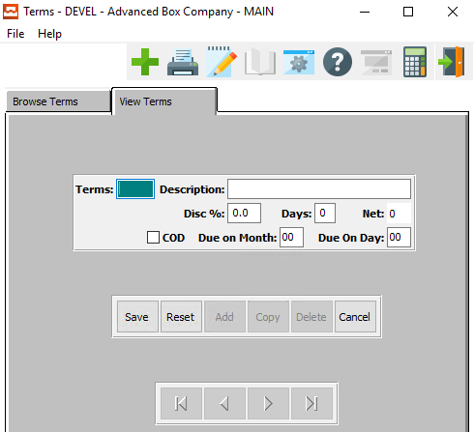

#### SAVE

Click the ***“Save”*** button to save all changes to the current Payment Term.

#### RESET

Click the ***“Reset”*** button to reset all fields to their original state.

#### CANCEL

Click the ***“Cancel”*** button to cancel all changes to the Payment Term without saving.

### Add/Update Terms Field Definitions

#### Terms

Enter a code to describe this term for payment (i.e., N30 for Net 30, or 0210N15 for 2% 10 days net 15).

#### Description

Enter a description to describe this term for payment (i.e., 2% 10 days, Net 30).

#### Discount %

Enter a discount percentage for early payment. Enter '2.5' for a discount of 2.5 percent.

#### Days

Enter the number of days for this discount to be valid. Enter '10' for this discount to be valid for ten days from the date.

#### COD – Toggle Box

To set this payment term as a COD, make sure that the COD toggle box is checked.

#### Due on Month

Enter a number between 1 and 12 to determine which month a payment term is due.

#### Due on Day

Enter number to determine which day of the month a payment term is due.

## Sales Territories [AF5]

The Territory File allows different territories to be defined so that the customer may be defined by territory whereas the sales reports are available by territory. Normally the territory may be defined by state. However, to simplify this approach, a region may be defined.

### Browse Territory

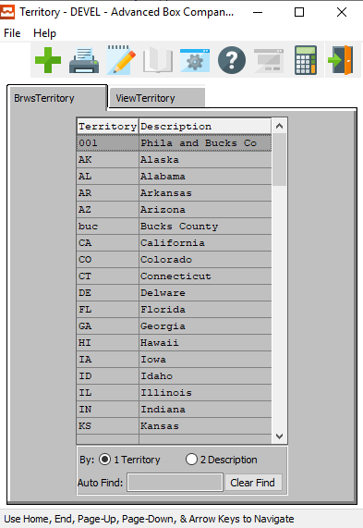

#### ADD

Click the ***“Green + Icon”*** to add a new Sales Territory.

### View Territory

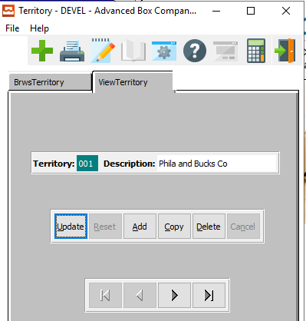

#### UPDATE

To change the currently selected Sales Territory, simply click the ***“Update***” button at the bottom of the screen.

#### ADD

To add a new Sales Territory, simply click the ***“Green + Icon”*** button at the top of the Sales Territory screen.

Alternatively, click the ***“Add”*** button at the bottom of the screen.

#### COPY

Click the ***“Copy”*** button to copy information from the currently selected Sales Territory.

#### DELETE

To delete the currently selected Sales Territory, simply press the ***"D"*** key. Alternatively, click the ***“Delete”*** button at the bottom of the screen.

#### NEXT

Press ***"N"*** (Next) to find next Sales Territory to view or modify. Alternatively, press the ***“Right Arrow”*** on the screen.

#### PREVIOUS

Press ***"P"*** (Previous) to find previous Sales Territory to view or modify. Alternatively, press the ***“Left Arrow”*** on the screen.

### Add/Update Territory

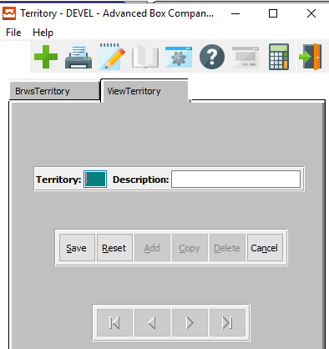

#### SAVE

Click the ***“Save”*** button to save all changes to the current Sales Territory.

#### RESET

Click the ***“Reset”*** button to reset all fields to their original state.

#### CANCEL

Click the ***“Cancel”*** button to cancel all changes to the Sales Territory without saving.

### Add/Update Territory Field Definitions

#### Territory

Enter a unique code to describe the territory.

#### Description

Enter a description to describe the territory.

## Taxing Authority Codes [AF6]

The Tax Codes file allows defining a tax structure so that three tax rates will be applied when invoicing. As an example, a group may be set up for Phila. so that the state, city, and local county taxes will apply all at once. in addition, General Ledger accounts can be assigned for each tax code. For companies in Canada the GST and VAT tax could be set up using the tax codes maintenance.

### Browse Codes

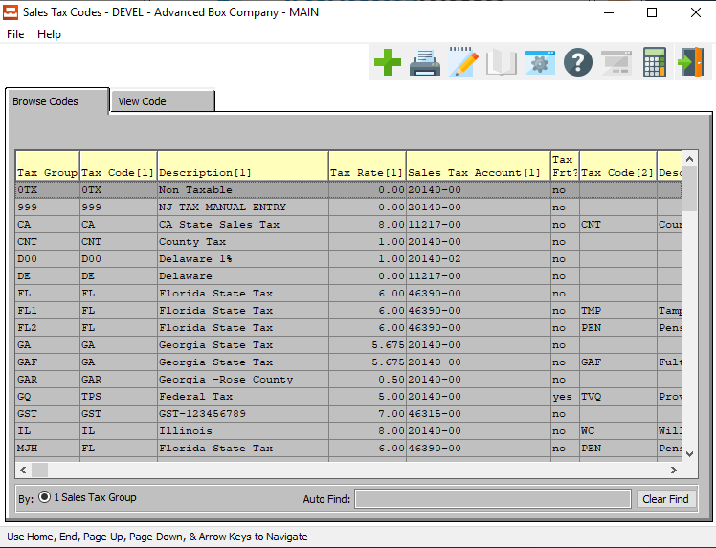

#### ADD

Click the ***“Green + Icon”*** to add a new Sales Tax Code.

### View Code

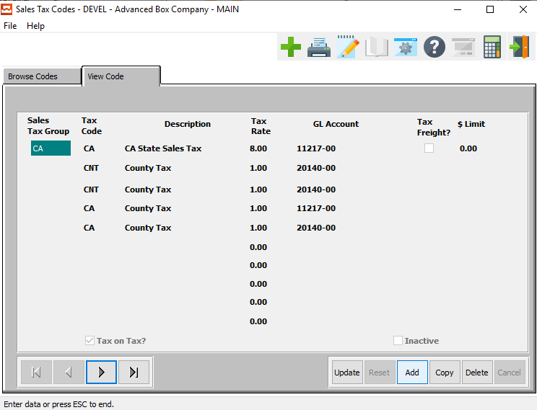

#### UPDATE

To change the currently selected Sales Tax Code, simply click the ***“Update***” button at the bottom of the screen.

#### ADD

To add a new Sales Tax Code, simply click the ***“Green + Icon”*** button at the top of the Sales Tax Code screen.

Alternatively, click the ***“Add”*** button at the bottom of the screen.

#### COPY

Click the ***“Copy”*** button to copy information from the currently selected Sales Tax Code.

#### DELETE

To delete the currently selected Sales Tax Code, simply press the ***"D"*** key. Alternatively, click the ***“Delete”*** button at the bottom of the screen.

#### NEXT

Press ***"N"*** (Next) to find next Sales Tax Code to view or modify. Alternatively, press the ***“Right Arrow”*** on the screen.

#### PREVIOUS

Press ***"P"*** (Previous) to find previous Sales Tax Code to view or modify. Alternatively, press the ***“Left Arrow”*** on the screen.

### Add/Update Code

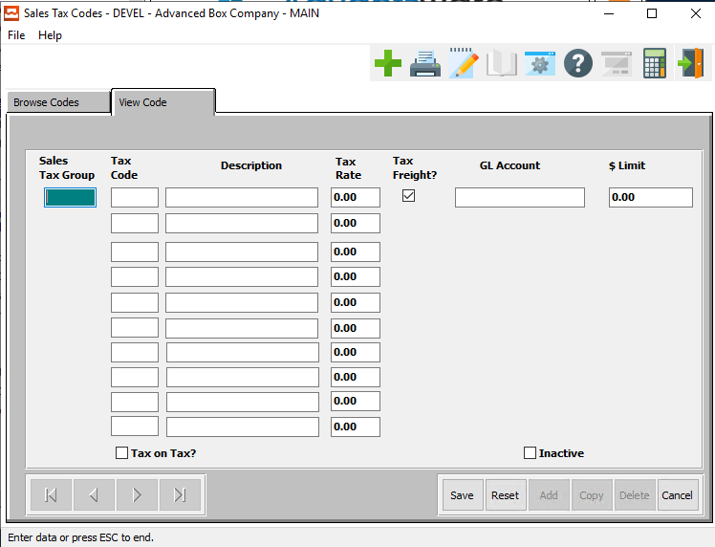

#### SAVE

Click the ***“Save”*** button to save all changes to the current Sales Tax Code.

#### RESET

Click the ***“Reset”*** button to reset all fields to their original state.

#### CANCEL

Click the ***“Cancel”*** button to cancel all changes to the Sales Tax Code without saving.

### Add/Update Code Field Definitions

#### Sales Tax Group

Enter the user defined sales tax group code. This code may be anything, but experience has found that easy to remember (mnemonic) groups excel. Following are examples of Sales Tax groups in use by companies; 'CA' (California), 'Pa' (Pennsylvania), and 'Pa1' (Philadelphia, Pa). The system allows a maximum of three Sales tax codes for each Group you want to create.

For example, a Sales tax group for the city of Philadelphia (PA). Both of these jurisdictions are taxing authorities. Two codes comprise the 'Pa1' group (Philadelphia, Pa); 'Ph' (Philadelphia) and 'Pa' (Pennsylvania). Each code has a sales tax rate and a G/L account associated with it. The system applies the sales tax to its related G/L account, for each code in the group. The system bases the sales tax on the sales tax rate and the net invoice amount.

#### Tax Code

Enter user defined codes to subdivide the sales tax group. The system allows a maximum of three Sales tax codes for each Group. You want to create, for example, a Sales tax group for the city of Philadelphia (PA). Both of these jurisdictions are taxing authorities.

Two codes comprise the 'Pa1' group (Philadelphia, Pa); 'Ph' (Philadelphia) and 'Pa' (Pennsylvania). Each code has a sales tax rate and a G/L account associated with it. The system applies the sales tax to its related G/L account, for each code in the group. The system bases the sales tax on the sales tax rate and the net invoice amount.

#### Description

Enter a user-defined description for the code.

#### Tax Rate

Enter the sales tax percentage rate for this code (within this group).

#### Tax Freight? – Toggle Box

To indicate that this tax authority code will be used to tax freight, make sure that the Tax Freight toggle box is checked.

#### GL Account

Enter the valid G/L Account for this code (within this group). Optionally, press the ***“F1”*** key to search, or press the ***“Page Up” / “Page Down”*** keys to scroll through the G/L accounts file.

#### $ Limit

Enter a dollar limit on this tax code.

#### Tax on Tax? – Toggle Box

To mark this tax authority code as a tax on tax option, make sure that the Tax on Tax toggle box is checked.

#### Inactive – Toggle Box

To mark this tax authority code as inactive, make sure that the Inactive toggle box is checked.

## AR Control [AF7]

The AR Control File allows defining default General Ledger account numbers for invoicing purposes. When an invoice is posted the last invoice number is automatically written to the AR control file so that the next sequential number will be assigned. In addition, when invoicing the receivables account is debited and the sales account is credited as well as freight discounts and sales taxes are applied simultaneously.

### AR Control Screen

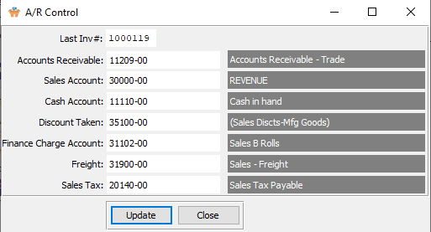

#### UPDATE

To change the currently Control system, simply click the ***“Update***” button at the bottom of the screen.

#### CLOSE

Click the ***“Close”*** button to exit the AR Control screen.

### Update AR Control

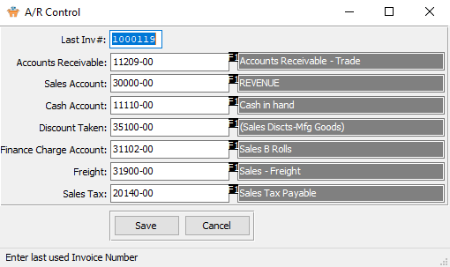

#### SAVE

Click the ***“Save”*** button to save all changes to the current Control system.

#### CANCEL

Click the ***“Cancel”*** button to cancel all changes to the Control system without saving.

### Update AR Control Field Definitions

#### Last Invoice #

This is the last invoice number automatically assigned when posting invoicing through OP or AR.

#### Accounts Receivable

Enter G/L account number for Accounts Receivable.

#### Sales Account

Enter G/L account number for Sales.

#### Cash Account

Enter G/L account number for Accounts Payable Checking Account.

#### Discount Taken

Enter G/L account number for discount taken.

#### Finance Charge Account

Enter G/L account number for Cash on Account.

#### Freight

Enter G/L account number for Freight Expense.

#### Sales Tax

Enter the G/L account number for Sales Tax.

## Truck Common Carriers [AF8]

The Common Carrier File is defined so that the cost of freight is calculated automatically for an estimate as well as for an invoice when invoicing through Order Processing. The carrier may be defined and within the carrier a different delivery zone may be defined. To set up multiple delivery zones and freight rates for a carrier, simply press the ***"M"*** (Matrix) key.

### Browse Carriers

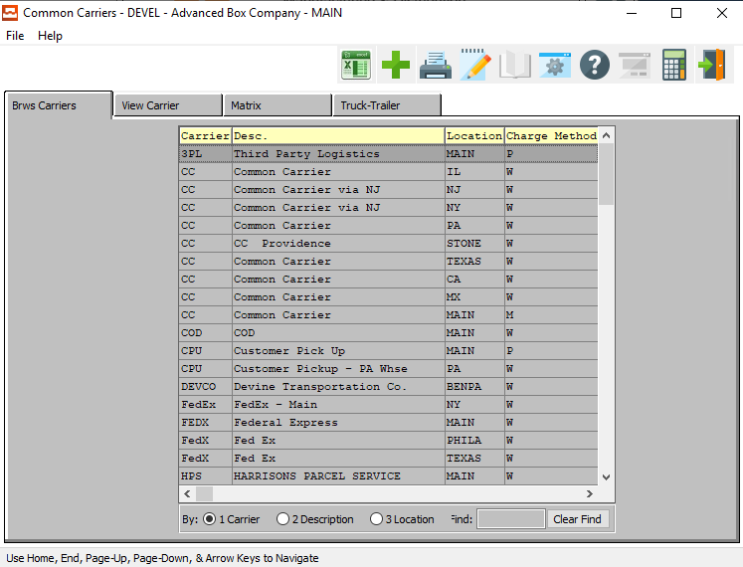

#### ADD

Click the ***“Green + Icon”*** to add a new Carrier.

### View Carrier

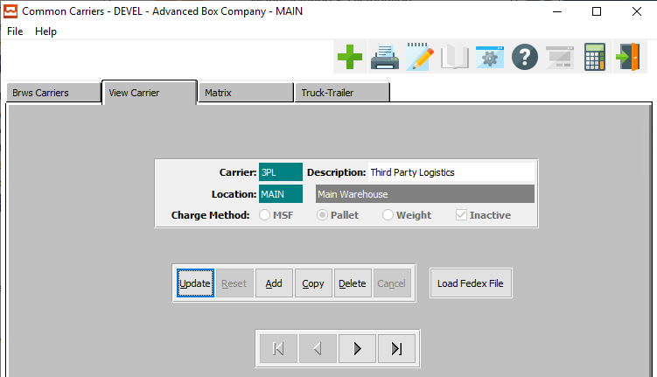

#### UPDATE

To change the currently selected Carrier, simply click the ***“Update***” button at the bottom of the screen.

#### ADD

To add a new Carrier, simply click the ***“Green + Icon”*** button at the top of the Common Carrier screen.

Alternatively, click the ***“Add”*** button at the bottom of the screen.

#### COPY

Click the ***“Copy”*** button to copy information from the currently selected Carrier.

#### DELETE

To delete the currently selected Carrier, simply press the ***"D"*** key. Alternatively, click the ***“Delete”*** button at the bottom of the screen.

#### LOAD FEDEX FILE

To load an existing FedEx file to attach to the current Carrier information, click the ***“Load FedEx File”*** button.

#### NEXT

Press ***"N"*** (Next) to find next Carrier to view or modify. Alternatively, press the ***“Right Arrow”*** on the screen.

#### PREVIOUS

Press ***"P"*** (Previous) to find previous Carrier to view or modify. Alternatively, press the ***“Left Arrow”*** on the screen.

### Add/Update Carrier

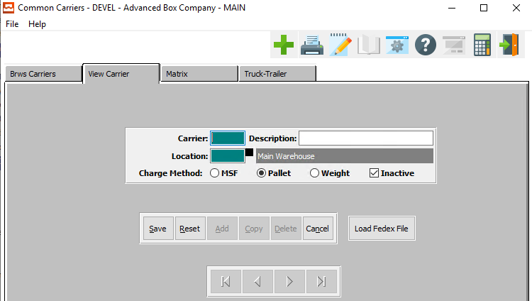

#### SAVE

Click the ***“Save”*** button to save all changes to the current Carrier.

#### RESET

Click the ***“Reset”*** button to reset all fields to their original state.

#### CANCEL

Click the ***“Cancel”*** button to cancel all changes to the Carrier without saving.

#### LOAD FEDEX FILE

To load an existing FedEx file to attach to the current Carrier information, click the ***“Load FedEx File”*** button.

### Add/Update Carrier Field Definitions

#### Carrier

Enter a unique common carrier code and a description or name of common carrier.

#### Description

Enter the description of the carrier code.

#### Location

Enter the location of this character.

#### Charge Method (Choice)

To choose the preferred charging method of MSF vs. Pallet vs. Weight, please make sure the desired option choice bubble is toggled.

#### Inactive – Toggle Box

To mark this carrier as inactive, make sure that the Inactive toggle box is checked.

### Matrix

The carrier zone allows defining multiple or various freight rates for each delivery zone for a common carrier. In addition, a minimum or flat charge may be charged if the weight multiplied by the weight per 100 pounds does not exceed the minimum charge. Under this circumstance, the minimum charge will be used for calculating the freight.

As an example of this Matrix your own truck could be defined with a delivery zone of 50 miles, 100 miles, etc. so that a different charge may be assigned to each delivery zone

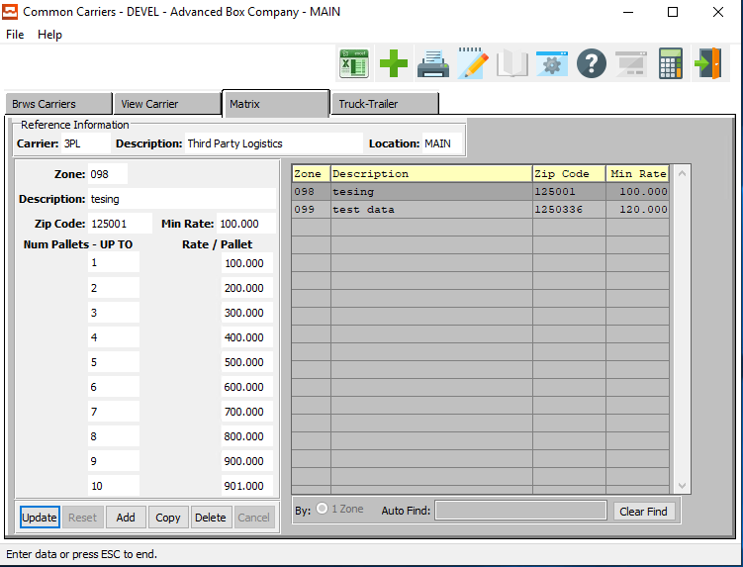

#### UPDATE

To change the currently selected Carrier Matrix, simply click the ***“Update***” button at the bottom of the screen.

#### ADD

Click the ***“Add”*** button at the bottom of the screen to add a new Carrier Matrix.

#### COPY

Click the ***“Copy”*** button to copy information from the currently selected Carrier Matrix.

#### DELETE

To delete the currently selected Carrier Matrix, simply press the ***"D"*** key. Alternatively, click the ***“Delete”*** button at the bottom of the screen.

### Add/Update Matrix

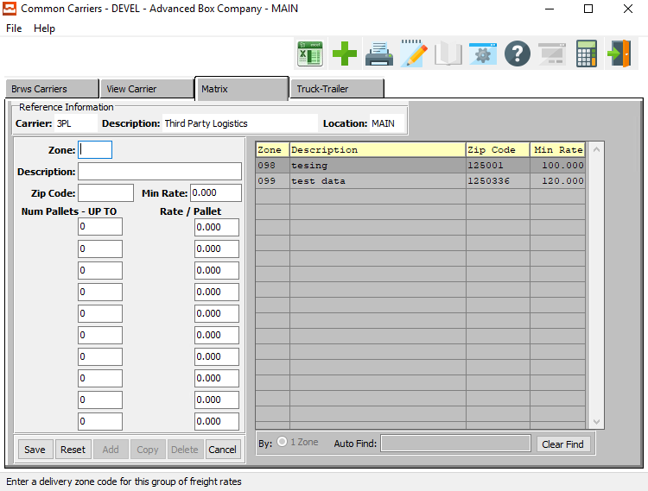

#### SAVE

Click the ***“Save”*** button to save all changes to the current Carrier Matrix.

#### RESET

Click the ***“Reset”*** button to reset all fields to their original state.

#### CANCEL

Click the ***“Cancel”*** button to cancel all changes to the Carrier Matrix without saving.

### Add/Update Matrix Field Definitions

#### Zone

Enter a delivery zone code for this group of freight rates.

#### Description

Enter a description for this delivery zone.

#### Zip Code

Enter zip codes within a delivery zone for special rates.

#### Min Rate

This is the minimum rate which will be used regardless of any weight.

#### Number Pallets

Enter the maximum number of pallets

#### Rate/Pallet

Enter the shipping rate for each price level break from highest to lowest. Once the system calculates the shipping weight for the estimate quantity, the rate per hundred weight is found here then multiplied by the total weight including case and pallet weight to calculate the freight cost. Enter from high to low.

### Truck/Trailer

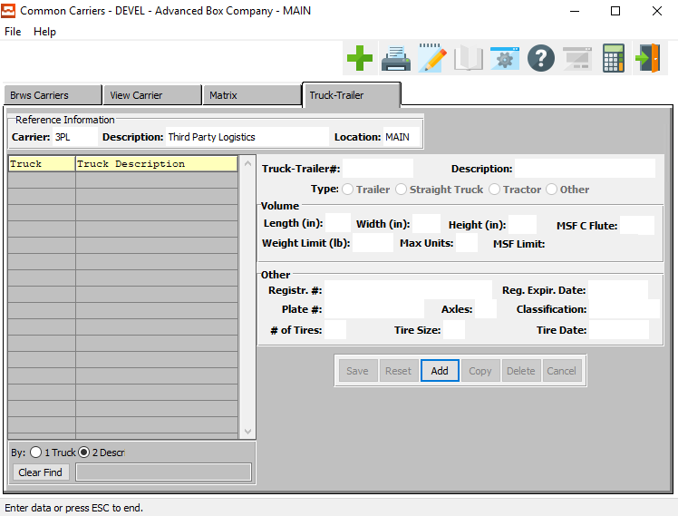

#### ADD

Click the ***“Add”*** button at the bottom of the screen to add a new Truck Trailer.

### Add Truck/Trailer

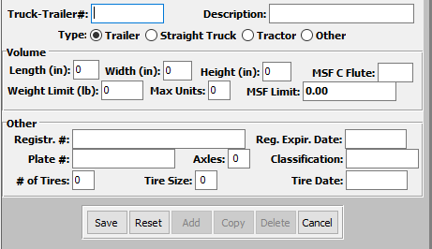

#### SAVE

Click the ***“Save”*** button to save all changes to the current Truck Trailer.

#### RESET

Click the ***“Reset”*** button to reset all fields to their original state.

#### CANCEL

Click the ***“Cancel”*** button to cancel all changes to the Truck Trailer without saving.

### Add Truck/Trailer Field Definitions

#### Truck-Trailer #

Enter the truck trailer number.

#### Description

Enter a short description of the truck trailer.

#### Type (Choice)

To choose the preferred Trailer Type for this truck trailer, please make sure the desired option choice bubble is toggled.

#### Length (inches)

Enter the volume length in inches for the truck trailer.

#### Width (Inches)

Enter the volume width in inches for the truck trailer.

#### Height (Inches)

Enter the volume height in inches for the truck trailer.

#### MSF C Flute

Enter the Flute volume for the truck trailer.

#### Weight Limit (Lbs.)

Enter the weight limit in pounds for the truck trailer.

#### Max Units

Enter the maximum number of units allowed in this truck trailer.

#### MSF Limit

Enter the MSF limit for this truck trailer.

#### Registration #

Enter the Registration number for this truck trailer.

#### Plate #

Enter the License Plate number for this truck trailer.

#### # of Tires

Enter the number of tires for this truck trailer.

#### Axles

Enter the number of axles for this truck trailer.

#### Tire Size

Enter the tire size for this truck trailer.

#### Registration Expiration Date

Enter the Registration expiration date for this truck trailer.

#### Classification

Enter the classification code for this truck trailer.

#### Tire Date

Enter the tire date for this truck trailer.

## AR Class [AF9]

### Browse AR Class

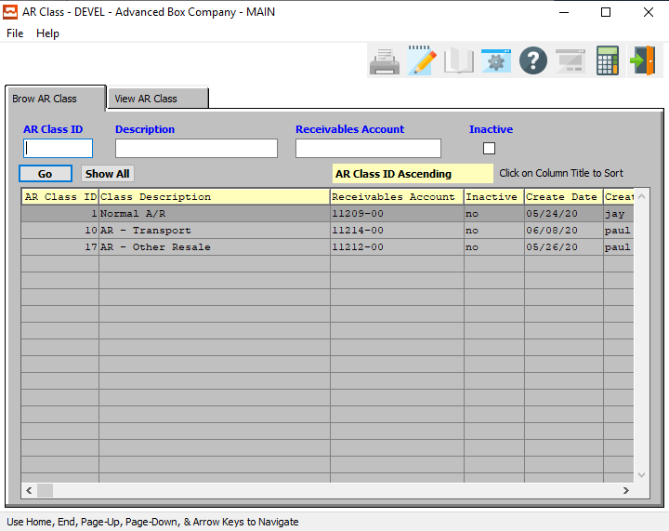

#### AR Class ID

Enter the Accounts Receivable class ID number to search for.

#### Description

Enter the Accounts Receivable class description to search for.

#### Receivables Account

Enter the Accounts Receivable Account number to search for.

#### Inactive – Toggle Box

To search for inactive AR classes, make sure that the Inactive toggle box is checked.

### View Class

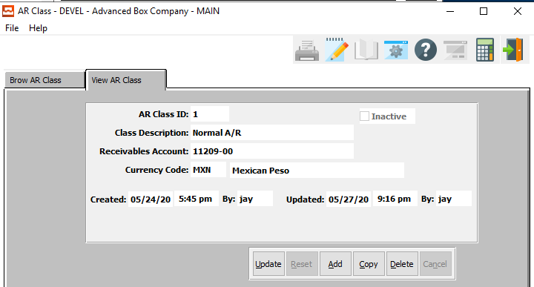

#### UPDATE

To change the currently selected Accounts Receivable Class, simply click the ***“Update***” button at the bottom of the screen.

#### ADD

Click the ***“Add”*** button at the bottom of the screen to add a new Accounts Receivable Class.

#### COPY

Click the ***“Copy”*** button to copy information from the currently selected Accounts Receivable Class.

#### DELETE

To delete the currently selected Accounts Receivable Class, simply press the ***"D"*** key. Alternatively, click the ***“Delete”*** button at the bottom of the screen.

### Add/Update Class

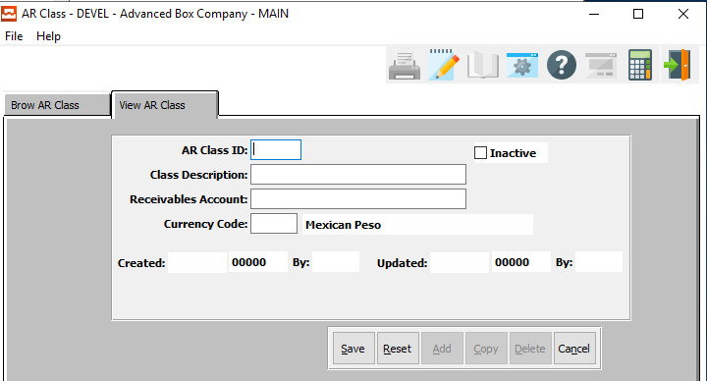

#### SAVE

Click the ***“Save”*** button to save all changes to the current Accounts Receivable Class.

#### RESET

Click the ***“Reset”*** button to reset all fields to their original state.

#### CANCEL

Click the ***“Cancel”*** button to cancel all changes to the Accounts Receivable Class without saving.

### Add/Update Class Field Definitions

#### AR Class ID

Enter a short Accounts Receivable Class ID number for this AR class.

#### Inactive – Toggle Box

To mark this AR Class as inactive, make sure that the Inactive toggle box is checked.

#### Class Description

Enter a small description for this Accounts Receivable Class.

#### Receivables Account

Enter a valid General Ledger account number for this AR Class. Alternatively, press the ***“F1”*** key to choose an account number from a list of valid General Ledger Accounts.

#### Currency Code

Enter a valid Currency Code for this AR Class. Alternatively, press the ***“F1”*** key to choose an Code from a list of valid Currency Codes.